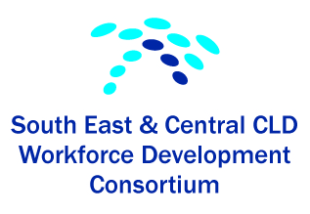
Background information
The SE and Central CLD Workforce Development Consortium was formed in 2011. Members consist of CLD partnership representatives from:
- City of Edinburgh, Vicky Petrie
- Clackmannanshire, Clarke Whyte and Julie McGrath
- East Lothian, Diann Govenlock (Chair)
- Midlothian, Karen McGowan
- West Lothian, Ian McIntosh
- Falkirk, Elenor Macdonald
- Scottish Borders, Oonagh McGarry, Norrie Tait
- Stirling Council, Fiona McLean ( joined in 2014)
Our main aim is to improve continuous professional development for CLD practitioners across our partnership by promoting good practice and sharing of good quality training opportunities.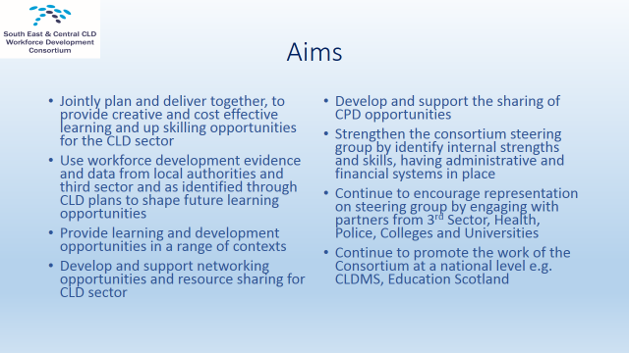
Work and Achievements
Since we formed we have been successful in organising a range of events and programmes which provide ongoing CPD for CLD practitioners , opportunities for networking and sharing practice and have worked together to develop new training resources. These successes include the following:
- Conference Launch in March 2012 – “What’s Hot, What’s New and What’s your View”
- OST Training for Trainers programme and creation of resource bank – boards, resource kit and delivery guide to support practice
- Adult Learning and Curriculum for Excellence conference
- Listen, Learn & Develop Conference in March 2013
- Video of CPD interviews with CLD practitioners March 2013
- The production of a DVD – Examples of good CLD practice
- Sharing of CPD opportunities, including Coaching Skills (individual and Team Coaching), PDA SQA, Dyslexia Course (SCQF level 7), “Engaging Communities” Community Learning and Development Training Programme, and Steve Skinner – Community Capacity Building Conference – and development of short videos for i-develop
- Joint delivery of a range of workshops – e.g diversity, world café conversations, open space session
- Creation of bank of graphic illustrations around CLD practice
- Development of Community Activist Training materials, Community
- Activist Training planning and development residential
- Completion of pack “Community Activist, Building Skills and Knowledge, Training Resource Pack, promotional events, briefing day
- Pack launched at our Passing Power to People and Communities
- Materials being located on 1-develop
- Currently in process of review and piloting phase
- “Inspiring Confidence, Confidence to Inspire” conference March 2014
- Inspiring Practice Follow up event May 2014 which included open space session facilitated by participants who attended the training for trainers programme
- Self-evaluation exercise and development planning day
- “Passing the Power to People and Communities” CLD conversation event with Education Scotland Sept 2015 and launch of Community Activist Resource pack. Held in Edinburgh City Chambers
- Held development planning day on 5th November
- Have created group space on I-develop for consortium members
- Shared opportunity on European project – Spinach for Popeye Congress – Social Sustainability (Falkirk, Scottish borders and West Lothian)
Current / future work and plans
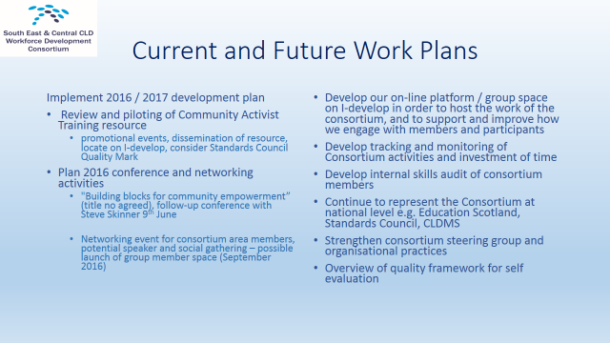
- Implement 2016 / 2017 development plan
- Review and piloting of Community Activist Training resource, promotional events, dissemination of resource, locate on I-develop, consider Standards Council Quality Mark
- Plan 2016 conference and networking activities
- "Building blocks for community empowerment” (title no agreed), follow-up conference with Steve Skinner 9th June
- Networking event for consortium area members, potential speaker and social gathering – possible launch of group member space
- Develop our on-line platform / group space on I-develop in order to host the work of the consortium, and to support and improve how we engage with members and participants
- Develop tracking and monitoring of Consortium activities and investment of time
- Develop internal skills audit of consortium members
Operational structure / membership
- The consortium meets regularly usually at Waverley Court, Edinburgh but we do and have met in other local authority areas e.g. Borders, Falkirk and East Lothian. Meeting dates have been set till end of June 2016
- Membership is open to CLD partners in the 8 local authorities areas
Funding and other contributions
- Funding in the main has been through Education Scotland
- The work of the consortium is currently possible through the in kind funding and contributions from consortium members e.g. providing refreshments, organisational input, administration and promotion, venues and support staff at events.
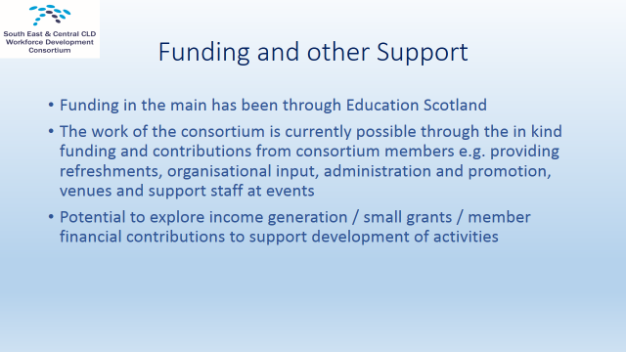
Future issues, concerns and questions
NB As Consortium members we are wholly commitment to the benefits of working together and the continuation of the Consortium.
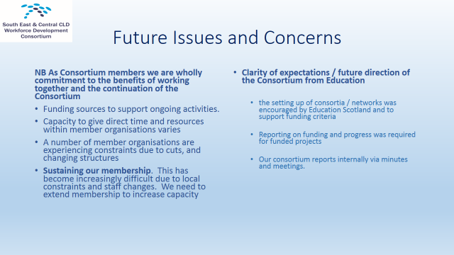
- Funding sources to support ongoing activities. Capacity to give direct time and resources within member organisations varies. A number of member organisations are experiencing constraints due to cuts, and changing structures. Whilst we recognise that funding is not the “be and end all”, it definitely encourages commitment, innovation and additionality.
- Sustaining our membership. This has become increasingly difficult due to local constraints and staff changes. WE need to extend membership to increase capacity.
- Development Planning. The consortium is at the stage of reviewing its role, remit and membership to inform and shape our “2015 and Beyond” action plan. We have a number of ideas for development however some of these are dependent on some of the issues, concerns and questions as expressed in this section.
- Clarity of expectations / future direction of the Consortium from Education Scotland. Initially the setting up of consortia / networks was encouraged by Education Scotland and to support funding criteria. Reporting on funding and progress was required for funded projects. Our consortium reports internally via minutes and meetings.

Current questions
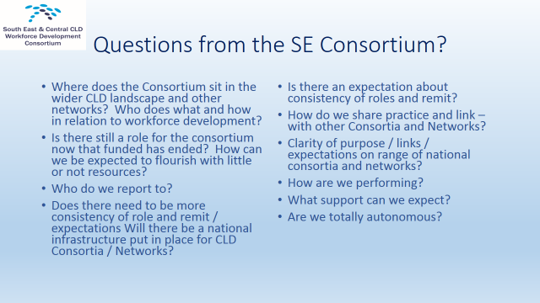
Where does the Consortium sit in the wider CLD landscape and other networks?
Is there still a role for the consortium now that funded has ended?
Who do we report to?
Does the role and remit / expectations of the consortium change?
Will there be a national infrastructure put in place for CLD Consortia / Networks?
Is there an expectation about consistency of roles and remit?
How do we share practice and link – with other Consortia and Networks?
Clarity of purpose / links / expectations on range of national consortia and networks? Who does what and how?

Joint Consortium day 24th February – Edinburgh

Aims of the day
- improve communication between both individual networks and between networks and key stakeholders such as Education Scotland
- provide an opportunity to share and learn from each other’s effective network structures
- share practice between networks to enhance capacity within the CLD sector across Scotland
- progress the formation of a more joined up approach to CLD professional learning & development between the regional networks, other CLD networks and Education Scotland where this will add value
- consider the above and future developments in relation to the changing nature of the CLD workforce and the changing policy landscape

2. The Action Plan
A draft action plan was created on the day with the following items.
1. Collate and share the information gathered and the presentations used on the Network day – action by Education Scotland
2. Ensure the key contacts for each network are accessible by all.
3. A shared network space to be established on i-develop
4. Establish and agree core network outcomes which every network will work to and evaluate against (individual networks may have additional outcomes).
5. Networks to explore further how they collectively support professional wellbeing.
6. Networks to explore how they can have a more co-ordinated approach to; structures (such as constitutions, concordats), sharing practice, joint lobbying and funding
7. Networks to jointly plan another Networks Day to be held Dec 16 or Jan 17.

