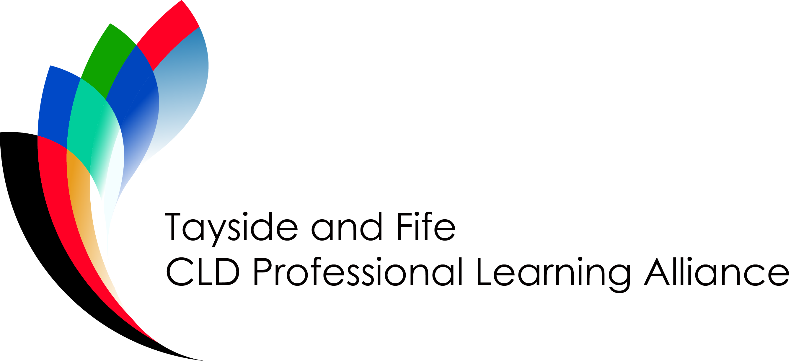

ESOL Practitioners Network

Terms of Reference
The ESOL practitioners Network is a multi-agency group consisting of ESOL practitioners, both paid and volunteers, from local authority and voluntary sector CLD providers. The network members will all be directly delivering to, and/or managing delivery of, community based ESOL learning classes and ESOL volunteering opportunities.

The aim of the Network is to ensure that community based ESOL practitioners benefit from regular and appropriate continuing professional development and learning opportunities.

- The Network will meet quarterly, in appropriate venues on dates conducive to reporting timeframes of the parent body, the Tayside and Fife CLD Professional Learning Alliance.

- Relevant papers will be circulated to Network members no later than 5 working days before each meeting.

- Notes of the Network meetings will be shared with the Tayside and Fife CLD Professional Learning Alliance for their information.

- A chairperson will be elected from within the Network membership for a period of up to 2 years. A member of the parent body will attend the Network meetings to ensure linkage between the two groupings.

- The Group will operate with a remit to:

- Develop a safe space for practitioners to share practice ideas and approaches.
- Offer opportunities for practitioners to critically reflect on their practice through professional conversations with others.
- Share delivery of accredited training opportunities for staff and volunteers using national frameworks such as, but not restricted to, SQA programmes.
- Establish a calendar of regular events for learners and practitioners to come together to celebrate community based ESOL learning opportunities.

Group Membership
The following organisations will be invited to take up a place on the partnership group:

Local Authority ESOL Practitioners:
- Angus Council
- Dundee City Council
- Fife Council
- Perth & Kinross Council

Voluntary Sector CLD ESOL providers
- NATECLA
- WEA
- Dundee Women’s Centre
- PKAVS ESOL programme

Network Funding
The Network will be supported through the funding available to the parent body in order to deliver CPD opportunities to ESOL practitioners. But will be free to secure additional funds to support learning programmes as appropriate and following agreement from the parent body.

