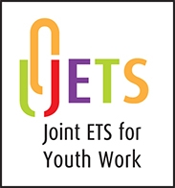

INDIVIDUAL RECOGNITION PROCESS

ROUTE to PROFESSIONAL RECOGNITION in

YOUTH WORK and

YOUTH WORK IN COMMUNITY LEARNING & DEVELOPMENT

GUIDANCE

A Co-operative Scheme of the UK & Ireland Joint ETS administered by its members: ETS (England), ETS (Wales), the North-South ETS (All Ireland), and CLD Scotland

CONTENTS
 |  | Page
1 | Aims of the Individual Recognition Process | 2
2 | Criteria for Recognition | 2
3 | Summary of the Individual Recognition Process | 3
 | Flowchart | 4
4 | The Individual Recognition Process in Detail | 5
5 | Management and Organisation | 6
6 | Fees | 8
7 | Appeals | 8
8 | Contact Details | 9
 | Appendix 1: Individual Recognition arrangements in Scotland | 10

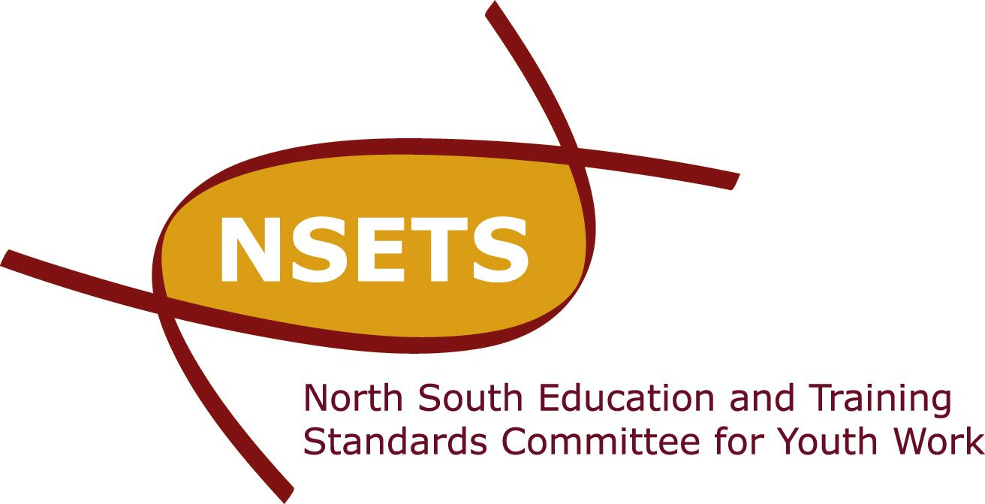


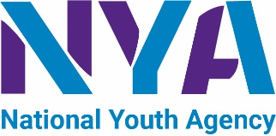
Individual Recognition is a co-operative Scheme of the UK & Ireland Joint ETS administered by its members: ETS (England), ETS (Wales), the North-South ETS (All Ireland), and CLD Scotland

1 | AIMS OF THE INDIVIDUAL RECOGNITION PROCESS
1.1 | The primary aim of the Individual Recognition procedure is to enable an individual with a relevant youth work qualification obtained outside of the UK or Ireland to gain professional recognition as a youth worker in England, Ireland and Northern Ireland, Wales and *Scotland , by means of demonstrating that:  - their qualification meets the minimum requirements as expressed in the Requirements for Professional Endorsement/ Validation of Higher Education Youth Work Qualification Programmes (or their equivalent) in England, Wales, Scotland, Ireland and Northern Ireland;  - they have undertaken relevant, supervised practice as expressed in the Professional Endorsement/Validation Requirements as above.  * NB Scotland has an Individual Recognition process managed by CLD Scotland, the professional body for endorsement of community learning development programmes. CLD Scotland notes the Individual Recognition herein and will implement as & when appropriate. See appendix 1 for details.
1.2 | From 2010 all who wish to be recognised as professional youth workers in England, Northern Ireland and Wales have been required to gain an honours degree. In Scotland professional workers are already required to gain a degree in community learning development.
1.3 | The Joint ETS partners also have an agreed protocol for mutual recognition. This means that a person who gains Individual Recognition of their professional qualification in either England, Ireland, Northern Ireland, Scotland or Wales will automatically be recognised in each jurisdiction.
2 | CRITERIA FOR RECOGNITION
2.1 | Individuals who have studied abroad may apply for recognition in England, Ireland & Northern Ireland, Scotland, & Wales (hereafter referred to as the Joint ETS Jurisdictions) on an individual basis on the grounds that the course of educational study they followed included appropriate youth work content and a period of supervised, relevant practical work in youth work settings. That course of study must have been undertaken outside the UK and Ireland. For detailed information applicants should refer to the Requirements for professional recognition in the jurisdiction to which they wish to apply.
2.2 | The criteria for recognition in this document are designed to ensure parity, as far as possible, between initial qualifying courses for youth work in the Joint ETS jurisdictions and require that:  i) The course of study undertaken was at honours degree level (European  Qualifications Framework level 6) or above and normally of at  least three full academic years duration or the equivalent in  part-time mode; and  ii) At least 50% of the academic content of the course was in any  one, or a combination of, sociology, psychology, social policy,  principles and practice of youth work; and  iii) Fieldwork practice normally constituted the equivalent of 24 weeks for undergraduate programmes over 3 years (or part-time equivalent), and 16 weeks for postgraduate programmes over one year (or part-time equivalent). The practice involved at least 30 hours per week of which over 50% was face to face work with young people aged 11 to 25, with a focus on 13 to 19s. The practice was undertaken in at least two or more different locations and included work with young people and development work with communities. The practice was supervised and assessed. (NB requirements for fieldwork practice hours & age range may vary slightly between jurisdictions)
2.3 | Applicants wishing to be considered for recognition under 1.1 must satisfy 2.2(i), (ii) and (iii) above for eligibility.
2.4 | Applicants who have followed postgraduate courses will be considered on the basis of the criteria set out above.
2.5 | Individual recognition will be moderated by the Joint ETS Individual Recognition Moderation Panel comprising representatives of each of the Joint ETS jurisdictions.
3 | SUMMARY OF the individual recognition process
The application process for Individual Recognition has three stages:

Stage 1: INITIAL EXPRESSION OF INTEREST

Stage 2: COLLATION OF EVIDENCE & SUBMISSION
This stage is undertaken only when the applicant has approval to proceed

Stage Three: ASSESSMENT PROCESS

These stages are summarised in the flowchart below.

Applicant completes Form IR1and returns it to relevant ETS agency
ETS agency gives approval to proceed to STAGE 2

YES
NO
Applicant is sent Form IR2

Applicant is not deemed suitable to proceed and reasons are provided*

Applicant completes Form IR2 and returns it along with supporting documentation and appropriate fee to relevant ETS agency
YES
NO
Assessor requests additional information from applicant

Applicant is not deemed suitable to proceed and reasons are provided*

NO,
Submission needs further work
Applicant provides additional information to assessor

Applicant is notified of decision and formal recording processes are conducted by Joint ETS

Summary of application process for Individual Recognition (IR) as Professional Youth Worker, UK & Ireland

Applicant seeking IR contacts relevant ETS agency for copy of guidance notes and ‘Expression of Interest’ Form IR1
STAGE 1
Expression of Interest
STAGE 2
Submission of Evidence
ETS agency appoints assessor to examine the applicant’s submission and produce report. Assessor may require additional information from applicant at this stage. Assessor will conduct interview with applicant.

Assessor sends report to Joint ETS Moderation Panel members (via ETS agency) for their comments and approval

Approval by all Joint ETS Moderation Panel members?

STAGE 3
Assessment Process
* An appeals process is available

4 | the Individual Recognition Process in detail
4.1 | STAGE 1: EXPRESSION OF INTEREST  Individuals wishing to apply for recognition are required to complete the expression of interest form IR1. The purposes of this form are to:  - register formally an intention to move forward within the process;  - provide contact details including email addresses to be utilised;  - provide the information needed to decide whether the applicant meets the scheme’s minimum entry requirements; and  - instigate the selection of an appropriate person to act as Assessor.  Process  - The applicant contacts the relevant ETS agency in the jurisdiction to which application is to be made and is sent an Expression of Interest Form (IR1);  - The applicant is required to complete form IR1 and submit it to the relevant ETS agency, including (as a condition of application) an email address for direct contact in addition to their correspondence address and telephone number.  - If the application is not suitable, the applicant is informed by the relevant ETS agency with reasons for not proceeding.  - If the relevant ETS agency approves the decision to proceed to Stage 2, the applicant will be emailed the submission form IR2.  - The agency will allocate an assessor to the applicant and notify the Joint ETS Individual Recognition Moderation Panel.
4.2 | STAGE 2: SUBMISSION  The applicant is expected to take full responsibility for preparing and submitting application Form IR2 plus required supporting, documentary evidence, which will include details and evidence of:  - academic study including name of institution, title of qualification and period of study;  - unit/element/module of study itemised into terms or semesters;  - supervised, fieldwork practice itemised into terms or semester and length of practice expressed in full days.  When completing form IR2, the applicant collates evidence including at minimum:  - authenticated photocopies of the relevant qualification ;  - a statement from either the fieldwork supervisors or college tutor(s) to confirm that the practice was supervised and assessed;  - evidence that the qualification cited is relevant and of the required standard. (NB written confirmation will be sought from the awarding institution and official bodies, in the country concerned, of its standing and acceptance);  - a detailed report of the major fieldwork practice(s); and/or  - a detailed report(s) from the fieldwork supervisor(s) for the major fieldwork practice(s);  - any other relevant information that provides evidence that there is experience that meets the criteria.
PLEASE NOTE:

The application cannot proceed until we have either original or authenticated copies of all relevant qualification certificates.

Certificates provided in a languages other than English, must be accompanied by authenticated translations .

Authentication must take the form of an original stamp and signature of an appropriate official from the university concerned.

In the case of translations, authentication must take the form of an original stamp and signature of an official translator, an embassy, the university concerned, a notary public, a justice of the peace, or an equivalent legal authority.

The applicant then submits to the relevant ETS agency:

- the completed IR2 form;
- all supporting documentation;
- the appropriate fee payable to the relevant ETS agency.

Documentation should be submitted using a registered mail service for security and will be returned to individuals.

A copy of form IR2 must also be submitted by email.

4.3 | STAGE 3: ASSESSMENT  Upon receipt of the submission (Form IR2 plus required supporting, documentary evidence) the nominated assessor …  - assesses the evidence according to the agreed criteria;  - seeks further information and any additional evidence from the applicant to support their application;  - conducts a interview with the applicant via telephone or internet communications (eg Skype);  - prepares and submits a report and recommendations to the relevant ETS agency.  Upon receipt of the assessor’s report and a copy of the applicant’s submission the agency/ ETS will submit the report to the Joint ETS Individual Recognition Moderation Panel, to ensure:  - the approved process has been undertaken and duly moderated;  - consistency and reliability of the recommendation(s) made;  the Joint ETS is informed.  The Joint Moderation Panel…  - moderates the Individual Recognition process;  - reviews and moderates the Assessor’s report;  - informs the relevant ETS agency of their moderation decision .  The Relevant ETS agency…  - manages the Individual Recognition process;  - communicates the decision to the applicant;  - informs the other jurisdictions and the JNC as appropriate.

5 | MANAGEMENT AND ORGANISATION
5.1 | Role of Relevant ETS Agencies

Management and organisation of the Individual Recognition process is delegated by the Joint ETS to the individual ETS agencies in each of the participating countries/jurisdictions. The relevant ETS agency will administer the application and assessment process.

Each agency’s role is to:
- act as the referral point for enquiries and applications relating to their jurisdiction;
- administer the Individual Recognition process when the application concerns working within their jurisdiction;
- nominate a member of the Joint Individual Recognition Moderation Panel;
- meet the criteria set out in this documentation;
- make the initial judgement whether an application for Individual Recognition is suitable to proceed from initial expression of interest to full submission;
- appoint Assessors as required to assess full submissions, and follow the assessment process as set out in section 3 above;
- inform the Joint ETS of any actions relating to Individual Recognition.

Final responsibility for approving an application for Individual Recognition rests with the relevant ETS agency. Following formal recording in the Minutes of the relevant ETS agency the applicant, the JNC and the other jurisdictions should be formally notified of the decision.

Each agency should maintain a record of recognised individuals in its jurisdiction and ensure that Joint ETS is informed. The NYA will maintain a central record of recognised individuals on behalf of the Joint ETS.

The Joint ETS should be informed of the decision at its next meeting.

5.2 | Role of the Joint Individual Recognition Moderation Panel
The role of the Joint Moderation Panel is to:

- receive the report and recommendations of the appointed Assessors on the applicants’ submissions for Individual Recognition;
- ensure that applications from individuals for professional recognition comply with the criteria approved by the participating countries/jurisdictions;
- make recommendations to the relevant ETS in accordance with the criteria in this documentation;

conduct their proceedings by email and telephone wherever possible.

5.3 | Role of the Assessor
The allocation of an Assessor to an applicant will be the responsibility of the relevant ETS agency in the jurisdiction to which application is made for Individual Recognition.

An Assessor is allocated to each applicant:

- to map the applicant’s academic qualifications against approved minimum criteria;
- to map the applicant’s supervised fieldwork practice against approved minimum criteria;
- to check the authenticity of documentation through direct contact with relevant institutions independently of the applicant
- to check the authenticity of the application through direct contact with the applicant via a telephone or internet-based interview.

Assessors will have the following qualities:

- a range of skills, knowledge and understanding within youth work;
- an understanding of the processes involved in making a submission for Individual Recognition;
- the ability to work within the principles and values of youth work;
- the ability to be analytical in the context of others’ work;
- the ability to write a clear and concise report with recommendations.

6 | FEES
 | Fees for Individual Recognition are only charged if the applicant is approved to make a submission using form IR2. Fees vary by jurisdiction and are available from the relevant ETS agency.
7 | APPEALS
An agreed procedure is in place and the Joint ETS partners are determined that all endorsement panel decisions will be made in an open and transparent manner conforming to best practice.

APPEALS PROCEDURE CRITERIA

The relevant ETS agency will review an endorsement decision under the following criteria only; no other grounds for appeal will be considered:
- The outcome of the Individual Recognition process was a decision that no reasonable person would have made on the basis of the information provided in the submission. It should be noted that disagreement with a decision does not of itself make the decision unreasonable. To appeal on the basis of this ground the individual will be required to provide substantive evidence as to why no reasonable person would have arrived at the decision that was made; and/or
- There was a failure in adherence to the application procedure or assessment process and that this procedural irregularity was such that it would have materially affected the decision or recommendation made.

APPEALS PROCESS

If individuals wish to appeal an Individual Recognition decision they must:
- Submit a request for a review of the decision in writing within 28 days the date of the decision letter issued by the relevant ETS agency;
- A written request for a review should be addressed to the relevant ETS agency secretariat, and clearly marked Individual Recognition Appeal;
- The request must clearly demonstrate/address the criteria upon which a review is being requested.

At this point the relevant ETS agency will NOT accept additional or new information in support of the application or the appeal.

The appeal will be dealt with by an Independent Appeals Panel of 3 persons whose members will not have been involved in the Individual Recognition process. The Appeals Panel will be chaired by the current Joint ETS Chair i.e. as at the Joint ETS meeting previous to the appeal or to an external appointee nominated by the Chairs of the participating jurisdictions’ ETS Committees.

Individuals will receive the final decision of the Appeals Panel within 28 days of receipt of the appeal request.

8 | CONTACT DETAILS

ENGLAND
National Youth Agency
nya@nya.org.uk
www.nya.org.uk

IRELAND AND NORTHERN IRELAND
NSETS (North South ETS)
info@ycni.org
www.ycni.org

SCOTLAND
CLD Standards Council
contact@cldstandardscouncil.org.uk
www.cldstandardscouncil.org.uk

WALES
ETS Wales
elizabeth.rose@wlga.gov.uk
www.etswales.org.uk
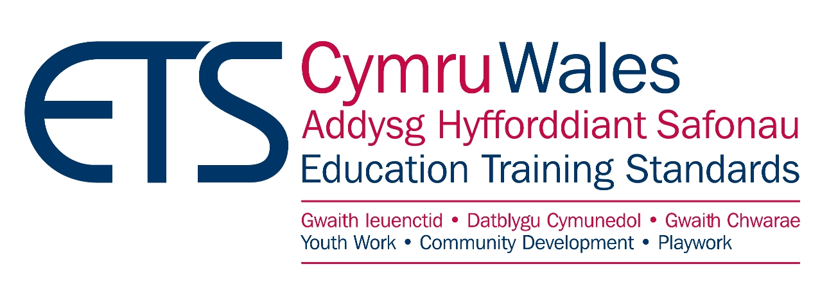

Flowchart: Starting the Individual Recognition Process

Does the applicant have a professional level qualification?

If applicant has worked in CLD in Scotland for 10 years or more: register as member
If applicant has worked in CLD in Scotland for less than 10 years: Individual Recognition Process
Applicant should follow the JETS Individual Recognition Process route to Youth Work Guidelines
If applicant also has two years’ verified experience: register as member
If applicant has less than two years’ verified experience: register as an associate until experience criteria met

If applicant has worked in CLD in Scotland for 10 years or more: register as member
If applicant has worked in CLD in Scotland for less than 10 years: Individual Recognition Process
If applicant has worked in CLD in Scotland for 10 years or more: register as member
If applicant has worked in CLD in Scotland for less than 10 years: Individual Recognition Process
YES: from UK or Ireland and not on the JETS list of mutually recognised qualifications
YES: from outside the UK and Ireland in Youth Work
YES: from outside the UK and Ireland in CLD field
YES: from UK or Ireland and on JETS list of mutually recognised qualifications
NO: qualifications are below degree level or no formal qualifications

