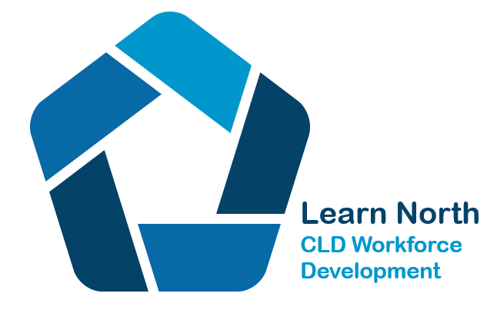
Supporting Community Learning and Development practice in the North of Scotland through professional learning

Memorandum of Agreement between partner organisations:
Aberdeen City Council
Aberdeenshire Council
Aberdeenshire Voluntary Action
TSI Moray
Moray Council
Highland Council /High Life Highland
Highland TSI
Shetland Islands Council
Voluntary Action Shetland
Orkney Islands Council
Voluntary Action Orkney
Argyll and Bute Council
Comhairle nan Eilean Siar
TSI Western Isles

Collaboration in Continuing Professional Development for CLD practitioners

At our meeting on 27th October 2022 we agreed and updated the basis upon which we would continue to develop our collaboration in the field of continuing professional development for Community Learning and Development (CLD) practitioners in the North of Scotland.

We agree that Learn North is a partnership of community learning and development practitioners from the eight North of Scotland Community Learning and Development Partnerships (CLD Partnership) of: Aberdeenshire; Aberdeen City; Argyll and Bute; Highland; Moray; Orkney; Shetland and Western Isles.

We recognise the added value of working together to achieve best practice standards across the north of the country by up skilling the CLD workforce.

We aim to improve opportunities and access to Continuing Professional Development (CPD) for the CLD workforce in the eight local authority areas to ensure positive learning outcomes in communities.

As CLD practitioners, Learn North shares a commitment to supporting positive change in communities and has a thorough understanding of the CPD needs of staff working in the field.

- We will commit to up to 4 priorities for Learn North that we will progress at any one time.

- In relation to external funding:

- we will commit 100% of funding jointly secured to support professional learning to collaborative programmes and activities involving our partnerships;
- one partner will act as the budget holder on behalf of Learn North. The specific partner taking on this role will be agreed on an annual basis;
- all funding secured for Learn North will be used to support our agreed initiatives and priorities;
- ensure that each partner will manage financial transactions within its own financial regulations;
- plan to ensure that any unused monies at the end of a financial year are carried forward by the budget holder or another arrangement will be made to secure its continued availability.

- In relation to National Awards we will:
(By national awards we mean nationally recognised qualifications that are part of the CLD qualifications network/pathway developed by the CLD Standards Council)

  - discuss and agree any future collaboration costs in the development of new
learning qualifications, materials or resources, where possible
  - support each other to deliver qualifications, by providing placements and work experience opportunities for award participants within the area covered by Learn North, when possible and practical
  - share learning materials and resources developed locally on a no cost basis
  - we will positively promote any accredited learning opportunities in the North

- In relation to general Professional Learning activity we will:

- agree to share information on opportunities that partners are developing and delivering in their own areas
- encourage staff and volunteers from across partnership areas to participate in opportunities
- encourage staff and volunteers to have a voice in Learn North
- carry out an audit of training requirements and priorities across the partnership areas every three year to correspond with the development of CLD plans and respond within resource available
- develop and deliver joint activities and programmes when appropriate and cost effective
- coordinate activity on an annual basis to extend access to opportunities
- commit to regular self-evaluation and improvement planning
- we will invite appropriate partners to join the partnership, in alignment with priorities

- In relation to practice placements:

  - Discuss and identify placements available within partnership areas
  - Discuss and identify demand for placements
  - Agree that all placements are coordinated through named person(s) in each authority area
  - Map the number of CLD practice supervisors and increase if required
  - Ensure that placement supervisors and mentors will have access to quality learning and development opportunities to support their role

In all of this, we will work to ensure that the opportunities on offer through our collaborative efforts reflect the needs of the whole CLD sector in our respective authority areas and take due cognisance of national policy directions.

We will review this agreement every 3 years in line with local CLD plans to take account of new circumstances and opportunities and amend if required.

