Event Brite template for Winter Learning Festival for CLD sessions

Please refer to this template when compiling an Event Brite page for your Winter Learning Festival for CLD event. The national planning group for the series is keen to make sure that sessions are open to CLD practitioners across Scotland and that there are some common features to the invites for every session. Many thanks for your help.

Create event: Eventbrite - Create a new event
If your organisation doesn’t have an Event Brite account, you can create one for free.

Basic Info:
Event Title (75 characters): | Please include ‘Winter Learning Festival’ (24 characters) and add the title of your event.
Organiser: | Add your network
Type: | Course, training or workshop
Category: | Choose one eg Family and Education
Subcategory: | Education
Tags: | - CLD  - Winter Learning Festival for CLD
Location (type of event): | Online event
Date and time: | Add the correct day and the start and finish time for your session

Details
Main event image: | Please use the Winter Festival logo  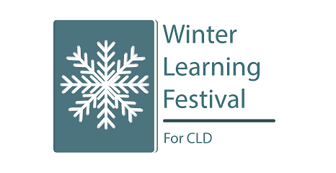
Description: | Summary: Use the descriptor from your planning template here.  Text: Please include: This session is part of a national series of online learning opportunities organised by regional CLD professional learning networks across Scotland. It is open to all community learning and development (CLD) practitioners from any part of Scotland.

Ticket

Name: | General Admission [check your settings]
Available quantity: | [Quantity?]
Price: | Free (click on ‘Free’ box)

Order Options / Order Form

(First name, surname and email address should be collected by default – check settings). Additional questions need to be added.

Add new question

Your organisation | Question format: use short text so people can type in their organisation
Which local authority area do you work in? | Question format: Single Choice / Select from drop-down – add the 32 areas plus national option
Are you a member of the CLD Standards Council? | Question format: Single Choice: Yes/No
Do you wish to be kept informed about future learning opportunities from your CLD network? | Question format: Single Choice: Yes/No

