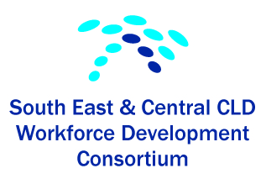
Networking Event 8th September 2016 at 4pm
South Bridge Resource Centre, Edinburgh
This was the first networking event held by the Consortium. The aim was to provide an informal forum for reflective practice and the opportunity to network with colleagues across boundaries. This was an early evening event held in Central Edinburgh with Canongate Youth Project providing the buffet. 18 people attended from City of Edinburgh Council, Midlothian Council, East Lothian Council, Falkirk Council, West Lothian Council, Four Square and Crisis. The guest speaker was Dr Margaret Petrie, Senior Teaching Fellow from Education, Community and Society (ECS) at Moray House School of Education.
Programme
Welcome and Introductions
Input by Dr Margaret Petrie (see PowerPoint presentation)
CLD Standards Council / i-develop
We asked “What’s lacking in CPD that the Consortium can help with?”
- Being resilient in difficult times
- How to work with computers
- Fundraising and the changing landscape for CLD across Scotland
- How do we get more people to give their view – come along?
- Discussion around the Syrian VP programme/ Role of CLD practitioners
- Focus on Family learning, looking at sharing practice across the network
- Fundraising and networking events, invite MSPs, councillors
- Mental health issues for young people
- Tips, tools and practice at arguing for a CLD approach with non-CLD (trained) colleagues/ partners
- Future events: CLD contribution to Poverty and Inequality
And “How do we get support? Future networking is there a need? If yes, how and when?”
- Good to get initial input and then a chance to talk in small groups
- Look at links with Standards Council Networks
- Bigger Digital networking to allow people to stay in touch even then they are busy. Social as well as work related get togethers.
- More networking and sharing good practice
- Very useful opportunity to network across Local Authority areas and debate issues and priorities for CLD
- Yes should be more as there is not many of us left
- Would be good to get an idea of local areas work such as youth work in West/ East/ City/ Mid or Adult Capacity Building etc
- Really enjoyed this met interesting people and heard different perspectives on our common concerns. Keep up the good work
- Thanks for putting on this event today! It was useful. Quite difficult to attend stuff like this at the moment...not got any suggestions at the moment! Sorry!

