-
Introduction to Scots Literacy
Guid Fer a Laugh
Level 1- Pack 3

Speakin’
Scots
Jacksie
Tummelt
Stramash
Croon
Drap
Sneck
Cuddie
Bogle
Oxter
Loon
Neb
Sark

Semmit
Dinnae
Ower
COONCIL
Introduction to Guid Fer A Laugh

We are part of the City of Edinburgh Council, South West Adult Learning team and usually deliver ‘Guid Fer a Laugh’ sessions for community groups in South West Edinburgh. Unfortunately, we are unable to meet groups due to Covid-19. Good news though, we have adapted some of the material and we hope you will join in at home.

Development of Packs
Following feedback from participants we plan to develop packs from beginner level 1 to 5 with 4 packs at each level. This will allow participants to gradually increase in confidence, recognising and understanding Scots. By level 5, participants should be able to: read, recognise, understand and write in Scots.

Distribution During Covid-19
During Covid-19 restrictions we are emailing packs to community forums, organisations, groups and individuals.

Using the packs
The packs can be done in pairs, small groups or individually. They are being used by: families, carers, support workers and individuals. The activities are suitable for all adults but particularly those who do not have access to computer and internet.

Adapting Packs
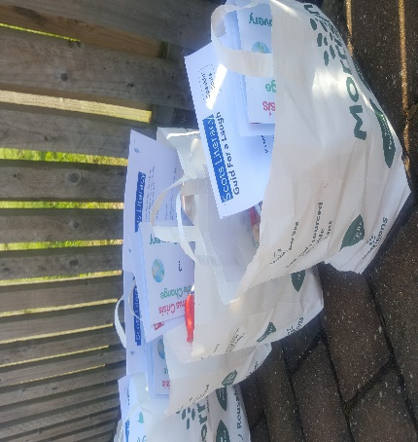
The packs can be adapted to suit participants needs. For example, we had feedback from a volunteer who used some of the activities when phoning isolated adults. Another worker photocopied the pack to put into their goodie bags. Tell us how you are using the packs.

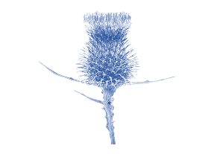
The Aims of the Session – Whit’s it a’aboot?

- it’s about learning Scots language and auld words
- takes a look at Scots comedy, songs, poetry and writing
- hae a guid laugh at ourselves and others

Scots Language
Scotland is a nation of over 5 million people has a range of regional accents and dialects, each with their own sayings and jargon, ranging from Doric to Lallans and Urban Scots. We want you to share your
Scots words, it makes the packs more interesting and gives examples of the wide range of words used in different areas of Scotland.

Some Feedback fae Packs 1 & 2
The first two packs have gone out and Kim Sibbald, Healthy Lifestyles Officer, Edinburgh & Lothian Greenspace Trust who used the pack with her walking group in Oxgangs, Edinburgh, sent us this photo.

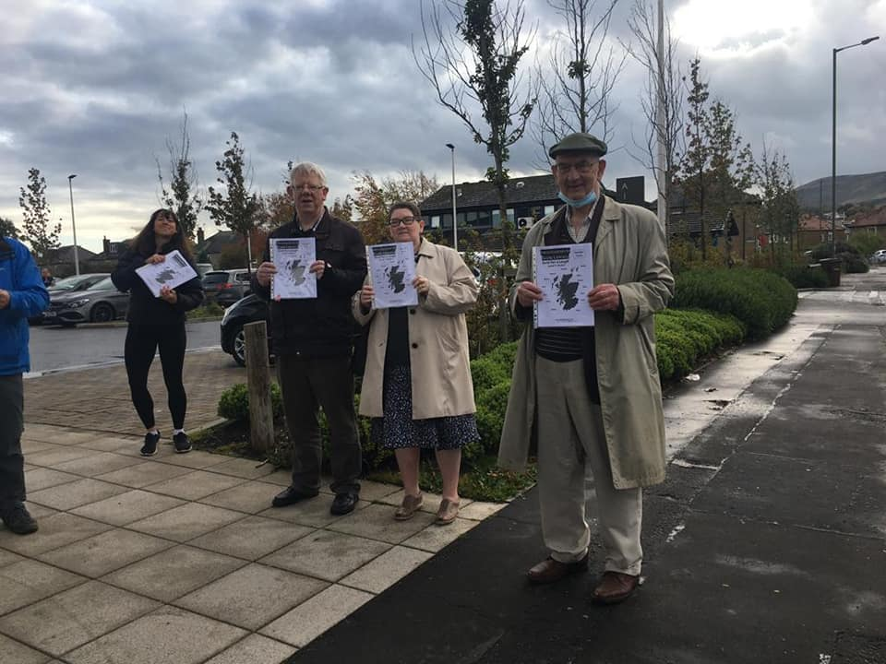

Mair feedback from previous packs

“We really enjoyed it”
“We liked looking and talking about the old words”
“It was really good”

Here’s the feedback in Scots

- “We hud a rer time wi it”
- “We hud a guid blether aboot a ra wurds”
- “It wisnae sae bad, no bad at a”

Favourite Wurds?

Whit are sum of yer favourite Scots wurds that yer grannie/mammy used to use? If you can, have a go at writing them here:

Here are some of ours:

bonnie, guid, braw, couthie, sonsie

How would you use these words? From this list, what’s your favourite.

Whit’s the Wurd?

Listed below on the left are some words in English, but do you know what the words are in Scots. Here’s an example to get you started ‘around is aroon’ in Scots. We’ve put some letters in the answers to help

English Scots

Donkey _ u _ d _ _
Crown _ _ _o _
Drop D _ _ _
Noise _ _ _
Armpit _ x _ _ r
Undershirt Shirt S _ _ m i _
Do Not _ i _ n _ _
Nose _ _ b
Over _ _ e _
Shirt S _ _ _

How did you get on? Answers on the next page.

English Scots

Donkey Cuddie
Crown Croon
Drop Drap
Noise Din
Armpit Oxter
Under Shirt Semmit
Do Not Dinnae
Nose Neb
Over Ower
Shirt Sark

Now have some fun using these Scots words

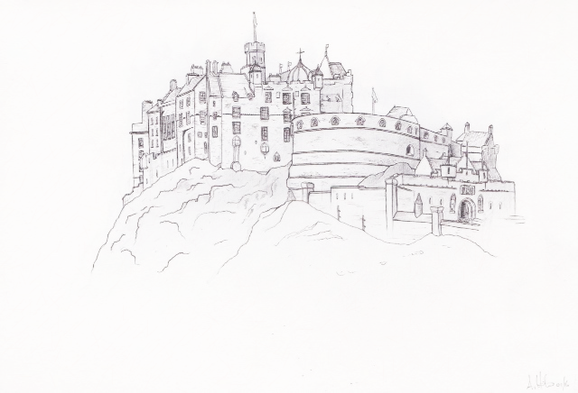

Put the Wurd In

Put the right Scots wurds into the sentences below, again select from the list below.

Jacksie Stramash Guid Sicht Bogle
Heid Sneck Haddie Ane Tummelt

- He was off his _ _ _ _.
- Stick your job up your _ _ _ _ _ _ _.
- There was a _ _ _ _ _ _ _ _ in the pub.
- Just _ _ _ _ _ the door behind you.
- He had a _ _ _ _ _ _ fur his tea.
- He has _ _ _ _ _ _ _ out of bed.
- She had a pram o’ her _ _ _.
- There is a _ _ _ _ _ out tonight.
- He was an awful _ _ _ _ _.
10.Have a _ _ _ _ day.

Answers

- He was off his heid.
- Stick your job up your jacksie.
- There was a stramash in the pub.
- Just sneck the door behind you.
- He had a haddie fur his tea.
- He has tummelt out of bed.
- She had a pram O’ her ain.
- There is a bogle out tonight.
- He was an awful sicht.
10.Have a guid day.

What word do you like and why? I like the word stramash because it’s a good descriptive word for a fight in the pub.

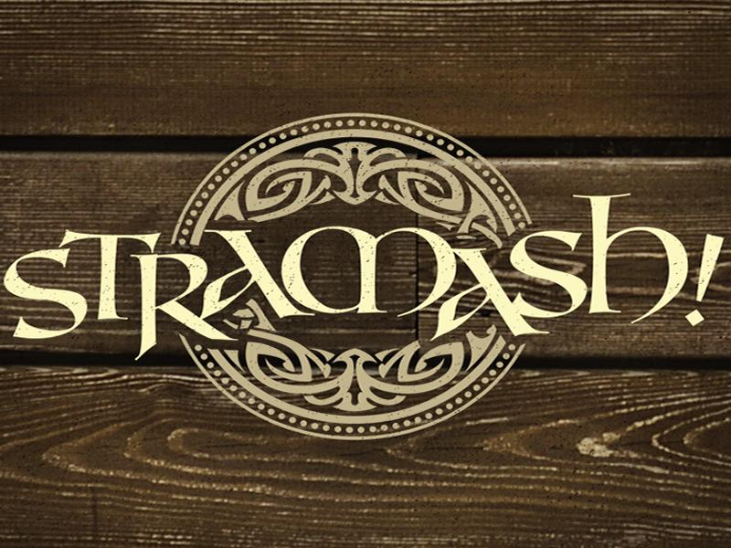

I also like ‘jacksie’, can you imagine saying to a horrible boss, ‘Stick your job up your jacksie”
Sum Scots Sayings

The Scots have many wise and couthie sayings. Complete the Scots sayings below, select from the list here

“Oot the windae” “Daft as a brush”
“Winnae go bye ye” “Bile yir heid”
“Richt fu o himsel” “ A man or a moose”
“Hud his chups” “ Fu o wind”
“Fu o mince” “Talk and nae action”

- His head is _ _ _ _ _ _ _ _ _ _
- His bum is _ _ _ _ _ _ _ _ _ _
- She is as _ _ _ _ _ _ _ _ _ _
- What is for _ _ _ _ _ _ _ _ _
- Away and _ _ _ _ _ _ _ _ _
- He is _ _ _ _ _ _ _ _ _ _ _ _
- Are you _ _ _ _ _ _ _ _ _ _
- He has _ _ _ _ _ _ _ _ _ _ _
- She is _ _ _ _ _ _ _ _ _ _ _
10.He is all _ _ _ _ _ _ _ _ _ _

How did you get on? Answers on the next page.

Answers

- His head is fu o mince.
- His bum is oot the windae.
- She is as daft as a brush.
- What is for winnae go bye ye.
- Away and bile yer heid.
- Hi is richt fu o himself.
- Are you a man or a moose.
- He has hud his chups.
She is fu o wind.
10.He is all talk and nae action.

Talk about what these sayings mean. Have some fun. Play about with them. What are some of your Scots sayings?

I like “His bum is oot the windae.” You’ve finished with your boyfriend and got a new one, you’d say of your ex, “His bum is oot the windae.”

Wurd O’ the Week

BAFFIES
The word comes from baffs first mentioned in 1923. The word baffies come from Fife and Angus and first appeared in the Sunday Post in 1956.

For us baffies comes from our Grannie Clara, pronounced Grannie Clerra. Grannie Clerra used to refer tae cauld dreich November days as ‘Baffie Days’ We all have a grannie Clerra or should have one. Grannie Clerra hud a smile like a shepard's warning sunrise in November, bricht wi licht. On cauld days she would licht the fire and get the griddle really hot. Next a smell of flour and dough would waft through from the scullery. On to the griddle, an in a flash you would be tucking into hot pancakes, butter and jeely. Grannie Clerra would say,
“Settle doon, ma loon and lass and hae a Baffie Day”.
Warm as toast, you always fell asleep sound and warm.

So, what’s your word o’ the week and do you have a cosy wee story to tell?
Corona Virus in Scots

It is very important to make sure that we all stay healthy and well. To make sure you remember what to do here is some standard advice. Select a Scots phrase from the list below that models the English phrase.

Bide at hame oan yer ane
Dae as yer telt
Be guid tae ane anither
Dinnae mak us ask, wear a mask
Gonnae no come sae close

- Please wear a mask _ _ _ _ _ _ _ _ _ _ _ _ _ _ _ _ _ _ _
- Please social distance _ _ _ _ _ _ _ _ _ _ _ __ _ __ __ _
- Self-isolate _ _ _ _ _ _ _ _ _ _ _ __ _ _ _ _ _ _ _ _ _ _ _
- Be kind to each other_ __ _ _ _ _ _ _ _ _ _ _ _ _ _ _ _ _
- Follow the advice _ _ _ _ _ _ _ _ _ _ _ __ _ _ _ _ _ __ _

Answers on the next page.

Answers

English Scots

- Please wear a mask Dinnae mak us ask, wear a mask
- Please social distance Gonnae no come sae close
- Self-isolate Bide at hame, oan yer ane
- Be kind to each other Be guid tae ane anither
- Follow the advice Dae as yer telt

STAY SAFE, HEALTHY AND WELL

“Dinnae be daft,
mind an wear yir mask”

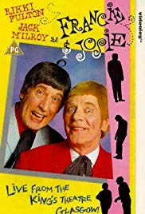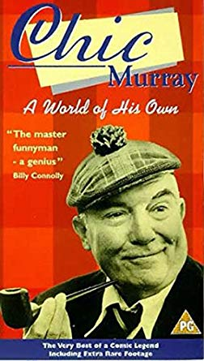

Joke fae the Poke

It time for a wee chuckle. We usually ask people to pick a joke from the bag and share it with the group. As you are in your house, we have added a few for you to read. It might help if you read out

I telt ma girlfriend tae slip intae something cool.
Ten minutes later found her in ra fridge.

If I gie up drink, tobacco, and sex doctor will I live longer?
“Naw, it’ll on seem longer”.

Twa fall aboot drunks were stopped and questioned by the polis.
“A richt, that’s enough” said the officer. He said to the first drunk
“Yer name and address please”.
“Hamish Finlay, no fixed abode”
The second drunk replied “Ian Black fae the flat above”.

Two Americans in a Dundee café, one asks for two horse steaks.
The waitress says, “We don’t eat horse over here”. The American
says, “So how come that guy over there ordered mare soup?”
Sent by Evelyn Watson, Edinburgh

Poem/Song O’ the Pack

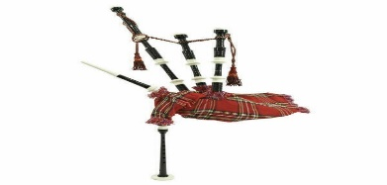
The Boy on the Train is a poem suggested by Rita Crombie, Volunteer, Seagrove Dementia Care Centre, Edinburgh after she read our first pack. The poem/song is full of questionings – An excited boy is on his way to see his Grannie in Kirkcaldy. Kirkcaldy was known for the smell from the linoleum factories that dominated the toon, it wis mingin.

The Boy on the Train
By Mary Campbell Smith
Whit wey does the engine say ‘Toot-toot’?
Is it feart to gang in the tunnel?
Whit wey is the furnace no pit oot
When the rain gangs doon the funnel?
What’ll I hae for my tea the nicht?
A herrin’, or maybe a haddie?
Has Gran’ma gotten electric licht?
Is the next stop Kirkcaddy?
There’s a hoodie-craw on yon turnip-raw!
An’ seagulls! – sax or seeven.
I’ll no fa’ oot o’ the windae, Maw,
Its sneckit, as sure as I’m leevin’.
We’re into the tunnel! we’re a’ in the dark!
But dinna be frichtit, Daddy,
We’ll sune be comin’ to Beveridge Park,
And the next stop’s Kirkcaddy!
Is yon the mune I see in the sky?
It’s awfu’ wee an’ curly,
See! there’s a coo and a cauf ootbye,
An’ a lassie pu’in’ a hurly!
He’s chackit the tickets and gien them back,
Sae gie me my ain yin, Daddy.
Lift doon the bag frae the luggage rack,
For the next stop’s Kirkcaddy!
There’s a gey wheen boats at the harbour mou’,
And eh! dae ya see the cruisers?
The cinnamon drop I was sookin’ the noo
Has tummelt an’ stuck tae ma troosers. . .
I’ll sune be ringin’ ma Gran’ma’s bell,
She’ll cry, ‘Come ben, my laddie’,
For I ken mysel’ by the queer-like smell
That the next stop’s Kirkcaddy
Scots English

haddie haddock
Sneckit locked
leevin eleven
frichtit frightened
pu’in a hurly pulling a barrow
gey wheen a lot
mou mouth
tummelt fallen

Dae ye ken……Mary Campbell Smith wrote the poem. She was born in 1869 and died in 1960. Mrs Smith was the wife of the headmaster at Merchiston Castle School in Edinburgh. Every year at Easter they travelled to Elle in Fife for their holidays. One year around 1912 they shared a compartment with a noisy excited wee loon. Mrs Smith was asked to contribute to the school’s magazine in 1913. She remembered the boy and wrote the poem immortalising the wee lad. She also used some North- East Scotland words like “Whit wey” instead of why. – The poem/song is now famous

Find the Scots Wurds

U | H | V | D | R | A | R | M | O | O | E | G | B | V | T
E | U | A | N | K | L | O | P | S | P | X | N | N | L | T
R | E | T | X | O | U | Y | A | O | W | E | R | E | K | X
V | I | Z | R | F | O | K | R | F | Q | C | M | R | B | H
A | C | R | A | S | T | R | D | M | N | M | A | H | Q | A
C | R | O | H | E | Z | H | C | D | U | S | A | N | T | X
R | Y | T | H | O | J | C | S | T | I | D | C | K | T | H
V | H | P | Q | E | C | U | U | D | D | N | N | J | I | K
O | G | C | O | I | V | D | J | I | E | I | N | I | K | P
O | G | W | H | V | R | D | E | N | R | O | A | A | C | E
J | M | S | E | M | M | I | T | S | D | N | A | K | E | N
N | U | V | F | S | S | E | W | B | P | A | H | Z | N | N
O | C | I | J | J | W | Q | U | H | P | I | N | C | S | M
Z | V | S | H | S | K | V | R | U | O | L | Z | O | I | D
E | N | F | E | X | U | B | C | G | R | W | L | D | Q | L

CROON | CUDDIE | DIN
DINNAE | DRAP | HADDIE
MOU | NEB | OWER
OXTER | SARK | SEMMIT
SNECKIT | TUMMELT
Mind noo, the 30th of November is St Andra's Nicht. Mind an raise a gless tae oor patron saint. The 14 November 2020 is Diwali, the Festival of Lichts which is celebrated by Hindu’s.

Hae Yer Say P

We are planning on developing more Scots Literacy packs and to help us do that we would like you to phone or email your favourite jokes, Scots words, sayings and anything else you’d like to see include in future packs. My email and phone are below.

- Did you enjoy it? If yes, what did you like?

- If not, why not?

- Anything else you would like to see in the pack?

Course material developed by Derek Suttie, Scots Literacy Tutor
Send your Scots words, jokes, poems, sayings, suggestions to:

Lydia.markham@ea.edin.sch.uk Mobile: 07719 420 424
Lydia Markham, Lifelong Learning Worker (Adult Learning),
SW Locality, City of Edinburgh Council

