-
Speakin’
Scots
Introduction to Scots Literacy
Guid Fer a Laugh
Level 2- Pack 6

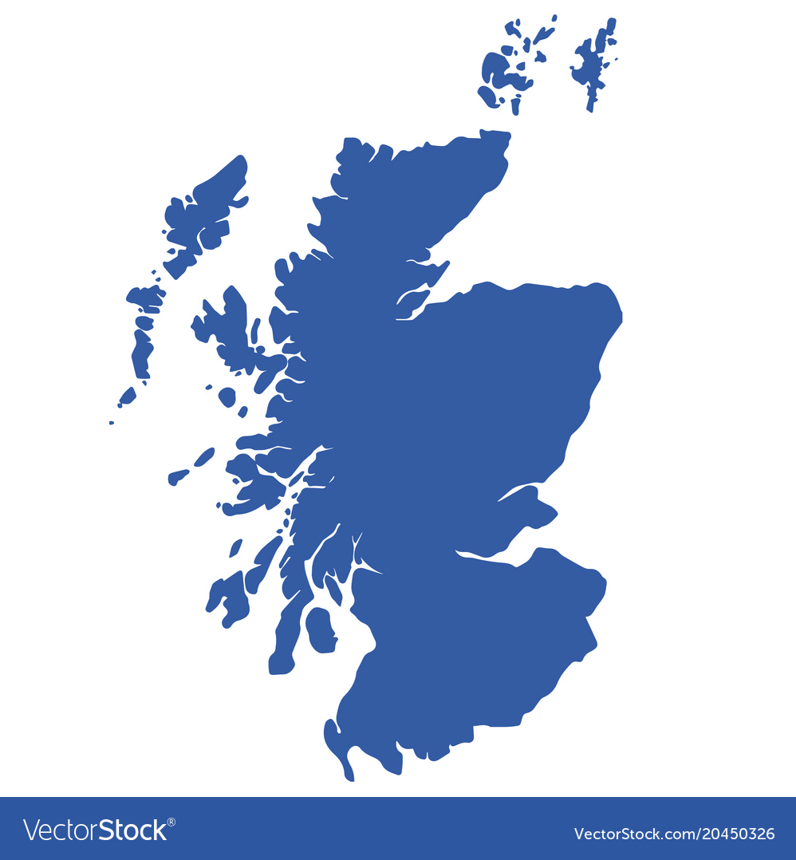
Smourich
Dancin

Houghmagandie

Coorie
Winchin
Gallus
Sheenin
Fairfaw
Dizzy
Loon
Flichterin
Dwam

Smoochin
Smitten
Bonnie
COONCIL
Introduction to Guid Fer A Laugh

We are part of the City of Edinburgh Council, South West Adult Learning team and usually deliver ‘Guid Fer a Laugh’ sessions for community groups in South West Edinburgh. Unfortunately, we are unable to meet groups due to Covid-19. Good news though, we have adapted some of the material and we hope you will join in at home.

Development of Packs
Following feedback from participants we plan to develop packs from beginner level 1 to 5 with 4 packs at each level. This will allow participants to gradually increase in confidence, recognising and understanding Scots. By level 5, participants should be able to: read, recognise, understand and write in Scots.

Distribution During Covid-19
During Covid-19 restrictions we are emailing packs to community forums, organisations, groups and individuals.

Using the packs
The packs can be done in pairs, small groups or individually. They are being used by: families, carers, support workers and individuals. The activities are suitable for all adults but particularly those who do not have access to computer and internet.

Adapting Packs
The packs can be adapted to suit participants needs. For example, Marjory from Portobello used the pack to start up a conversation with her dad about Robert Burns. She said, “My dad was the most animated I’ve seen and heard him in a long time. Thank you.”

Age Scotland’s ‘Burns in a Bag’ Initiative

Special thanks to Elizabeth Bryan, Age Scotland for funding printed copies of our Burns Special edition. This was included in their ‘Burns in a Bag’ initiative and sent to 3,000 people all over Scotland. We’ve had a fantastic response to the bags, it fair cheered everyone up during this difficult time. Thank you everyone who helped get the Burns Bags out to your group members at this challenging time. We’re looking forward to working with Elizabeth and her team at Age Scotland for the Spring edition in April.

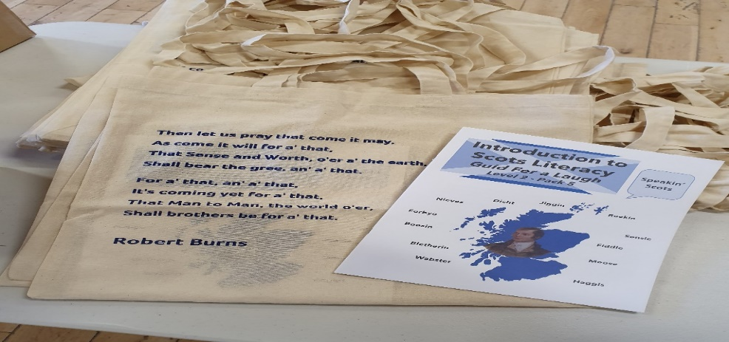
Thanks to Jenny Miller, Dove Centre, Edinburgh who sent us this photo they delivered 40 bags to their members. One member said to Jenny that she thoroughly enjoyed the latest pack and remembered some of the words but enjoyed learning the new ones and to thank us.

The Aims of the Session - Whit’s it a’aboot?

- it’s about learning Scots language and auld words
- takes a look at Scots comedy, songs, poetry and writing
- hae a guid laugh at ourselves and others

Scots Language
Scotland is a nation of over 5 million people has a range of regional accents and dialects, each with their own sayings and jargon, ranging from Doric to Lallans and Urban Scots.
Romantic Luve

It’s February and the theme for this edition is romantic love, we are going roamin’ in the gloamin’. We will be looking at the kind of love celebrated on Valentine’s Day. Valentine’s Day originated in Roman times and was a Festival of Spring that celebrated fertility rites, in the month of February. We’ve a wee bit mair aboot Valentine’s Day later on in the pack.

We should never forget just how amazing it is when two people meet and then go on a journey of discovery that is being in love. At this particular time, love is a very special feeling that should be treasured. As always we at ‘Guid Fer a Laugh’ take a comic look at the subject and have a wee smile to ourselves.

Whit are yir favourite wurds?

What are your favourite Scots words that come tae mind when you think of love. Here are some of our wurds:

Bonnie Braw Merrit Luve Hert Smourich

Which Scots wurd do you like most from the above? Why do you like them? What about your own favourite. Try and make up some sentences with these words.

Whit’s the Wurd?

Listed below on the left are some words in English, but do you know what the words are in Scots. Here’s an example to get you started ‘potato is tattie’ in Scots. We’ve put some letters in the answers to help

English Scots

Courting _ _ nc _ i _
Shining S _ e _ n_ _
Married _ _ r _ i _
Blessed F _ _ r f _ _
Bold G _ l _ u _
Beautiful _ o _ n _ _
Love _ _ v _
Kiss S _ a _ k _ _
Cuddle C _ _ r _ _
Sex H _ _ g h _ a _ a n _ _ _

How did you get on? Answers on the next page.

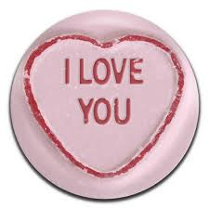

Scots English

Courting Winchin
Shining Sheenin
Married Merrit
Blessed Fairfaw
Bold Gallus
Beautiful Bonnie
Love Luve
Kiss Smacker
Cuddle Coorie
Sex Houghmagandie

Which words do you like best? Try making up sentences. We like ‘winchin’. Here’s a sentence with winchin.

“The winchin couple were a bonnie sicht.” Now, have some fun using these Scots words

We also like ‘houghmagandie’ as we’d heard many expressions in English and Scots for sex but never this one.

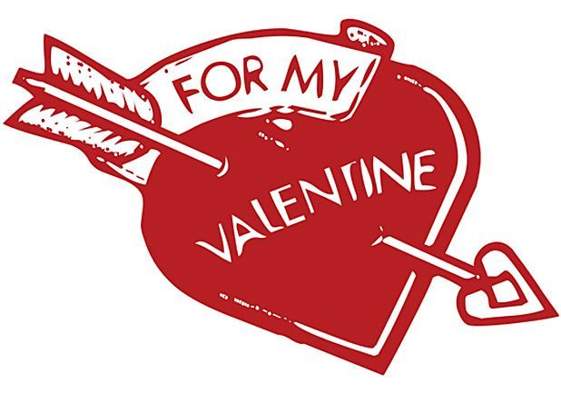
Put the Wurd In

Put the Scots wurds into the sentences below.

Smitten Dizzy Dancin Smoochin Riddy
Dazzler Fankle Het Flichterin Smourich

- He asked are ye _ _ _ _ _ _.
- The couple in the back row were _ _ _ _ _ _ _ _.
- When she spoke to he, he got a _ _ _ _ _.
- He said he was fair _ _ _ _ _ _ _ with her.
- She was a right bobbie _ _ _ _ _ _ _.
- Her heart started _ _ _ _ _ _ _ _ _ _ when she saw him.
- He got _ _ _ under the collar at the sicht of her.
- She gave him a right good _ _ _ _ _ _ _ at the end of the nicht.
- She did not show up, she had given him a _ _ _ _ _.
10.He got in a _ _ _ _ _ _ when she asked him out.

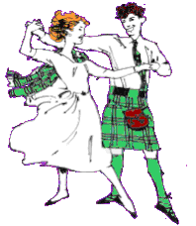

Answers

- He asked are ye dancin.
- The couple in the back row were smoochin.
- When she spoke to him, he got a riddy.
- He said he was fair smitten with her.
- She was a richt bobbie dazzler.
- Her heart started flichterin when she saw him.
- He got het under the collar at the sicht of her.
- She gave him a right good smourich at the end of the nicth.
- She did not show up, she had given him a dizzy.
10.He got in a fankle when she asked him out.

Which words do you like best? We like riddy. Who has not been embarrassed by the one you love. We also like smoochin and smourich. They jist say it all.

Sum Scots Sayings

The Scots there are many sayings that are peculiar to Scottish culture. Put the right saying into the sentences below.

“A richt wee stoater” “Fu o’himsel”
“Goin her dinger” “Gie it laldie”
“A richt rerr perr” “ma wee chookie hen” “like twa wallie dugs” “Hert as big as a hoose”
“Heid ower heels” “were fair smitten”
“Wernae pushed nor shoved” “Hud oan noo”

- They were _ _ _ _ _ _ _ _ _ _ in luve.
- They were smoochin and she said _ _ _ _ _ _ _ _ _
- He turned to his pal and said “She’s _ _ _ _ _ _ _ _
- The two of them were _ _ _ _ _ _ _ _wi each other.
- They are together now and they _ _ _ _ _ _ _ _ _.
- She kent he was _ _ _ _ _ _ _ _ _ _ _.
- They were _ _ _ _ _ _ _ _ _ _ _ on the mantlepiece.
- She wis _ _ _ _ _ _ _ at her partner for being late.
- She hud a _ _ _ _ _ _ _ _ _ _.
10.The two of them were _ _ _ _ _ _ _ at the dancing.
11.Seein them thegither a’body said they were _ _ _ 12. He said, “Yes _ _ _ _ _ _ _ _ _ _ _ _.

How did you get on? Answers on the next page.

Answers

“A richt wee stoater” “Fu o’himsel”
“Goin her dinger” “Giein it laldie”
“A richt rerr perr” “ma wee chookie hen” “like twa wallie dugs” “Hert as big as a hoose”
“Heid ower heels” “were fair smitten”
“Wernae pushed nor shoved” “Hud oan noo”

- They were heid ower heels in luve.
- They were smoochin and she said, “Hud oan noo.”
- He turned to his pal and said “She’s a richt wee stoater”
- The two of them were smitten wi each other.
- They are together now and they wernae pushed nor shoved.
- She kent he was fu o’himsel.
- They were like twa wallie dugs on the mantlepiece.
- She wis goin her dinger at her partner for being late.
- She hud a hert as big as a hoose.
10.The two of them were giein it laldy at the dancing.
11.Seein them thegither a’body said they were a
richt rerr perr.
12.He said, “Yes ma wee chookie hen.”

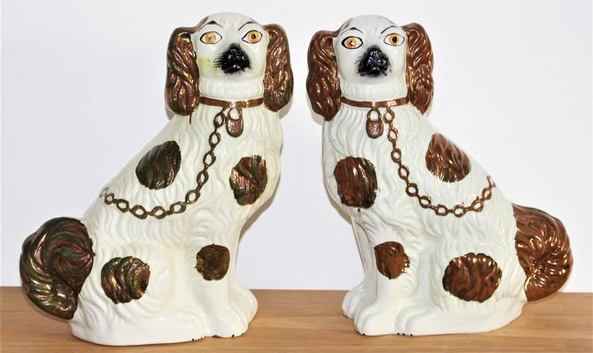
How did you get on? We hope you did well. What are your favourite phrases? Why do you like them? Try using them in sentences. Do you have any of your own phrases?

A few favourites of ours is “like twa wally dugs” Always seen together.

Wurd O’ the Pack

DWAM

The word dwam means to swoon or be in a dream or trance. It stems from the early 16th century and was used by the makar (poet) William Dunbar. It is a word associated with those who like to dream or for those that are in luve.

For us it brings back fond memories o’ the tales that Grannie Clerra and Grandie Chay telt us aboot their coortin days. We wid ca it winchin noo’adays. Ye will mind how Grannie Clerra first met Grandie Chay when he first fitted her hoose oan Hogmany. She liked his black curly hair. Efter that, Grandie Chay said that “We hud a’ ee fur each ither, “Clerra wis a richt bonnie quine.” Grannie Clerra wud reply “Aye ye wernae bad yersel, richt bashful mind.” Grandie Chay still goat a riddy when she said that.
Onyway, one Saturday Grannie Clarra, Bunty an a few o her pals were standin at the end of the road haen a blether before they heided intae toon. Pushin his bike along cam Grandie Chay. Bunty saw Clerra’s ees sparkle at the sicht o him.
Grandie Chay said “A’ that a cud see wiz her, ah wiz in a dwam. My hert wiz lowpin and a’ went richt ower tae her an asked her if she wid like a backie oan ma bike. Grannie Clerra said, “He wiz as reed as a beetroot but braw and a said aye!” Bunty an’ the rest hud a richt guid laugh at the perr o them, saying “A richt rerr perr they were.”

Oan the way intae toon Grandie Chay hardly said a wurd. A he said wiz, “Am richt glad ye said aye.” Clerra said “Och hoo cud a’ say no? Dae ye ken whit day it is?” Grandie Chay played dumb. “It’s Valentine’s Day ye muckle daftie.” Efter that they always hud a wee smooch, an a cuddle tae mind themselves o’ whit a special day it wiz. Aboot a year tae the day efter the hurl oan the bike, Grandie Chay and Clerra met up in the byre, Grandie Chay wiz a’ het up in a richt fankle. Clerra asked him, “Whits up wi ye? C’mon ah’ll gie ye a wee smourich.” Chay knelt doon an he blurted oot, “Will ye merrie me?” Sparklin and sheenin wi glee, Grannie Clerra laughed oot an’ said, “Weel whit ye’ve knelt doon oan, brings ye luck. You’ve never been luckier – Aye a wull”
A year tae the day they were merrit. “Aye whit a DWAM”

So what did ye make of that, what are your favourite bits and favourite wurds? Do you have any memories of Valentine’s Day, or even better still whit memories of first love do you have – Whit wiz the first date like? Write them doon if you can, talk aboot them.

My first date wiz a howler, Ah goat the time an’ place richt only it wiz the wrong day! We goat aff oan the wrang fit an it wiz doonhill a the way.

Corona Virus in Scots

Weel the jab is here. However, the virus is not going away. It is still oot there. It is important to mind and be vigilant, keep safe and weel.

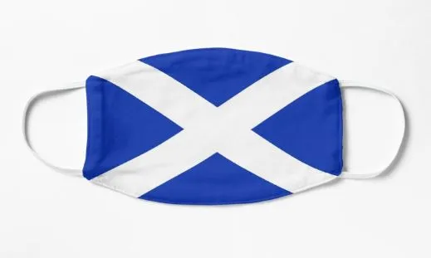
The jab is fab, tak the jab
Dinnae mak us ask, wear a mask
Stay at hame fur noo

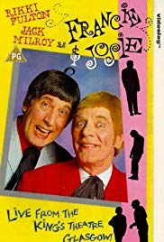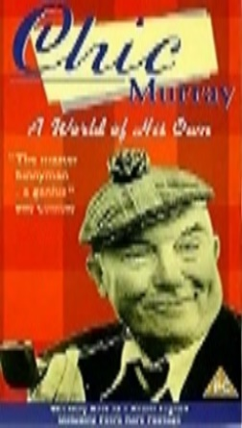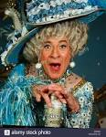

Rhymes fur yer Valentines

Here are some pithy sayings and funny wee Valentine’s rhymes. Thanks to Caroline Heenan, Eric Liddell Centre, Edinburgh for sending in some of the Valentine verses. They are all about love and relationships and tell us aboot oorsels.

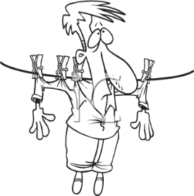
I luve ye, I luve ye, I luvy ye almighty
I wish yer pyjamas, wiz next tae ma nightie
Dinnae be mistaken, dinnae be misled
I meant oan the wash line, no in yer bed

If I wis a jigsaw, ye’d be the last wee bit
The one that’s maist important,
tae mak the picture fit
The pieces go thegither,
wi love an care, sae neat
But withoot you ma darlin,
I’m a puzzle no complete

We tried it oan the sofa, we tried it oan the chair
We tried it oan the window sill, we couldnae dae it there
I ken whit ye are thinking and it really maks me laugh
But a that we were trying ta dae wiz tak a photograph
Postie, postie dae yer duty
Tak this tae ma dark ee’d beauty

beauty
Postie, postie ring the bell If hur maw answers, run like hell!

Postie, Postie fir a laugh
Dae the Cha, Cha up the path
Postie, postie dinnae tarry
Tak this tae the one I’ll marry

If ye merrie a chicken, ye’ll get henpecked

Ah wiz smoochin ma girlfreen, when a o’a sudden ah goat a lump in ma throat. She’d been chewin oan a pickled onion

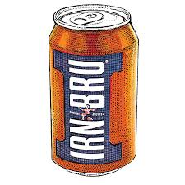
Valentine, I luve ye mair than…
A poke o’ chips,
a jeely piece or sherbet dips
I love ye mair than Irn Bru,
Soor Plooms and dumplin too,
An’ even mair, (tho’ I hud tae think)
Than porrage oats an’ Cullen Skink!

Which one did you like best? Read them out loud as fast as you can.

Why do you like them? Can you make some up yourself or ‘Do you ken any guid yins.’

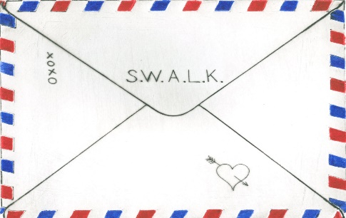
S.W.A.L.K –who remembers putting this at the back of an envelope and what the letters mean? Do you remember any other acronyms?

Poem/Song O’ the Pack

We have two poems for ye tae read an’ talk aboot. The first poem is by Sheena Blackhall and it’s aboot a Romantic Convention.

The Time Traivellers’ Convention
By Sheena Blackhall
Bring a pairtner tae the Ceilidh
Dress informal, the invite stated
At the time traivellers’ convention.
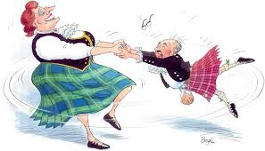
Mary Queen o Scots arrived hersel
Signed up fur speed-datin.
Said she wis a romantic,
Cud lose her heid ower the richt chiel.
The sheik in the tartan troosers
Turned oot tae be Rabbie Burns
Wi a bevy o beauties he’d gaithered
On his traivels.
John Knox tuik charge o the raffle
The kirk being eesed tae collectin
Naebody socht him fur a lady’s choice.
Lord Byron niver missed a single dance
In the Gay Gordons. He wis last tae leave.
The Loch Ness Monster, playin watter music
Last seen wis reelin roon bi Ailsa Crag
Wi thirteen kelpies and a Shetlan silkie.
Feedback suggests they’ll aa be back neist year.
This second poem is anonymous

Sonsie Senga fell in love,
she planned tae marry Joe
She wiz so happy bout’ it all,
she telt her faither so
Faither telt her “Senga doll,
you’ll hae to find anaither”
“I dinnae want yer maw to ken,
but Joe is half yer brither”
So Senga put aside her Joe
and planned to marry Wull
But when she telt her faither,
he said “Oh, there’s trouble still
Ye cannae marry Wull ma doll,
an’ please dinnae tell yer mither,
But Wull and Joe and serveral mair,
I ken is half yer brother”
But mither kent and said
“Ma doll, dae whit maks ye happy
Marry Joe or marry Wull……….
Cause FAITHER’S NO YIR PAPPY!!”

Hae a blether aboot the two poems. Which of the poems did you like best? Which lines, words or phrases did you like?

Do you know other poems, songs or ditties? Have you written any poems of your own? Send them in if you want.

On page 15 we asked if you knew what S.W.A.L.K means and it’s
‘Sealed with a loving kiss’ Did ye mind that one? Send us any others you remember.

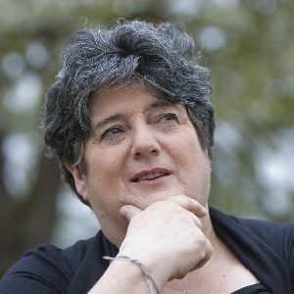
Dae Ye Ken…….Sheena Blackhall was born in January 1946 in Aberdeen. She attended and graduated from the Open University in 1995 aged 49. She was Creative Writing Fellow in Scots at Aberdeen university from 1998 – 2003. She has written four novels and has published over a hundred poetry pamphlets. In 2009 she was made Makar (Poet Laureate) for North East Scotland. She is a champion of the Doric dialect. ‘Doric’ is one of the of the major dialects of Scots that is used in Scotland today.

Dae Ye Ken……..Valentine’s Day according to Encyclopaedia Britannica it also called St. Valentine’s Day, is a day when lovers express their affection with greetings and gifts. The holiday has origins in the Roman festival of Lupercalia, held in mid-February. The festival, which celebrated the coming of spring, included fertility rites and the pairing of women with men by lottery. At the end of the 5th century, Pope Gelasius I replaced Lupercalia with St. Valentine’s Day. It came to be celebrated as a day of romance from about the 14th century. Valentine's Day is celebrated on Sunday, February 14, 2021.
FIND THE SCOTS WURDS
 |  |  |  |  | L | Z | S | V |  |  |  |  |  |  | O | O | X | W
 |  |  |  | R | O | A | R | F | T |  |  |  |  | Q | R | F | S | E | H
 |  |  | R | Q | O | Q | Q | M | H | S |  |  | E | E | J | M | R | H | G | B
 |  | R | E | L | Z | Z | A | D | A | S | M | J | F | V | O | H | G | R | Z | L | U
 | O | G | O | D | P | J | Y | F | W | A | L | A | L | O | O | E | I | Y | L | V | B | U
A | B | M | G | N | W | N | Z | U | Q | U | Y | C | C | U | I | W | L | O | V | O | I | Y | V
O | L | K | A | B | I | E | F | C | R | M | V | H | G | K | J | T | K | K | N | A | T | L | I
I | E | Q | L | X | O | C | I | U | E | N | I | H | W | U | E | R | Z | N | N | A | E | B | I
Y | O | H | L | W | D | B | N | R | J | N | M | U | A | Y | Z | R | I | V | M | A | H | B | I
B | D | K | U | G | X | I | R | A | O | A | J | N | F | V | T | E | I | R | K | Q | F | V | K
C | C | D | S | X | R | I | W | F | D | O | I | N | R | Z | Q | N | P | T | U | N | V | R | S
 | R | D | I | R | T | T | M | A | G | N | C | I | I | C | G | N | O | J | W | E | E | M
 | Q | U | S | R | B | S | N | F | E | X | F | R | A | S | A | B | B | U | D | V | O | X
 |  | Y | Z | Z | I | D | W | E | G | Y | V | T | F | M | P | F | R | H | A | U | B
 |  |  | W | R | I | T | H | G | B | H | R | H | R | I | X | N | A | D | R | L
 |  |  |  | E | J | S | V | Y | Z | H | F | C | K | T | D | X | W | I | N
 |  |  |  |  | Q | T | Q | R | E | N | O | I | I | T | H | G | C | I
 |  |  |  |  |  | M | C | R | X | V | M | L | B | E | L | H | H
 |  |  |  |  |  |  | T | J | Q | H | A | F | P | N | P | C
 |  |  |  |  |  |  |  | G | V | R | W | T | Y | F | N
 |  |  |  |  |  |  |  |  | D | L | D | O | P | I
 |  |  |  |  |  |  |  |  |  | Q | Y | P | W
 |  |  |  |  |  |  |  |  |  |  | F | I

BONNIE FairFaw  BRAW Fankle  COORIE Flichtrin  DANCIN gallus  DAZZLER Hert  DIZZY Het  DWAM houghmagandie  luve |  | MERRIT  RIDDY  SHEENIN  SMACKER  SMITTEN  SMOOCHIN  SMOURICH  WINCHIN

Feedback fae the Burns Special Edition

We’ve had a braw time sifting through all the rare feedback. There’s been lots of good stuff sent in to us. We welcome contributions and feedback and where possible we’ll use it. Here’s some examples:

Ah hae been tae a wheen o Burns Suppers an hae a lot o guid memories. A puckle suppers feenished the nicht wae abody singin “The Star” (O Rabbie Burns) in tribute. Efter the first verse we a’ stood up fur the chorus. Efter the saicint verse we a stood on the chairs fur the chorus, an efter the last verse we a stood on the tables, whaur we could. Some feedback from Alistair Mochar

Best one yet! What a lot of work must have gone into producing such a treasury of information and fun things to do to celebrate Robert Burns. This could be used for so many groups and different ages to enjoy and learn from. Not to mention stirring memories of good Scottish words and perhaps encouraging their use! - Rita Crombie, Edinburgh

Thank you very much for the Burns themed literacy pack - it is absolutely fantastic! I am a great Burns aficionado and have enjoyed it very much, as will many other people. Congratulations to all who contributed. - Aileen Cunningham, Community Help & Advice Initiative (CHAI)

Well, what can I say, your pack is excellent. It contains easily digested historical facts and examples of Burns’ work throughout. It provides opportunities to reflect on school poetry and participate in discussion. I particularly enjoyed Murdo’s toast and The Drookit Moose. This pack is a valuable resource...I’m sure that schools would benefit from it too! Very well done everyone! – Greta Yorke, Children’s Author, Ayrshire

I loved this gave me a guid laugh, as a Burns speaker I feel strongly that our native tongue should never be lost please keep up this guid work. Bob Macdonald, Glasgow

The packs gave hours of entertainment, especially the word search and the poems they all loved them and have been asking if there will be any others to follow. Alison Wilson, Fife Forum

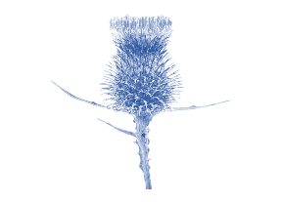
Hae Yer Say P

We are planning on developing more Scots Literacy packs. The next themes for our pack in March will be about Scottish Women as we celebrate International Women’s Day on 8 March 2021. As we move into April and spring is upon us, we will look at nature. If you want to contribute send in your stuff good and early --------as in NOW!!! My email and phone are below.

- Did you enjoy it? If yes, what did you like?

- If not, why not?

- Anything else you would like to see in the pack?

Course material developed by Derek Suttie, Scots Literacy Tutor
Send your Scots words, jokes, poems, sayings, suggestions to:

Lydia.markham@ea.edin.sch.uk Mobile: 07719 420 424
Lydia Markham, Lifelong Learning Worker (Adult Learning),
SW Locality, City of Edinburgh Council

