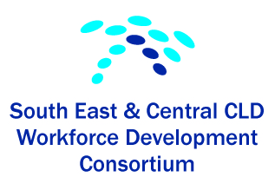
Event Title: South East and Central Consortium Networking Event
Date: 9.30am – 1.30pm on Friday 17th March 2017
Venue: Business Centre, City of Edinburgh Chambers
Event Outcomes:
- To highlight the work of the SE & C consortium, encourage use of i- develop, promote membership of the CLD Standards Council and Learner Voice
- To increase practitioner knowledge and understanding through adult learning themed workshops
- To provide networking opportunities for practitioners during the morning and over lunch

Workshops: Mindfulness Workshop Mary - Jane Armstrong - A1 and A2
Mindfulness meditation is a life skill which deepens our sense of wellbeing and fulfilment. It involves paying attention to what is occurring in our present moment, without judgement. This short introduction to the subject will highlight key aspects of mindfulness and offer tools and techniques that you can use with individuals or groups.

Learn with Fred Janet Weir and Anne Campbell– B1 and B2
Find out more about Learn with Fred a family learning programme. At the heart of this programme is the recognition that parents and carers are their child's first educator and play a significant role in giving their child the best start in life. The ‘Learn with Fred’ project emphasises the importance of a child’s home-life and parents’ role as early educators in developing literacy skills.

Creative opportunities; engaging with adults through the arts Kirsty Scott – C1 and C2
How you can use creative opportunities to engage with adults and communities. Using examples from practice and discussions we will share ideas and theories on how practitioners can incorporate the arts in community learning and development work. This approach can be especially useful in dealing with difficult issues and promoting solidarity.

Attendance: The event was attended by 23 participants from the South East and Central local authority areas.
18 completed forms about CLD Standards Council registration, 8 were already members with 10 intending to join the CLD Standards Council as a result of attending the event.

Funding: Our thanks to the CLD Standards Council for the CLD Secure, Strengthen and Grow grant which allowed the Consortium to fund this event
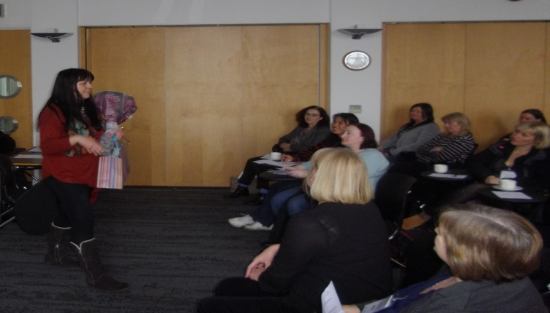
We said farewell to one of the original members of the SE & C Consortium, Elenor McDonald.
Elenor was retiring from Falkirk Council. The Consortium wanted to say a HUGE thank you to Elenor for all her hard work and input at the Consortium over the years and to wish her well for the future.

EVALUATION/ FEEDBACK ABOUT THE EVENT
How was it today?
- Learning how much I still have to learn
- Good to hear the challenges that others are experiencing and how they are addressing them
- Workshops x 3
- Workshops really useful
- Useful and fun!
- Useful and informative
- Nice to look at practical opportunities
- Great help with developing ideas for current projects
- Good fun lots of new ideas to use
- Enjoyed the workshop
- Great to learn about the role of CLD Standards Council and how to get more involved. Very inspirational
- Great to feel part of a larger community of practice as so often we work remotely
- Good great ideas
- Good to meet new people with new ideas
- Nice to meet new people
- It’s nice to know others face similar issues
- Lots of ideas to take back
- Kirsty was really professional and very inspiring
Suggestions for future sessions?
- What are you most interested in?
- Something about effectively involving young people in decision making
- More practical workshops
- An event to consider ways to capture the work we do, to be use as evidence for sourcing funding
- More practical hands on workshops
- Happen more often
- More regular sessions
- More regular meetings
- Workshops to help her to translate animated evidence into useful user studies?

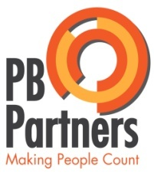
South East & Central Consortium Networking Event
Friday 17th March 2017

Programme

Timing | Topics
9.30am | Coffee and Registration
9.45am | Welcome and input on the work of SE & C Consortium and CLD Standards Council Elenor Macdonald
10am | Learner Voice Oonagh McGarry
 | WORKSHOPS
10.15am | Mindfulness Mary- Jane Armstrong  Learn with Fred Janet Weir/ Anne Campbell  Creative Opportunities Kirsty Scott
11.30am | Mindfulness Mary- Jane Armstrong  Learn with Fred Janet Weir/ Anne Campbell  Creative Opportunities Kirsty Scott
12.40pm  12.45pm | Evaluation  LUNCH
1.30PM | CLOSE

