Professional Peer Mentoring in CLD Settings

A shared investment in building leadership and resilience
An approved model for use in Community Learning and Development (CLD) settings

At this point in time the world of CLD is more challenging than ever and our work more needed than ever before. Whilst at an acknowledged point in time, this model of professional support and challenge is being offered as an opportunity to build the resilience and capacity of CLD colleagues for the future.
The model is based on experiential learning and a relationship that developed over time between two peers from distanced authorities which in turn became a pilot, has worked and been sustained. This is partly due to shared commitment to CLD and improving the quality of it but also a shared creativity that the relationship brings out in these two colleagues.
The peer support role is based on the understanding that as CLD leaders (leadership is not about place in an organisation - it is about your role) we have a shared responsibility for leading and driving CLD. In challenging climates, we need to fly the flag and dig deeper than ever to sustain ourselves in the sector. Our personal and professional resilience intertwine as we ride out storms stabilise our lives and seek to flourish.

You choose to be involved and you choose the peer. They can be from your own or another authority and or section of CLD. The relationship needs to be with someone whom you can have challenge with. This needs to be more than a friend and/or acquaintance and/or colleague. Mutual respect has to be a given. This is a professional development role and not a buddy. A buddy role exists through a CLD Standards Council initiative, details of which can be found on their website.
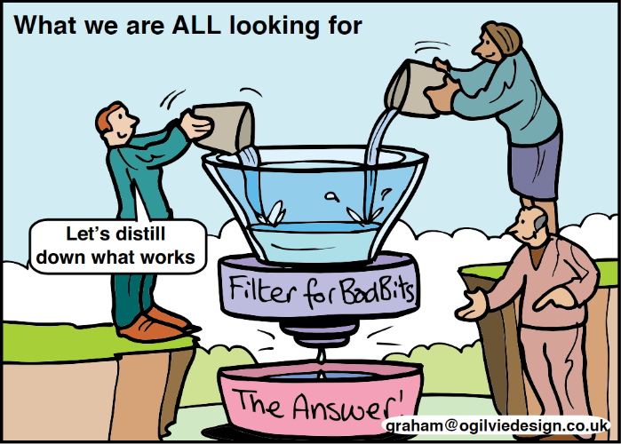
Key to the success of the professional peer support model captured here is providing:
- professional support and challenge with a peer.
- creating and encouraging enthusiasm
- discovering creativity and drive in each other during these sessions to underpin the relationship.

This work will form part of you and your mentors’ personal and professional learning and development as recognised by the CLD Standards Council for Scotland. It will be underpinned by the CLD competencies and based on sound professional boundaries, embracing the principles of practice as set by the CLD Standards Council.

CLD Standards Council Code of Ethics link:
9 Professional Learning - In order to improve our capacity to meet our obligations to constituents, we will work reflectively, identifying, using and sharing information, resources, skills, knowledge and practices with colleagues and others.
12 Selfcare - We will work to ensure CLD practice is consistent with the safety, health and wellbeing of CLD practitioners.
https://cldstandardscouncil.org.uk/wp-content/uploads/Code_of_Ethics_2017.pdf

The relationship is based on the premise that each individual has an understanding of themselves, how they work and their trigger points. They must understand how they learn, be willing to develop and where appropriate be challenged on this.
The frequency of sessions should be mutually agreed, not onerous, but could be more frequent where needed.
This is protected development time and therefore also has a focus on self and personal development and improvement. Support needs to take account of how your world is at the moment - with recognition that we are all human and affected by situations around us both professionally and personally.

Inevitably – working in CLD there are a range of differing operating contexts. Principles should however remain the same with the code of ethics at the heart of delivery. This tool is designed to complement your current arrangements and bring added value to your Continuing Professional Development.
Below is a series of questions designed to support and challenge which you may find a useful starting point with an appendix which may also be useful.

Potential themes/areas to consider:
The focus for discussion between Peer Mentors should be based on mutually agreed topics. The list below is designed to prompt thinking and is not a checklist. You can add your own if helpful.

 |  | Date
1 | Arrangements for the reflection and practice of self-evaluation  ……for you
2 | Arrangements for developing leadership skills and opportunities ……for you
3 | Arrangement for sharing skills knowledge and experience  ……for you
4 | Adopting a creative and constructive approaches to problem solving
5 | Displaying confidence in my own judgement
6 | Identifying my personal strengths and weaknesses and my impact on others
7 | Adapting quickly and effectively to new demands for change
8 | Influencing others positively and effectively
 | Evidence - and how do you know – ask yourself - what evidence do you have of this?

This approach underpins the quality focus on professional learning in the standards framework for CLD
(draft - How good is our community learning and development? 4 Nov.2020)
Quality indicator 5.2 A & B. Building and sustaining a strong workforce
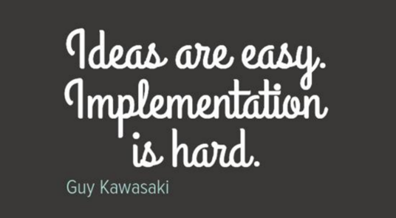
Useful links
https://cldstandardscouncil.org.uk/
https://education.gov.scot/
https://cldmanagersscotland.wordpress.com/

Created by Dominique Carlisle-Kitz and Sue Briggs – November 2020
Appendix 1

Professional Peer support in CLD settings

Self-evaluation table

You may wish to record names and dates for record keeping – this is of course optional
Name: Date completed:

Tick the box that describes your level of confidence. Use to reflect and direct discussion.

LEADERSHIP

I am able to - | Less confident | Quite confident | Confident | Very confident
Create and communicate a clear vision
Manage change effectively
Build and support a high performing team
Use team strengths effectively
Inspire trust and support
Empower others appropriately
Motivate others and inspire commitment
Handle sensitive situations well
How do I know?

STRATEGIC THINKING

I am able to… | Less confident | Quite confident | Confident | Very confident
Demonstrate a strong grasp of policy and strategy formulation
Assess policy options effectively
Develop and share strategic aims
Anticipate future demands, opportunities and constraints
Reconcile day to day demands with long term objectives
Translate strategic aims into practical and achievable plans
Demonstrate sensitivity to cross-service and political issues
How do I know?

MANAGEMENT OF FINANCIAL AND OTHER RESOURCES

I am able to - | Less confident | Quite confident | Confident | Very confident
Encourage new and more efficient use of resources
Work effectively with a proper regard for best value
Focus on continually finding ways to improve the quality of our delivery
Demonstrate commitment to using IT as a resource
How do I know?

DELIVERY OF RESULTS

I am able to - | Less confident | Quite confident | Confident | Very confident
Prioritise and schedule work effectively for the team
Manage competing pressures effectively
Define results taking account of needs of customers / partners / other stakeholders
Manage relationships with customers / partners / other stakeholders effectively
Organise work processes to deliver on time, on budget and to agreed quality standards
Monitor performance and incorporate feedback into future plans
Seek and apply best practice from other organisations or services
How do I know?

COMMUNICATION

I am able to - | Less confident | Quite confident | Confident | Very confident
Negotiate effectively
Handle conflict calmly
Listen to what is said and show sensitivity to others` reactions
Participate effectively in meetings
Encourage participation in meetings
Build, maintain and use an effective network of contacts
Communicate clearly what is expected of others
Respond positively to feedback, both positive and negative
How do I know?

MANAGEMENT OF PEOPLE

I am able to - | Less confident | Quite confident | Confident | Very confident
Encourage staff/volunteers from diverse backgrounds to develop their potential
Establish and communicate clear standards and expectations
Delegate effectively, knowing when to step in and when not to
Give effective face to face feedback and recognition
How do I know?

CREATIVITY AND JUDGEMENT

I am able to - | Less confident | Quite confident | Confident | Very confident
Adopt a creative and constructive approach to problem solving
Offer insights and original ideas with practical application
Display confidence in my own judgement
Respond constructively to alternative ideas
Encourage creativity and innovation in others
How do I know?

PERSONAL EFFECTIVENESS

I am able to - | Less confident | Quite confident | Confident | Very confident
Identify my personal strengths and weaknesses and my impact on others
Demonstrate commitment to my own personal and professional development
Develop good working relationships with outside bodies and partners
Develop good working relationships with internal partners and colleagues
Adapt quickly and effectively to new demands for change
Manage my own time well to meet competing priorities
Influence others positively and effectively
How do I know?

