Introduction to Scots Literacy
Guid Fer a Laugh Level 2 - Pack 9

Speakin’
Scots

COONCIL

Boolies
Weans
Cawin
Lessuns
Pawkies

Sook

Word
Word

Heidie

Schule
Fitba

Clype

Peevers

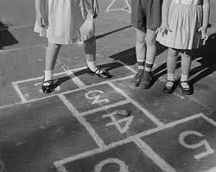

Introduction to Guid Fer A Laugh
We are part of the City of Edinburgh Council, South West Adult Learning team and usually deliver ‘Guid Fer a Laugh’ sessions for community groups in South West Edinburgh. Unfortunately, we are unable to meet groups due to Covid-19. Good news though, we have adapted some of the material and we hope you will join in at home.

Development of Packs
We plan to develop packs from beginner level 1 to 5. Participants will gradually increase in confidence and by level 5, should be able to: read, recognise, understand and write in Scots.

Distribution During Covid-19
During Covid-19 restrictions we are emailing packs to community forums, organisations, groups and individuals.

Using the packs
The packs can be done in pairs, small groups or individually. They are being used by: families, carers, support workers and individuals. The activities are suitable for all adults but particularly those who do not have access to computer and internet.

Adapting Packs
The packs can be adapted to suit participants needs. For example, Jess Fergus prints a copy and sends it to her cousin and her cousin’s husband who are both in their 80’s, one is from East Lothian the other Fife. She said, “We love doing the activities and quizzes and finding out Fife and East Lothian differences.” Thank you Jess we appreciate your email.

The Aims of the Session – Whit’s it a’aboot?

- it’s about learning Scots language and auld words
- takes a look at Scots comedy, songs, poetry and writing
- hae a guid laugh at ourselves and others

When We Wur Sma

Welcome to level three and pack nine. This is oor early years special. It’s aboot the time we were weans and bairns. The time when we were sma and the world wiz stappit fu o wonder. The colours, the sichts, the licht and the soonds were a brand new, fu o surprise.
The great poet and ‘bairn rhymes’ writer William Soutar said of this experience that,

“I thocht the hale o the world was there sae sma in a sma room.”

In oor hames and classrooms we sang oor rhymes and songs that are the distant landscapes o oor imaginations, whaur we keep oor benmaist thochts. Do you mind o coorin doon and singing,

Ally, bally ally bally bee
Sitting on yer mammys knee
Greetin fur anither bawbee
Tae buy mair Coulders Candy.

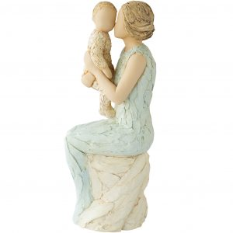

Nooadays all new born bairns in Scotland are welcomed wi a baby box, just tae gae them a guid start tae life. In the box is a welcome poem to the new born by oor Makar Jackie Kay. If yer like us ower auld tae hae goaten ain, we welcome you anew tae the world o Early Years.

Welcome Wee One by Jackie Kay

O ma darlin wee one
At last you are here in the wurld?
And wi aa your wisdom
Your een as bricht as stars
You’ve filled this hoose wi licht
Your trusty wee haun, your globe o’a heid
My cherished yin, my hert’s ain
Oh my darlin wee one
The hale wurld welcomes ye
The mune glowes, the hearth wairms
Let your life hae luck, health and charm
Ye are my bonny blessed bairn
My small miraculous gift
I never kent luve like this.

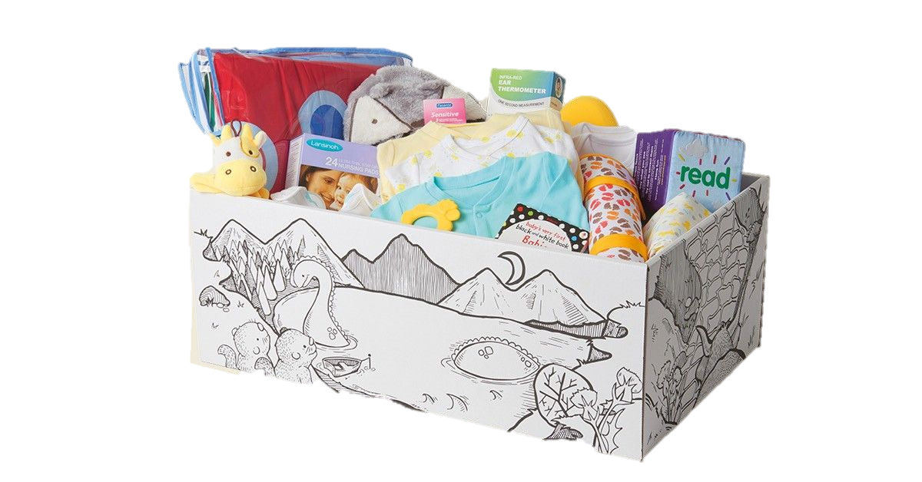

What a wonderful welcome for every new born baby in Scotland. Things have certainly changed as we see from information Russell Clegg from Auld Reekie Retold sent us about early years in Edinburgh.

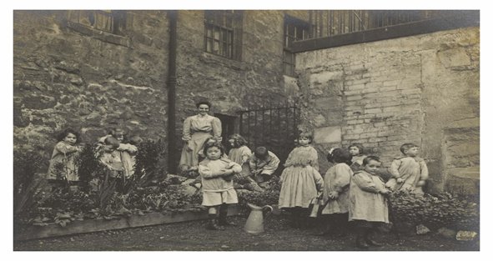

Image Reproduced with kind permission of The City of Edinburgh Council Museums & Galleries. Thanks to Russell Clegg from Auld Reekie Retold for sharing this image with us.

Lileen Hardy (1872-1947) opened the St. Saviour’s Child Garden in 1906 in the Canongate, part of Edinburgh’s Old Town. The nurseries were set up for children in the urban slums to foster opportunities for them to enjoy green space, time to learn and access to nature, not seen as beneficial at the time. Many of the younger children in the Old Town were left to entertain themselves while their parents worked or were incapacitated. Hardy needed help and funds for her Kindergarten and sought to raise awareness by producing a booklet entitled The Life History of a Slum Child outlining the dangers on the streets and homes presented to these children. Hardy was English but quotes children in her ‘Diary of a free kindergarten’ 1912 as she hears them in Scots.

https://www.edinburghmuseums.org.uk/auld-reekie-retold

Whit’s yir Favourite Wurd

Whit’s your favourite Scots word that comes to mind when you think back to when ye were a bairn? Some of ours are:

Heidie Pawkies Schule Bonnie Lessuns

What are your favourites from the above? Why dae ye like them? Use your own wurds or use the one above and make some sentences. Have some fun playing with them or make up wee rhymes.

Vera Harvey emailed us the word ‘hummel doddies’ do you know what this means? Hummel doddies is another Scots name for mittens. Have ye heard o this wurd fur mittens?

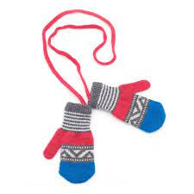

When visiting my granny oan a Sunday she’d say. ‘Yir hans are freezing, whur’s yir pawkies?’ I always lost them, so she’d tut, get her needles oot and knit me a pair before I left. She wis a fast knitter. Did yer ma and granny knit? Can ye knit?

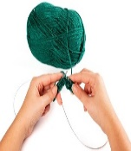

Yir Ain Scots Dictionary
Mak it up

This is a new bit o the pack…..so get an auld jotter or a wee note book wi blank pages and pit your favourite Scots wurds in yer ain book. Do it in alphabetical order like:

Bairn goes under B
Clype goes under C

And so on. Write in the Scots wurds with the meaning in English like
Bairn – Child
Clype – Tell on

We want you to build yer dictionary up pack by pack. Once you have done it, share it wi everybody ye ken. If yer in a group, work together making a group dictionary. Hae fun and enjoy it.

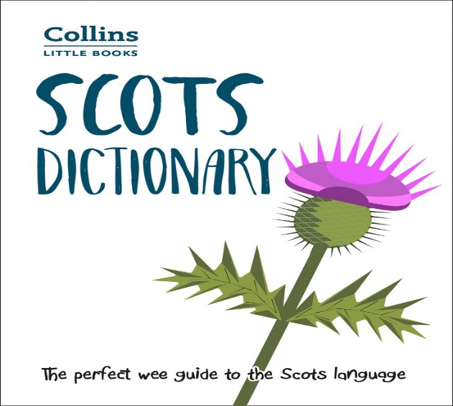

Whit’s the Wurd

Below are some English wurds. What are the Scots wurds fur them? We’ve pit some letters intae help.

English Scots

Very Skinny _ _ _ n n _ _ _ _ _ n k _

Songs _ a _ _ _

Wipe _ i _ _ t

Toilet _ a _ _ i _

Sandwich P _ _ _ _

Stupid N _ _ _ p _

Mittens P _ _ _ i _ _

Pretty _ o _ _ i _

Headmaster H _ _ d _ _

Small _ m _

How did you get on? Answers are on the next page.

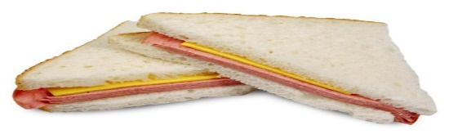

Answers

English Scots

Very Skinny Skinnymalinky

Songs Sangs

Wipe Dicht

Toilet Lavvie

Sandwich Piece

Stupid Numpty

Mittens Pawkies

Pretty Bonnie

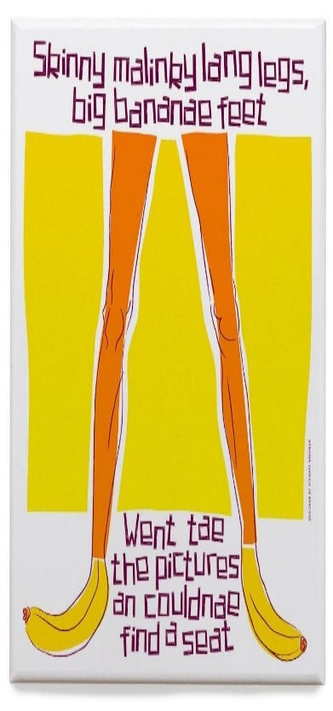
Headmaster Heidie

Small Sma

Use some of the wurds in sentences, play aroon with the wurds. Our favourite wurd is ‘skinnymalinky’. Do you have any favourites?

Name the Game
Below are images of children playing games, can you name them? Answers on the next page.
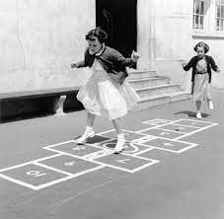
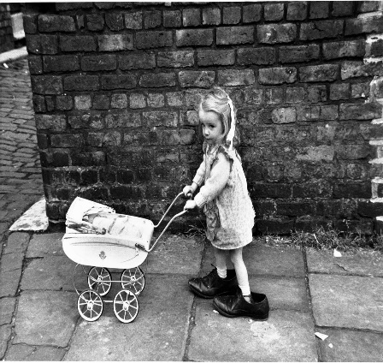
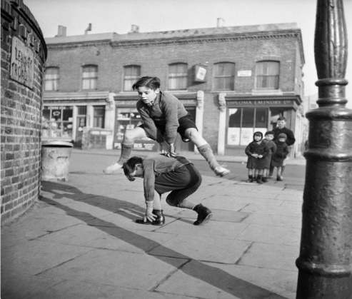
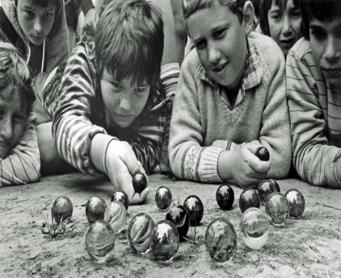
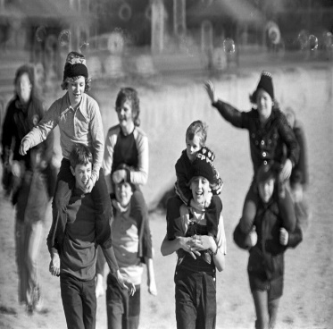
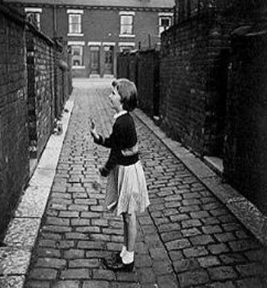
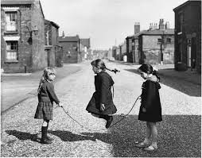
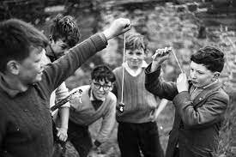
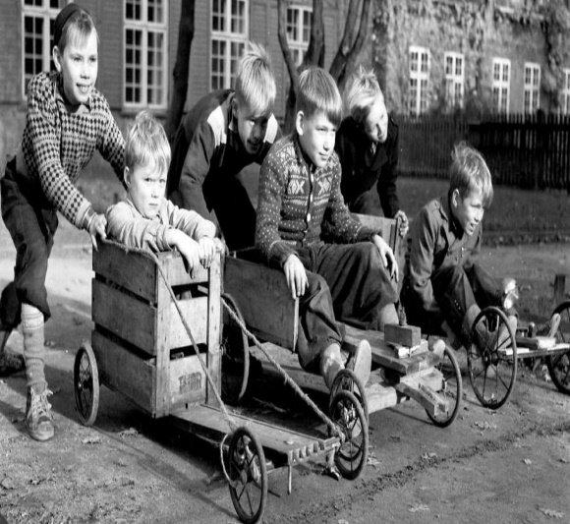
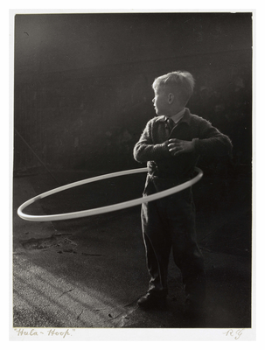
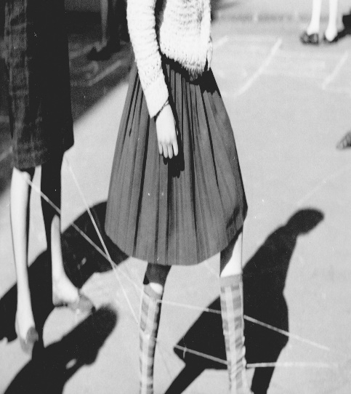
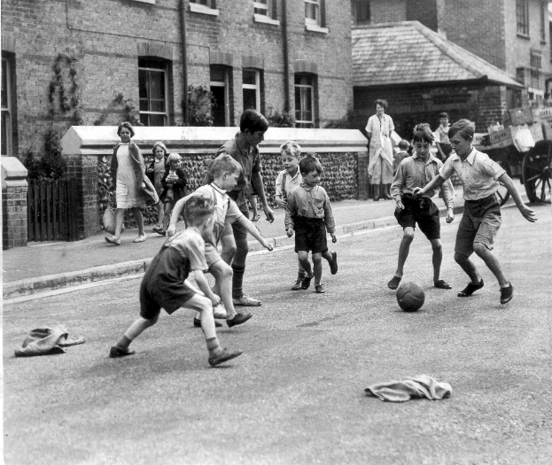
Answers
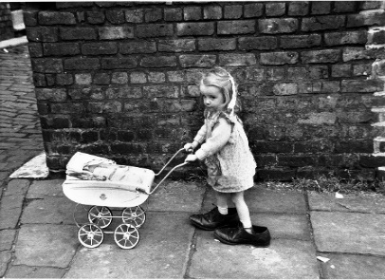
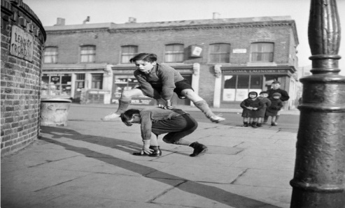
Mammies
Peevers
Hoosies
Leap Frog
Peevers

Boolies Skipping Colliebuckies
Twa Ba’s
Elastics
Fitba

Conkers
Kertin
Hulu Hoop
How did you get on? Do you have anither name fur the games? Whit wis your favourite games when ye wur wee? Oors are peevers and colliebuckies. Hae a wee blether aboot the games ye used to play.
Pit the Wurd In

Put the richt Scots wurd into the sentences below. Select from the words below

Bairns Jannie Clype Sookin Rype Dunce
Dinnae Fankle Stookie Jaikets Mince Stramash

- The headmaster said the _ _ _ _ _ _ were good.

- We all knew it was wrong to _ _ _ _ someone’s sandwich.

- Our _ _ _ _ _ _ was a kind auld man.

- She was always _ _ _ _ _ _ _ up tae the teacher.

- We were telt _ _ _ _ _ _ gossip at lessuns.

- He was a richt wee _ _ _ _ _ always telling tales.

- She got in a _ _ _ _ - _ da’en homework.

- She had her broken airm in a _ _ _ _ _ _ _.

- The laddies fell oot at fitba an’ there was a richt _ _ _ _ _ _ _.

- We hud tae hinge up oor _ _ _ _ _ _ _ in the hall

- She wisnae guid at maths and wiz called a _ _ _ _ _

- The school dinners were always _ _ _ _ _.

Answers are on the next page. How did you get on? Can you make up more sentences with the wurds.
Answers

Bairns Jannie Clype Sookin Rype Dunce
Dinnae Fankle Stookie Jaikets Mince Stramash

- The headmaster said the bairns were good.

- We all knew it was wrong to rype someone’s sandwich.

- Our jannie was a kind auld man.

- She was always sookin up tae the teacher.

- We were telt dinnae gossip at lessuns.

- He was a richt wee clype always telling tales.

- She got in a fankle da’en homework.

- She had her broken airm in a stookie.

- The laddies fell oot at fitba an’ there was a richt stramash.

- We hud tae hinge up oor jaikets in the hall

- She wisnae guid at maths and wiz called a dunce.

- The school dinners were always mince.

How did you get on? Can you make up more sentences with the wurds.

We like dunce. It comes from a short version of Duns Scotus who was in fact a philosopher who was a genius. How odd is that! So… if you got called a dunce – you were actually really clever.
Wurd of the Pack …..SANGS

We like it as it minds us o a’ the wee rhymes and sangs we sang as weans. They are a key pairt o growin up.

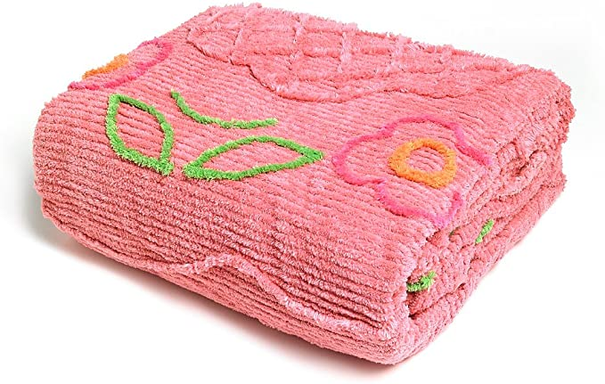
Our favourite time tae sing oor sangs and tae say oor rhymes wiz when we hud a stay over at Grannie Clerras and Grandie Chays. There wiz alweys a puckle of us. We goat a rerr tea o chups an ham and lemonade then it wiz aff tae clean oor teeth and intae oor jammies. There were twa big wooden beds one for the lassies and one fur the laddies. The lassies bed hud a pink candlewick and the laddies hud Grandie Chay’s auld army coat. “Jist tae mak shair yer happit and warm” Grannie Clerra wid say.
In oor beds and as the licht wiz fading, we’d hae fun wi the shadows oan the wall making birds an animals shapes wi oor fingers and hans. Ye goat a turn if ye guessed richt. Then we’d sing hymns we’d been learning in schule assembly, “All Things Bricht and Beautiful” Then we’d sing wi gusto….

Oor schools a bonnie wee school
It’s made wi brick and plaister
The only thing that wrang wi its’
The baldy heided maister

He goes tae the pub oan a Saturday night
He goes tae church oan Sunday
He’s prays tae God each day and nicht
Then belts the bairns oan Monday.

Once we’d sung that sang aroon 5 times in a row, we’d start telling clarty jokes, “Did ye hear aboot the wee man that fell doon the lavvie pan? He banged his heid oan a jobbie” Grannie Clerra, hearing the loud laughter wid cam through an say "Noo noo bairns its time ye were aff tae sleep. Coorie doon.” The laddies wid then whisper an’ tell us a’aboot their adventures, building gang huts at the tips and seeing foxes an’ rabbits. They’d scare us wi stories aboot the haunted hoose and the Gray Lady. They’d say in spooky voices, “She’s …coming…. Tae…. GET YE.” Grandie Chay wid come intae the room when he heard the lassies screaming saying, “Right, time tae settle doon an get tae sleep.” He’d tuck us in and then started us off singing oor favourite fae ‘wee Willie Miller,
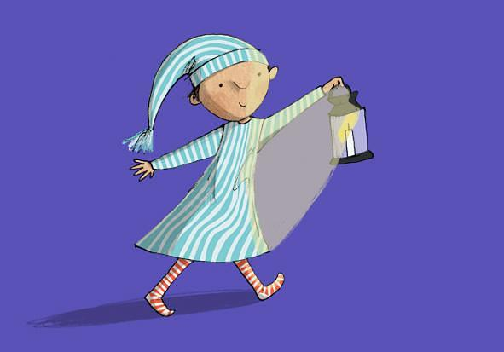
Wee Willie Winkie runs through the toon
Upstairs doon stairs in his nicht goon
Tappin at the windae, crying through the lock
Are the weans in ther bed, it’s past 8 O’Clock
Hey Wullie Winkie are ye comin here!

Grandie Chay then pit oot the licht and sang. He’d sing affie saftly
Coorie doon, coorie doon, coorie doon my darling
Coorie doon the day
Coorie doon coorie doon coorie doon my darling
Coorie doon the day.

We were a’ sleeping by the end. Grannie Clerra wiz in hur bed and Grandie Chay went through after checking the door. Before goin tae bed he wid say, “Aye bairns and sangs were made fur ain an ither.
SANGS

Whit were your favourite sangs or rhymes? Can you still sing them? Goan have a go…..hae fun with yer sangs. Did ye mak any rhymes or sangs up? We did but that’s another story ……………………
Sangs & Rhymes n’ Games

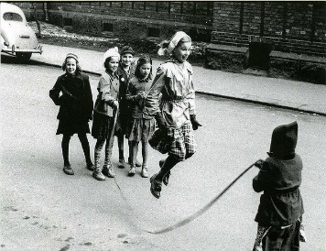
Skipping
Captain Cook wis makin' soup,
His wife wis makin' jelly,
Captain Cook fell in the soup,
And burnt his rubber belly.
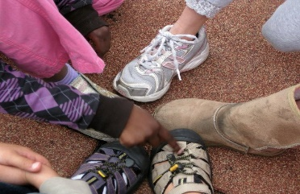
When picking someone to be ‘it’ picker would go round circle tapping shoes and saying,
“Eetle, ottle, black bottle, Eetle, otttle, oot
Eenty Teenty, Figgery Fell. Ell Tell Dominell.
Ran Tan Toozy Jock, You - are- oot!” last person was ‘it’

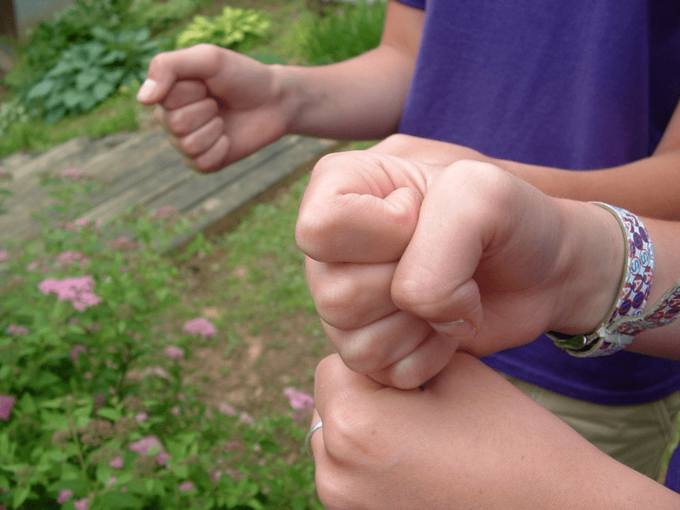
Children would stand in a circle with their fists (potatoes) held out like they were holding ski poles. Picker would hit each fist in turn and the one who was hit on the word "more" would lower that fist. The winner was the last one with a fist held out.
“One potato two potato three potato four, five potato six potato seven potato more.”
.
Presenting both hands (clenched fists) with a sweetie hidden in one
“Nievie, nievie, nack, nack, Fit han' will ye tack?
Tack een, tack twa, tack the best een o' the twa.”

Ball Game
The ball would be bounced off the ground against the wall and back on each number sung! At the word "overboard" over the shoulder of the thrower to the next in line who would continue the chant.

“One two three a leary, Four five six a leary, seven eight nine a leary, ten a leary overboard.”
Pit the richt endings in…..

Below are sentences fae some well kent bairns sangs and rhymes. Can ye match them up?

‘Cos she’s yer mammy’s mammy’ ‘Ma bonnie laddie’
‘Sitting on yer mammies knee’ ‘This wee piggy stayed at hame’ ‘Where wull the babies dimple be’ ‘Big banana feet’
‘It went joggin in the fog’ ‘An she fell an skint hur knees’ ‘On a cauld and frosty mornin’
‘Upstairs doon stairs in his night goon’

- Three craws sat upon a wa………………………………………………………
- This wee piggy went tae market …………………………………………….
- Katie Bairdie had a dog …………………………………………………………..
- Wee Wullie Winkie runs thru the toon ……………………………........
- A sent hur fur cheese ……………………………………………………………..
- Skinny malinky long legs …………………………………………………………
- Dance tae yer daddy ………………………………………………………………
- Oan the babies hand, oan the babies knee……………………………….
- Oh ye cannae shove yer granny …………………..............................
10.Ally Bally, Ally Bally bee ………………………………………………………….

How did ye get oan? Answers oan the next page.

Whits yir favourite childhood rhymes and sangs? Oors are Ally Bally and Oh ye cannae shove yer granny aff a bus.

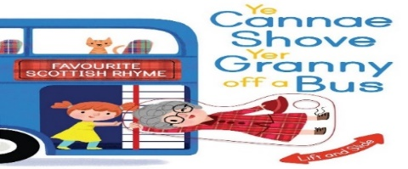

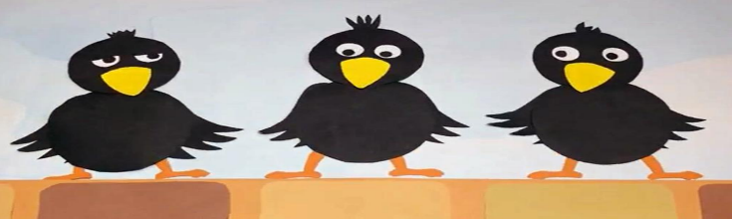

- Three craws sat upon a wa ‘On a cauld and frosty mornin’
- This wee piggy went tae market ‘This wee piggy stayed at hame’
- Katie Bairdie had a dog ‘It went joggin in the fog’
- Wee Wullie Winkie runs thru the toon ‘Upstairs doon stairs in his night goon’
- A sent hur fur cheese ‘An she fell and skint hur knees’
- Skinny malinky long legs ‘Big banana feet’
- Dance tae yer daddy ‘Ma bonnie laddie’
- Oan the babies hand, oan the babies knee ‘Where will the babies dimple be? Oan his cheek or oan his chin or always wrapped up in a safety pin.
- Oh ye cannae shove yer granny ‘Cos she’s yer mammy’s mammy’
10.Ally Bally, Ally Bally bee ‘Sittin oan yer mammies knee, greetin fur a wee bawbie tae buy some Coulter candy’

The "Coulter" in this song was Robert Coltart (Coulter) who sold his "candy" (sweeties in Scottish parlance) round the houses. His song would alert the children to beg for pennies from their parents to buy his wares (a bit like the music played by ice-cream vans going round the streets). There is no "translation" for the first line as it is just a meaningless set of words for a song meant for children.
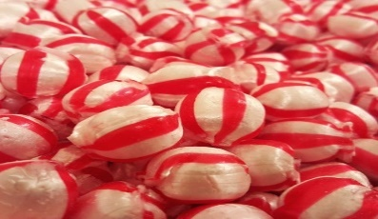
Joke fae the Poke

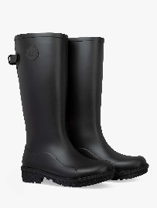
Oh wellies they are wonderful,
Oh wellies they are swell
Cause they keep oot the water,
and they keep in the smell

Ma ma an da used tae tak us tae the pet department
an tell us it wiz a zoo.

I dinnae ken why I should hae tae learn algebra,
I’m never likely tae go there.

What school does the ice cream man go tae?
Sundae Schule.

Why did she fling her watch oot the Schule windae?
She wanted tae see time flee.

Why did six feel afraid of seven?
Because seven ate nine.

Knock, knock. Wha’s there? Boo. Boo hoo? Why are you greetin?

Knock, knock. Wha’s there? Atch. Atch who? Bless you!

Knock, knock. Wha’s there? Cows go. Cows go who? No silly, cows go MOO

Knock, knock. Wha’s there? Goliath. Goliath who? Goliath doon, you look-eth tired!
Poems o’ the Pack

The Bogle – Greta Yorke

There’s a bogle in the corner
an it frichtens me maist nichts,
Ah rin fur cover, coorie doon
an’ squeeze ma een real ticht.
That wey Ah cannae see it
though Ah ken Ah’m in its sight
as Ma comes ben tae tuck me in
an’ switches aff the light.

Ma mither says there’s nae such things
as bogles in the hoose
but ask ma gran an she’ll agree
there’s somethin strange aloose.

It muddles a hur things aroon
an maks hur clean forget
whaur she pit hur this an that
mind, she hasnae seen it yit.
But when she’s loast hur glesses,
hur purse, remote or pen
she shrugs hur shoulders, winks an says,
‘Thon bogle’s been again!’

Ah hope the bogle disnae stay
in ma hoose fur tae lang,
‘cos though ma mither’s maistly right
there’s aye a chance she’s wrang.

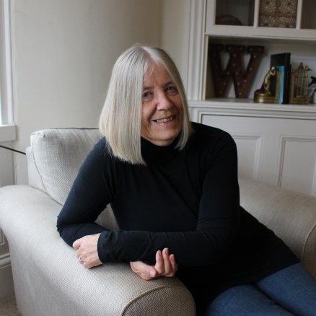
Did ye ken….Greta Yorke was born in Dunoon and is a writer living in Prestwick, Scotland. When she was 42 she returned to education. Greta goat her highers then went tae university. She won the under 7’s category in the Scottish Association of Writers Competition in 2010. She has written several Children’s stories and also writes poetry. Greta is a great supporter of Guid Fer a Laugh and you can find out more about her at BLOG AT WORDPRESS.COM

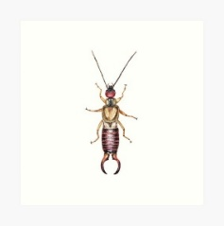
Coorie in the Corner by William Soutar
Coorie in the corner, sittin a’alane,
Whan the nicht wind’s chappin
On th’e winnock-pane:
Coorie in the corner, dinna greet ava;
goloch - earwig
It’s juist a wee bit goloch

Aince Upon a Day by William Soutar

Aince upon a day my mither said to me:
Dinna cleip and dinna rype
And dinnna tell a lee.
For gin ye cleip a craw will name ye,
And gin ye rype a daw will shame ye;
And a snail will heeze its hornies out
And hike them round and round about
Gin ye tell a lee.

Aince upon a day, as I walkit a’my lane,
I met a daw, and monie a craw,
And a snail upon a stane.
Up gaed the daw and didna shame me:
Up gaed ilk craw and didna name me:
But the wee snail heez’d its hornies out
And hik’d them round and round about
And – goggled at me.
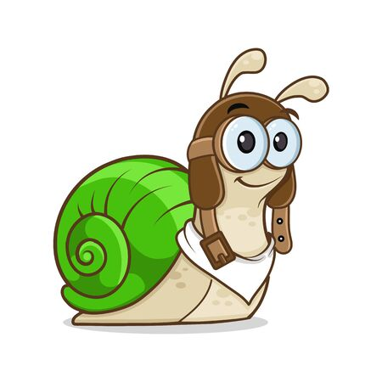
Daw - Jackdaw

Cradle Sang by William Soutar

Fa’owre, fa’owre, my hinny,
There’s monie a weary airt:
And nae end to the traikin,
For man has a hungry hert.

What wud ye hae for ferlie
And no ken the want o’mair?
The sun for a gowdan aipple:
The mune for a siller pear.

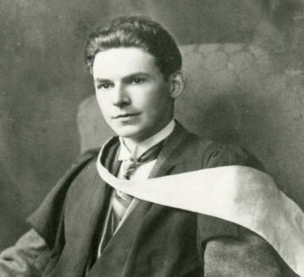
Did Ye Ken…..William Soutar was born in Perth in 1898. He died in 1943. His father was a master joiner and his mother Margaret wrote poetry. By 1918 he was suffering from chronic arthritis. He was a lively out-going man who was slowly incapacitated. By 1930 he was bedridden and for 13 years he lived in his sma room. He started to write ‘bairn rhymes’ after his parents adopted his orphaned 7 years old cousin Evelyn. William wrote great poetry and in the face of death he wrote The Diary of a Dying Man. William was a lovely man who once his poetry enters your heart it stays there forever. William Souter was a great Scottish poet and a braw man.
Corona Virus

Guid news, the restrictions are lifting
Mind and wear yir mask
Especially playin’ peevers wi yir pals

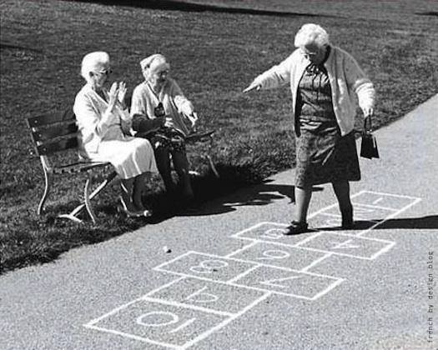

South West Edinburgh Adult Summer Programme
Scottish Cultural Trips - July & August 2021

Explore the auld toon wi Derek & Lydia oan oor toors
Museums, Galleries, Royal Mile Walk, Poetry in the Park

For mair information or to book a place, email or phone
Lydia.markham@ea.edin.sch.uk
Phone: 07719 420 424

Find the Scots Wurds

L | S | E | R | F | B | Y | E | P | Y | L | C | H | C | G
C | O | L | L | I | E | B | U | C | K | I | E | V | I | Q
P | G | F | K | R | A | Z | B | B | E | C | E | I | P | V
V | S | M | S | T | M | F | W | L | A | V | V | I | E | U
W | F | E | H | A | B | T | I | F | W | S | T | S | L | B
B | L | J | C | H | O | A | L | N | C | E | G | W | O | P
K | V | D | O | E | O | T | Z | H | K | N | A | N | L | B
I | Z | Y | L | I | L | W | U | Q | A | K | N | N | K | I
N | V | P | O | D | I | L | H | S | F | I | K | E | S | B
U | U | T | G | I | E | T | H | S | E | S | O | O | H | S
M | W | R | O | E | S | W | E | E | J | I | D | L | Q | M
P | S | K | I | N | Y | M | A | L | I | N | K | I | E | A
T | G | T | H | C | I | D | H | K | O | O | S | W | R | E
Y | P | B | A | I | R | N | S | O | I | M | C | R | A | B
R | U | A | H | W | P | E | E | V | E | R | S | P | Z | P

Boolies Bairns Peevers Sangs
Clype Colliebuckie Wee Dicht
Piece Sma Fitba Hooses
Pawkies Schule Bonnie Sook
Goloch Skinnymalinkie Yersel Lavvie
Weans Numpty Heidie

Thanks for your contributions

Russell Clegg – Auld Reekie Retold, Edinburgh Museums & Galleries, Information about Lillean Hardy
Linda Garcia - Regularly sends us lots of information
Vera Harvey – Children’s Games, Sangs & Rhymes
Carol Marr - Stockbridge Library, Edinburgh, Photographs from Edinburgh Collected.
Sandy McGill – Children’s Games, Sangs & Rhymes

We’d like to leave you wi a wee riddle

A Riddle by William Soutar

Whaur the fit has never been
It’s there ye aye gang wi’ it:
Whaur the e’e has never seen
It’s there ye aye will see it.

Whan ye ken that it is near
Nane but yersel’ will find it:
Whan it is nae langer there
Nane but yersel’ will mind it.

Dae ye ken whit it is? Answer on the next page.

Hae Yer Say

Our next issue is on Those Teenage Years …..fashion, music, games, 1st date/crush/love. My email and phone number are below.

Answer to the riddle ---------- A Dream ………………..Goat Ye!!

- Did you enjoy it? If yes, what did you like?

- If not, why not?

- Anything else you would like to see in the pack?

Course material developed by Derek Suttie, Scots Literacy Tutor
Send your Scots words, jokes, poems, sayings, suggestions to:

Lydia.markham@ea.edin.sch.uk
Phone: 07719 420 424
Lydia Markham, Lifelong Learning Worker (Adult Learning),
SW Locality, City of Edinburgh Council.
Learn tae Laugh - Laugh tae Learn

