Video Conferencing User Guidance
And
Risk Assessment

Version | Date | Changes
Version 1 | 01/07/2020

Contents
Working 4U - Digital Platform User Guidance 1
WDC Key Policies to Consider 1
Zoom: how to use guide 2
Getting started 2
Inviting Participants 2
You’re in! 3
Zoom Functions 3
Some tips and rules to make this run smoothly 4
How to organise a secure meeting on zoom. 4
On a mobile device 4
On a Laptop of computer 4
Scheduling a Zoom meeting 5
How to stay secure on Zoom 5
Breakout Rooms 5
Participating in Breakout room 5
Managing breakout rooms 6
Participants Induction 7
Online Participation - Group Housekeeping 7
Useful Training Links 9
Digital Platform Engagement - Risk Assessment 10

Working 4U - Digital Platform User Guidance
It is recognised that digital platforms are a suitable way to engage with service users and external partners. It is also recognised that no single digital platform will be relevant to all circumstances. However, the broad principles are appropriate irrespective of the platform utilised.
This guidance for staff has been developed to assist you planning and delivery of Working 4U services on digital platforms in a safe and appropriate way.
This is an interim document in response to delivery of services during Covid 19 in line with government guidance regarding lockdown phases and will be updated as appropriate.
This user guidance is in addition to West Dunbartonshire Data Protection Guidance, GDPR regulations, Information Security Policy Framework and Social Media Policy.
GDPR means General Data Protection Regulations. These are laws governing the safe and appropriate handling of personal information and data. West Dunbartonshire Council must be compliant with this. These guidelines do not replace any GDPR policy of West Dunbartonshire Council.

WDC Key Policies to Consider
WDC Information Security Policy Framework
Data Protection Guidance
Social Media Policy

Zoom: how to use guide
Zoom is a digital communication (a group video ‘conference’) tool, that allows a group of people to come together to have a conversation in a virtual space. Zoom can be used to run Working4U groups and one-to-one sessions with our service users.
This section sets out some instructions on the use of Zoom.
There is a useful video for joining a meeting here:
https://support.zoom.us/hc/en-us/articles/201362193-Joining-a-meeting

Getting started
You need to download an application ﬁrst:
If you are using a PC or Laptop | If you are using a smart phone or tablet
You can download it here:  https://zoom.us/download  (Zoom for client meetings) | Search for zoom in apple app store of Google Play store  (Zoom Cloud meetings)

Inviting Participants
The host will send other participants a link. It will look something like this:
“https:// zoom.us/j/8968577910”.
This will load a webpage and a pop-up window will appear. If you have already downloaded the app on that device, click on “open zoom.us” or (if you are on a smart phone or tablet) open in the Zoom app.
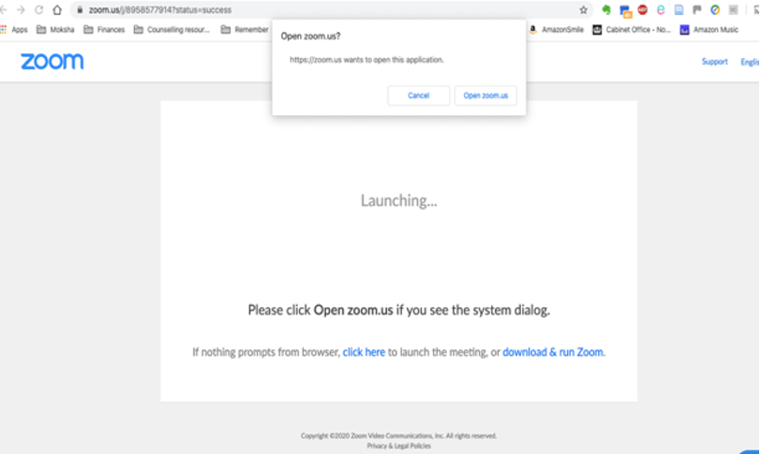

If you have not downloaded Zoom before on that device:
If you are on a PC / laptop | If you are on a smart phone / tablet
Click on the hyperlinked text “download & run Zoom” and wait for the application to download. Depending on your computer, you may need to click to agree to install the application on your computer. | You will need to download the Zoom app from Apple App store or the Google Play store. When you click on the meeting link, choose to open in the Zoom app (if it does not do this automatically
The host will have provided a name for the session. You must use a recognisable name so that the host knows who you are!

You’re in!
When you’ve joined the Zoom, you enter what is known as a ‘session’.
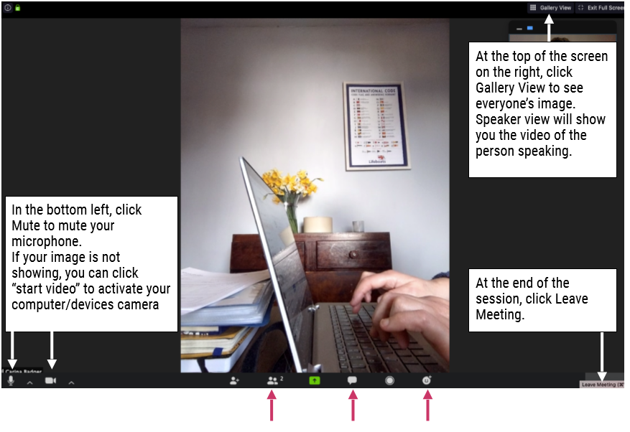

Zoom Functions
While participating in a session you can use a number of functions to interact with the other participants. This includes:
- Find out who else is in the meeting by clicking Participants. A panel will come up on the right hand side of your screen.
- Click the Chat bubble to ask questions via text, share links to websites etc. You can chat to everyone in the meeting, just the host, or a speciﬁc person. A panel will come up on the right hand side of your screen.
- Click on Reactions to either do an applause or thumbs up to what the speaker is saying.
- If you are on a phone you may need to tap your screen to reveal them.

Some tips and rules to make this run smoothly
- Use the waiting room facility as this allows you only to accept the individuals you have invited.
- Put your microphone on mute: Please keep your microphone on mute if you are not speaking. This means you will have to ‘unmute’ yourself to speak.
- Use the chat box: To prevent everyone all trying to talk at the same time, we suggest you use the chat box to let someone know you would like to speak.
- Video: if you are a participant don’t feel you have to use video. If you do use video, you must check what’s behind you, that you are displaying to everyone on video.

How to organise a secure meeting on zoom.

On a mobile device
- Tap “new meeting” with the camera icon.
- For most people, the Personal Meeting ID (PMI) should be toggled off. A PMI is your unique account number: it means that if you're holding regular meetings with the same group, you're easier to find, but if you're holding a lot of meetings with different people, they may enter at the wrong moment. Toggling it off generates a random ID that only serves for the purposes of that meeting.
- Once you press "Start a Meeting" you will be in the call. Then select "Call using Internet Audio". Make sure neither "Mute" or "Stop Video" is selected if you want people to see and hear you.
- Tap "More" and then "Meeting Settings" to check your security measures. Make sure that "Put Participant in Waiting room on Entry" is switched on so you can screen who enters. Tap "Done".
- To invite people, press "Participants" and "Invite". You can choose to send emails, texts or contacts. Alternatively you can choose "Copy link" if you want to send in an app such as WhatsApp.
- When your invitees click the link, they will arrive in the Waiting Room. Press "Participants" again to move them to the call. You can also switch on the “Play chime for Enter/Exit” in Settings so you know when someone is arriving in the meeting.
- When everybody is in the call, you can select "Lock meeting" to allow no more participants

On a Laptop of computer
- Sign into your Zoom account, either at zoom.us or through the desktop app if you have downloaded it.
- Click on "Host a meeting" on the web, or on "New meeting" on the desktop app.
- Select "Call using Internet Audio". Once in the call, make sure neither "Mute" or "Stop Video" is selected if you want people to see and hear you.
- Tap "Security" to check your security measures. Make sure that "Enable Waiting Room" is switched on so you can screen who enters.
- To invite people, press "Manage Participants" and "Invite". You can choose to send an email, or to a Zoom contact. Alternatively you can choose "Copy URL" if you want to share the meeting in another way by pasting it in another app. send in an app such as WhatsApp.
- When your invitees click the link, they will arrive in the Waiting Room. Press "Manage Participants" again to move them to the call. You can also switch on the “Play chime for Enter/Exit” in Settings so you know when someone is arriving in the meeting.
- When everybody is in the call, you can select "Lock meeting" to allow no more participants

Scheduling a Zoom meeting
- If you want to set up a meeting ahead of time, you can schedule one, allowing you to choose your security settings in advance.
- On either smartphone, desktop or tablet, click "Schedule" instead of starting a meeting. This generates a menu of settings, which can be tweaked. The default security settings will be switched on, so the main thing you have to do is pick a time.
- Once you select "Schedule" or "Done" you will see a box with a big chunk of text, or a calendar event on mobile. That can then be copied and shared as above.
- When you want to start the meeting, go to "Meetings" in your app, and select start.

How to stay secure on Zoom
- do not share the link or the meeting ID on public platforms (and if you share photos of the meeting make sure the ID is not visible).
- Use the waiting room facility to accept only the participants you have invited.
- never use the personal meeting ID, instead allow Zoom to create a random number for each meeting.
- add a meeting password.
- set screen sharing to "host only".
- disable file transfer.
- disable "join before host" .
- disable "allow removed participants to rejoin" .
- carefully consider any recording - recorded meetings can be accessed by Zoom administrators.

Breakout Rooms

Participating in Breakout room
Breakout rooms are sessions that are split off from the main Zoom meeting. They allow the participants to meet in smaller groups. Breakout rooms can be used for collaboration and discussion of the meeting.
Users joined into the Zoom meeting from the Zoom Desktop Client, Zoom Mobile App, or H.323/SIP devices can participate in breakout rooms. Users joined using Chromebooks/Chrome OS or Zoom Rooms are unable to join breakout rooms, but the main room can be used as an alternative session for these users.
Only the host can assign participants to breakout rooms.
The co-host can leave and join any breakout room only if they join a breakout room assigned to them by the host.

Managing breakout rooms
Full instructions on Managing Breakout rooms can be found here: https://support.zoom.us/hc/en-us/articles/206476313

Participants Induction
Pre – Session Preparation (Virtual Hub Engagement)
All registration data and required information sharing for participation on Working 4U events, training and learning sessions will be complete prior to an invitation to participate in digital and on-line web based events. On completion of registration participants will be forwarded joining instructions prior to the start of the session.
Participants will be reminded and asked to acknowledge that they understand that others will be able to view them within the group based, digital sessions but that the groups will be closed session by invitation only and entry will be managed by West Dunbartonshire Council staff. An on-line participation contract will be introduced.
Where participants are under 16 years of age they will be asked to use the platform through a parent/carer’s account. West Dunbartonshire Council staff will contact parent/carers to discuss participation prior to session instructions being forwarded to the participants. If appropriate, they will discuss appropriate clothing and self-care before joining a group meeting – staff will apply the same conditions for participation in a face to face group.
If there are specific concerns around the person accessing meetings online they will be addressed in one to one meetings with their adviser/learning support staff before the participant joins a group. Technical and practical issues will re resolved prior to invitations to general sessions is forwarded. The importance of keeping up to date with the apps updates and latest versions will also be mentioned.
All participants will enter the sessions through a ‘virtual waiting room’ facilitated by a member of West Dunbartonshire Council staff. On recognition of the participant, the session facilitator will allow access as appropriate.
On Entry
Participants will be asked to change their name on the Zoom window where they appear. This will identify the name that other participants will know them by, rather than their email address which comes up on the bottom of their email.
This will also be the opportunity to support the participant to choose which space/s in their home will be visible during meetings and how to make modify the view presented to the rest of the group.
There will be a PowerPoint slide of Zoom Housekeeping rules at the start of each session. The induction will cover conduct at the sessions; the length of time the session will take; basic use of the platform; how to join and leave a meeting; turn mic and camera on/ off; how the session will end what will happen after the session.
At the start of each session the online participation contract (see below) must be introduced to all participants with verbal agreement from all participants. Where agreement is not obtained, participants will be prevented from participating in the session..
Online Participation - Group Housekeeping
At each session participants will be informed:
- When to turn on/ off film / mic;
- What content is appropriate to share – including reminders about not posting personal contact or any other personal details;
- Camera placement and where participants are when they take part in groups (to avoid filming other members of their household). Zoom has functionality to set ‘video backgrounds’;
- That filming / capturing images of the sessions on another device is prohibited;
- Who can be included the video chat;
- What will happen if boundaries are broken.

Useful Training Links
There are a number of resources that will provide details for the best use of the platform. These resources can be found at:
- Getting started (essential watching) - https://livetraining.zoom.us/rec/play/78Ytfruppj03EoeRswSDU_dxW43ofaisgXIWqfVYnxu2BXlSMFf0YuQUarf_OXJhEbPFJVjDP8_UBJy4?continueMode=true&_x_zm_rtaid=ck7riuB5R5yqEunMW8AKpQ.1592896524316.3c4e846c9994654574586b9539bb3430&_x_zm_rhtaid=648

- Joining a meeting: https://youtu.be/hIkCmbvAHQQ

- Scheduling a meeting: https://youtu.be/XhZW3iyXV9U

- Meeting Controls: https://youtu.be/ygZ96J_z4AY

- Breakout Room Function: https://youtu.be/jbPpdyn16sY

- Sharing your screen: https://youtu.be/YA6SGQlVmcA

There are a number of other training videos that may be useful for the purpose of your Zoom Usage –
https://support.zoom.us/hc/en-us/articles/206618765-Zoom-Video-Tutorials
https://support.zoom.us/hc/en-us/articles/217214286-Watch-Recorded-Training-Sessions.

Digital Platform Engagement - Risk Assessment
Risk | Who’s at risk | Measures to Reduce Risk | Whos responsible
Participants contact information being published on the internet | Staff/  Participants | Zoom will be used to set up meetings which is a secure platform.  Zoom is used widely by schools, businesses and other organisations.  Zoom’s privacy policy can be found here: https://zoom.us/privacy  All contact information and participation details will be exchanged prior to the start of the session. | Staff
Young people under 16 accessing age-inappropriate software | Participants | Young people aged under 16 will use zoom through a parent/carer’s account with their permission and understanding following induction.  All sessions will be facilitated by West Dunbartonshire Council staff. | Staff
Participants accessing each other's contact information without consent | Participants | Zoom meetings to be set up by workers and workers to remain as ‘Host throughout.  Workers will be present first at the meeting, then the participants will be invited to join.  Meetings to be set up by adding participants contacts to the workers account. They can then invite them to the meeting one at a time once the worker is present. Participants supported to check profile name and privacy settings. Meetings to be set up with the messaging facility set so participants cannot contact each other through private messaging. | Staff
Images of participants being captured without consent during online during group sessions | Participants | Group contract established.  Worker to disable the recording function for participants. | Staff
Participants accessing workers personal information | Staff | Workers to use work mobile numbers and email addresses for meetings Workers to be aware of the area of their home which Participants will be viewing during video calls. | Staff
People who have not been invited to the meeting accessing the facility. | Staff/  Participants | Link only to be sent to Participants, or parents/carers if under 16 – sent the day before the meeting and only to agreed email address.  Meetings will include a password which is only sent to participants.  Waiting room function always used so participants have to be let in by meeting host.  Host to ‘lock’ the meeting once all participants are present so no-one else can join the meeting. | Staff
Participants not following guidelines set out by workers for online safety | Staff/  Participants | New group contracts to be established by worker and participants at the beginning of each group – (see Online Participation group contract section of this document)  Participants who are not adhering to the contract may be asked to leave the meeting and can be removed by the host. If this happens workers will contact them individually to explain why and conduct follow up work and support to participant. | Staff
Inappropriate content/ language being posted to the group | Staff/  Participants | Private chat between individuals disabled  Group contract.  Host can remove content and block participants from writing / posting if necessary.  Links will be disabled.  Only workers will be able to ‘share screen’ | Staff
Individual issues and concerns | participants | Participants to be offered 1-1 support if necessary outside the group.  If there are any safeguarding concerns including young persons safety online or outside of the sessions, please follow the Child protection guidance. | Staff
Group dynamics | Staff/  Participants | Small groups to be matched up by workers as per dynamics of known young people. | Staff
Participants struggling to communicate on online groups due to disabilities | participants | Individual support offered, alongside group support as required. Workers to offer bespoke support as required and groups to be set up to accommodate for participants needs as appropriate (e.g. smaller group sizes). | Staff
Feedback and evaluation not being captured due to online nature of groups | Staff/  Participants | Participants to be encouraged to email feedback and ideas after each session | Staff
Participants and staff being exposed to inappropriate material / content in the background of a video. | Staff/ | Group contract.  Participants and staff to be aware of what is in their background and make sure their home setting appropriate to be shared with the rest of the group.  Internet Safety course taken by all staff and delivered in bitesize chunks to participants. | Staff
Staff and Participants private living space is no longer private due to it being used for gathering socially online. | Participants | Individual discussions with participants around managing their space before groups begin.  Group contract.  Staff aware of managing their own space.  An awareness at all times if view changes because of camera positioning. | Staff
Participants support needs not being met if they cannot access online group sessions | participants | Participants will also be offered support by staff over the phone.  Participants will be signposted to other services where appropriate. | Staff
Conversations becoming unmanageable by workers | Staff/  Participants | Groups limited in size so workers can monitor discussions and content posted. Group agreement on how participants will have their voices heard during discussions. | Staff

