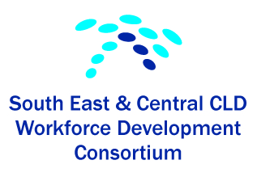

Summary Report on funding from Education Scotland 2013-2014
The South East and Central Workforce Development Consortium (Consortium) represents CLD partnerships in Edinburgh, East Lothian, Midlothian, West Lothian, Scottish Borders, Falkirk and Clackmannanshire Local Authority areas. The consortium facilitates involvement in a range of joint CPD for partners across the CLD sector.

The aims of the Consortium were to secure funding to continue the development of opportunities for practitioners and volunteers within the CLD field including the voluntary sector to:

- foster a vibrant learning environment at all levels
- support employers to encourage CLD registration for employees and volunteers
- deliver the CPD requirements of CLD Council registered staff
- encourage the use of idevelop
- play a key role in developments nationally

With the funding secure the Consortium planned and delivered two Conferences designed to concentrate on staff development and staff encouragement. The Consortium felt that staff needed the opportunity to network, consult, debate and demonstrate good practice in an environment that was encouraging and that promoted sharing of ideas and issues concerning CLD in its widest sense.

In this atmosphere the Consortium drew on all the skills within the network and also of others in the field to bring ideas and challenges to the fore. The Consortium felt that they had achieved the following:

- created a positive climate for sustainable continuous learning across the Consortium, where individuals were involved in a continuous process of improvement and development
- improved uptake of CPD opportunities across partners across the CLD sector by
organising a conference bringing together practitioners, managers, academics and other leaders from the CLD field on the theme of CLD Strategic Guidance
- encouraged and supported the sharing of CPD opportunities across the consortium
- strengthened the Consortium including the steering group through administrative systems, partnership agreement, further joint planning
- encouraged representation on steering group from partners including 3rd Sector, Health, Police, Colleges and Universities.

The first conference entitled “Inspiring Confidence and Confidence to Inspire” took place on 20th March, 2014 in Edinburgh and was well attended by approximately 100 people. The Consortium felt that this conference should encourage open discussion and debate and consequently invited to major speakers to deliver an address. These two speakers were:

Fraser Patrick retired Director of Dundee City Council’s Neighbourhood Resources and Development and who is currently a consultant in Community Learning.
- Fraser Patrick prepared a paper entitled: “Education is not neutral – and CLD?”
Sir Harry Burns who is Chief Medical Officer for Scotland where his responsibilities include aspects of public health policy and health protection.
- Prepared a presentation on Community Health.
Both speakers were inspirational and the discussions on these presentations was lively and challenging. Feedback from this event was very positive and everyone deemed it a great success.

As an invited guest we asked Graham Ogilvie who is a Corporate Artist with a degree in Fine Art and Illustration from Duncan of Jordanstone College of Art, Scotland to illustrate the discussions with his expressive artwork. This was also a great success and produced a range of graphics that highlighted the points made during the conference.
As a result of all the graphics the participants of the conference were asked to vote for the 12 most relevant. These were then finalised by Graham and sent to us in a useable format. These were circulated to all the participants and feedback is that they have been used in lots of ways within CLD practice in the community.

Evaluative comments:
Content: Excellent input- Fraser e.g. books, case studies, challenge. Also Harry Burns – inspirational to challenge assumptions. Personal: I’m from a partner – thank you – third sector can find CLD very receptive to new ideas, more than other statutory partners.
Excellent speakers – inspirational, informative and enjoyable. Good mix of input and discussion. Good space to talk and discuss and network with staff and students from other local authorities and third sector. Venue – central, close to station – good choice.
The second conference entitled “Inspiring Practice – A conference to discuss the dilemma of practice in a ‘safe harbour” was delivered on 29th of May in Grangemouth. The idea of the ‘safe harbour’ came from the comments of the participants at the first conference and a graphic chosen as one of the 12.

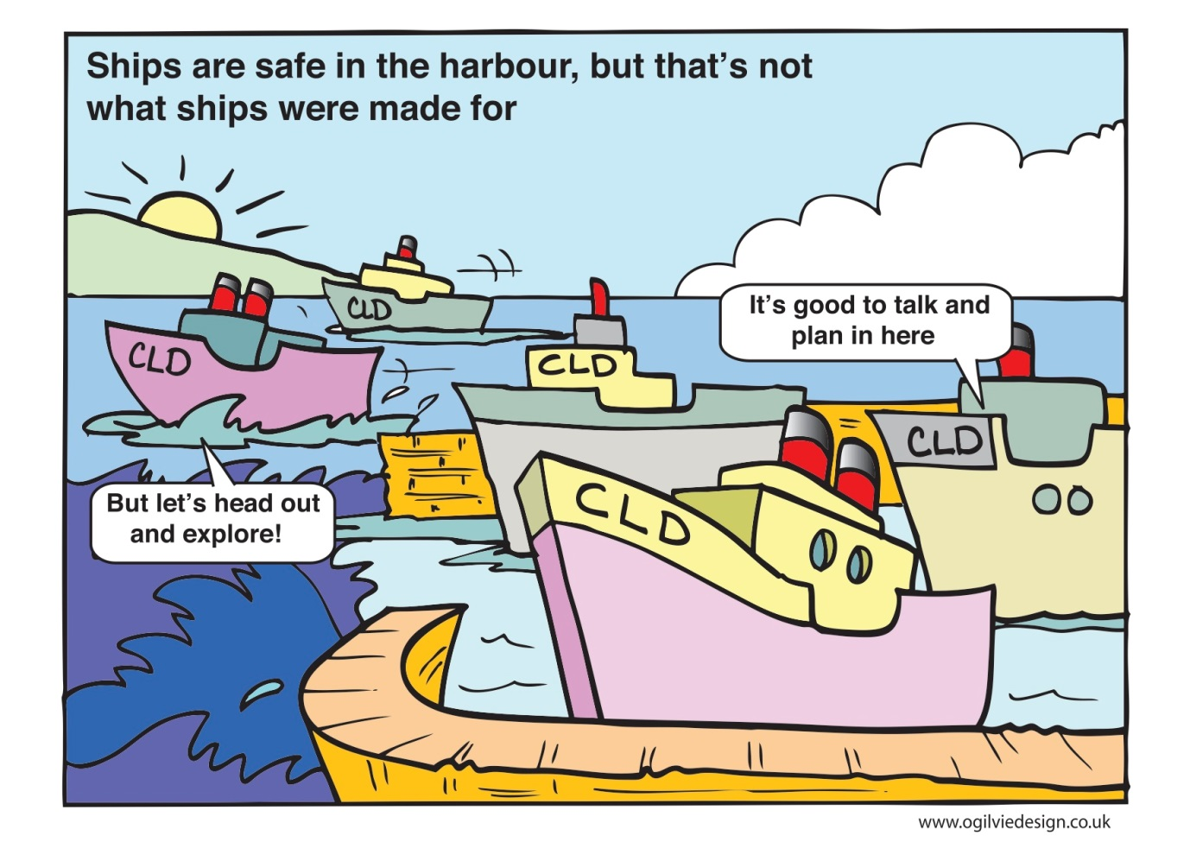

As further staff development it was agreed by the consortium to encourage all the participants to attend the second (follow-up) conference. This conference was delivered using an innovative technique called Open Space Technology where the participants got the opportunity to discuss any issues, dilemmas, barriers or blockers in a safe and confidential environment. The discussions were led by practitioners who originally were trained by CLD in Falkirk Council (Open Space Technology - Training the Trainers) who provided the opportunity to members of the consortium or practitioners within CLD using funding from Education Scotland to subsidise their training. They were given a refresher briefing on the evening prior to the conference and they then led the discussions using the OST techniques on the day.
Evaluative Comments:
- Loved Open Space
- Really good to experience Open Space – could use this with some of my learners/
Glad to share experiences with colleagues from other authorities – important that we aren’t isolated. Really upbeat day!
- Brill discussion – exchange of good ideas
- Workshop too short – meant it just skimmed over
- Enjoyed the open space but feedback went on too long
- Was reminded of what a good method open space is – participants setting agenda
In summary both conferences were very successful and although the second conference was not as well attended as the first the Consortium agreed that both were very worthwhile and delivered the outcomes that were identified when asking for funding.
Thanks to Education Scotland for their support and funding.

