CLD delivery of Family Learning
case study

Making a difference through: Family Learning in Aberdeenshire
Community Learning and Development – key purposes
1.1. Community learning and development (CLD) has a powerful impact on the lives of learners and communities, supporting them to identify and work towards change. Whether that change takes place in an individual’s life, helps to create a resilient and enterprising community or contributes to better public services in a changing landscape, Scotland has a need for successful learners, confident individuals, responsible citizens and effective contributors working together to build a shared future. https://www.education.gov.scot/Documents/cld-regulations-la-guidance.pdf
Family Learning encourages family members to learn together as and within a family, with a focus on intergenerational learning. Family Learning activities can also be specifically designed to enable parents to learn how to support their children’s learning. The Northern Alliance are keen to capture case study examples of Family Learning activity from each of the 8 Local Authority areas to showcase Family Learning as a powerful method of engagement and learning.
https://education.gov.scot/improvement/research/what-is-family-learning

Here is an example of this practice:

Need for the project / activity why?

During the covid pandemic and lockdowns, partners across Kincardine and Mearns local learning community partnerships, spoke of an increase in primary aged children experiencing low self-esteem and anxiety.
Within CLD adult learning there was also an increase in the number of adults attending our person-centred provision during the pandemic. Many were parents who spoke openly about struggling to support their children’s self-esteem and emotional well-being. CLD adult learners are targeted from areas of disadvantage or are those suffering from poverty related impacts. This collection of information led to the creation of a programme focussing on self-esteem.
Description - the self-esteem garden project what and how?
Adult learning CLD staff created a programme designed to give parents and their children the skills needed to grow their own self-esteem using the analogy of a garden. This learning programme focussed on growing their own self-esteem while gaining the skills and confidence to engage positively with their children through the activities. It was titled the self -esteem garden.
Due to Covid-19, provision has been developed to be delivered online to enable adults to continue with learning throughout the pandemic.
7 online sessions were delivered with parents and children, as outlined in the programme below:

Good soil: Positive, supportive people and relationships
Flowers and seeds: positive qualities, attributes, and skills
Sunshine: positive experiences
Gentle rain and storms: thoughtful feedback and destructive criticism
Fences: protective boundaries
Weeds: Negative thoughts
Gardeners: Caretakers of self-esteem

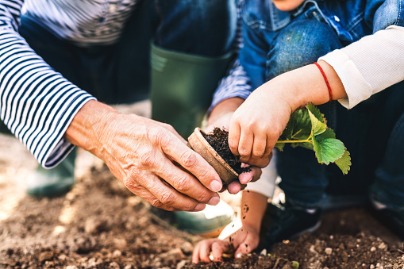
A self-esteem garden activity booklet was sent out to families to accompany the online sessions. This enabled learners to have paper based resources to read and refer to at home, which also supported any potential literacy needs.

CLD staff also provided one-to-one catch-up sessions if participants were unable to attend the group session and provided a re-connect session a month after the self-esteem garden finished, to see how the parents and children were progressing. This also supported parents who were dealing with the impacts from health and wellbeing and/or low mental health due to the pandemic to give further support, if required. Many adults have suffered in confidence and with social isolation during this time so this supported the wellbeing aspects for learners during the course.

This work underpinned the competency of staff involved – in particular around:
- Building and maintaining relationships with individuals and groups
- Providing learning and development opportunities in a range of contexts

Impact difference made

- Improved family communication around emotional well-being - parents felt more confident and skilled in having these conversations.
- Increase in parents’ self-esteem, which in turn allowed them to become positive self-esteem role models for their children. Evaluations reflected an impact on parent mental health through promoting themselves as positive role models.
- Families worked together to complete the self-esteem garden activities which in turn encouraged positive engagement between parents and their children. This also supported attachment between parent and child, building and strengthening relationships whilst dealing with the effects from the pandemic
This was reflected in the evaluations which highlighted the benefits of engaging in activities together, improving relationships and behaviours for both parent and child.
Evidence how do we know?

- Participant feedback/ evaluations at the end of the programme and re-connect session. This showed positive comment from both parents and children involved.
- Planning documentation capturing need and intentions
- Materials and resources – developed to specifically suit the group, shared with wider partners and reviewed for future use.
Lessons learned
Digital fatigue was an issue for some parents, whose attendance varied. They completed the programme via one-to -one phone calls and support emails.
Pre-programme phone calls with participants may have been beneficial, as some parents/ children had very complex emotional needs that were challenging to manage in the group online setting.
A practical gardening session to be included in future for the families or little bags of gardening to be sent out with the self-esteem garden activity booklet to break down barriers around families with low incomes struggling to be able to afford simple garden supplies. The programme links with Learning for Sustainability and outdoor learning outcomes connecting learners with nature so future links are possible here.

Images / learner quotes if available
“I can see the weeds that I need to tackle in my garden, so that I am a positive self-esteem model for my daughter, using the activities is helping her to journal her feelings” quote from parent

When you are growing your self-esteem, look out for rocks in the garden! quote from child.
"The families who engaged in the programme have benefited greatly, the children can discuss their feelings more openly and confidently than before, we see improvements in their self-esteem"
quote from Primary school Teacher
“Quality family time, we have planted up window boxes and spend time together on a shared interest, positive change from before” quote from parent
“We learned that gardens need good soil for beautiful flowers to grow, through the programme we identified our good soil people, that support us “
Quote from parent

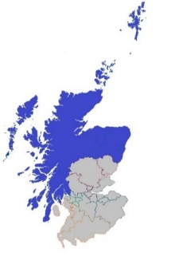
Date: January 2022 Local authority: Aberdeenshire Council

https://northernalliance.scot
Community Learning and Development (CLD) Lead Officers coming together to deliver on the vision for the Northern Alliance across the geography of the North

