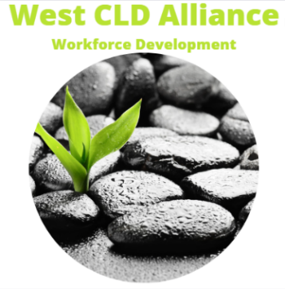
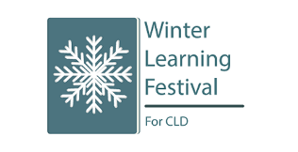
West CLD Alliance: Winter Learning Festival for CLD, 2023-24
The Winter Learning Festival for CLD is a national programme of professional learning for the CLD workforce. The West CLD Alliance will host their week of sessions in February 2024. Online sessions are open to all CLD practitioners across the country. Please come and join us! Sign up details below.
Focus | Workshop Description | Day/Date/Time | Where to sign up | QR Code, if using
- Considering Working Memory in CLD practice | An online session sharing knowledge on working memory and how it can impact on learners’ ability to perform everyday activities. Hosted by Inverclyde Council’s CLD team | Monday  5/2/24  2pm-3.30pm | Please contact tricia.donaghy@inverclyde.gov.uk to reserve a place (25 max)
- How ‘Participative’ is your PB? | An online session on CLD approaches to Participatory Budgeting from East Renfrewshire Council’s CLD team. PB approaches in ERC were recently highlighted as practice worth sharing by HMI. | Tuesday 6/2/24  10.30am-12pm | https://www.eventbrite.co.uk/e/winter-learning-festival-2024-how-participative-is-your-pb-tickets-795239892927
- Multiply – Sharing CLD experiences and best practice | A face to face session on what’s been learned so far from the Multiply Programme in the West region. Hosted by Glasgow Life and co-delivered by West Alliance members. | Wednesday 7/2/24  9.30am-1pm | https://forms.office.com/e/k9rMmEx5LQ  Venue: The Emirates Arena, Glasgow, G40 3HG | 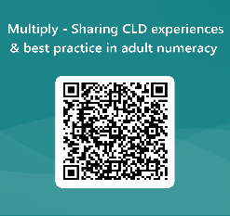
- CLD approaches to youth employability | An online session focusing on the Thrive Programme which supports 16-24 year olds in West Dunbartonshire to progress towards employment. Hosted by the Working4U team. | Wednesday  7/2/24  2pm-3.30pm | West Alliance Winter Learning Festival - West Dunbartonshire Council Tickets, Wed 7 Feb 2024 at 14:00 | Eventbrite
- Critical Reflection using the CLD Values | This online participatory workshop will explore a range of critical reflection tools for use by CLD staff and volunteers. Participants will explore how to use CLD values to ask key questions about our practice at an individual and also at a group level. Hosted by the Inverclyde CLD team. | Thursday  8/2/24  10am – 11.30am | https://www.eventbrite.co.uk/e/critical-reflection-using-cld-values-winter-learning-festival-for-cld-tickets-789172745927?aff=oddtdtcreator
- ESOL Family Play – The Glasgow Life Approach | An online session focusing on family learning approaches with families in Glasgow. Hosted by Glasgow Life’s Family Learning team. | Thursday 8/2/23  3.30pm-4.30pm | https://www.eventbrite.co.uk/e/winter-learning-festival-esol-family-play-the-glasgow-life-approach-tickets-773116390937?aff=oddtdtcreator

Evaluation Form: participant feedback: Winter Learning Festival for Community Learning & Development (CLD) Practitioners (office.com)

