**Introduction to Scots Literacy**

***Guid Fer a Laugh Level 2 - Pack 5***

**Speakin’**

**Scots**



**COONCIL**



**Nieves**

**Jiggin**

**Dicht**

**Reekin**

**Sonsie**

**Fiddle**

**Word**

**Word**

**Moose**

**Boosin**

**Wabster**

**Haggis**

**Bletherin**

**Forbye**

**Introduction to Guid Fer A Laugh**

We are part of the City of Edinburgh Council, South West Adult Learning team and usually deliver ‘Guid Fer a Laugh’ sessions for community groups in South West Edinburgh. Unfortunately, we are unable to meet groups due to Covid-19. Good news though, we have adapted some of the material and we hope you will join in at home.

**Development of Packs**

We plan to develop packs from beginner level 1 to 5. Participants will gradually increase in confidence and by level 5, should be able to: read, recognise, understand and write in Scots.

**Distribution During Covid-19**

During Covid-19 restrictions we are emailing packs to community forums, organisations, groups and individuals.

**Using the packs**

The packs can be done in pairs, small groups or individually. They are being used by: families, carers, support workers and individuals. The activities are suitable for all adults but particularly those who do not have access to computer and internet.

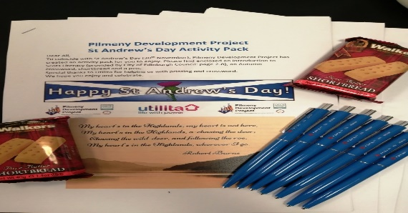**Adapting Packs**

The packs can be adapted to suit participants needs. For example, the Pilmeny Development Project used The Scot Literacy Pack as part of a St Andrews Day Activity Pack which was posted out to 65 local older people. In the pack they included the Scot Literacy Pack 1 and 2, crosswords, short bread and a blue pen. Please see photo.

**The Aims of the Session –** **Whit’s it a’aboot?**

* it’s about learning Scots language and auld words
* Shape

  Description automatically generatedtakes a look at Scots comedy, songs, poetry and writing
* hae a guid laugh at ourselves and others

**Feedback fae folk**

This is pack number five and we move on a little to Level 2. Christmas and Hogmanay have passed and the feedback from our last pack was just great. Thank you, Mary O’Connell for sharing the Pilmeny Group’s feedback in English and we’ve put it in Scots below.

In Scots

* It wiz barrie, a really enjoyed the activity pack and cannae praise it enuf.
* It wiz fandabbiedozzie and made me laugh, it wiz so funny. Ta awfie.
* It wiz smashing brought back childhood memories of the way ma and da spoke tae us in Scots.

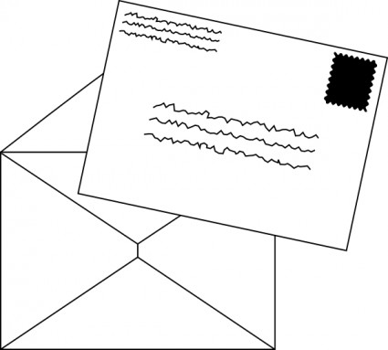

**BURNS SPECIAL!**

January is the time of year when the world celebrates our national poet the one and only Robert Burns. Many of us will have memories of Burns at school and of Burns’ Suppers. Some say this was the one time of year that Scots was spoken in schools and celebrated as one of our languages.

**Dedication**

While we celebrate Burns we dedicate this pack to the **‘lassies o’** and a the ‘**wummin fowk’** who play a supreme role in the life of humanity. We particularly dedicate this pack to the women who have cared and nursed others during this difficult year. As Burns himself said,

**“….The wisest man the warl' e'er saw,   
He dearly loved the lasses, O!**

**[](https://www.google.com/url?sa=i&url=https://www.standard.co.uk/news/health/nhs-volunteers-sign-up-fight-against-coronavirus-half-a-million-people-join-a4398016.html&psig=AOvVaw3WELxhMQP-9lRpsThie3DH&ust=1608671700183000&source=images&cd=vfe&ved=0CAIQjRxqFwoTCOi7ibX_3-0CFQAAAAAdAAAAABAD)Auld Nature swears the lovely dears,   
Her noblest work she classes, O!   
Her prentice han' she tried on man,   
An' then she made the lasses, O….**

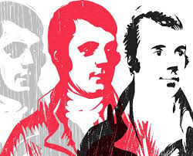

**Whit’s a’ the fuss aboot Burns**

* He was at the heart of Scottish culture and wrote in his own language and traditions.
* He helped write and collect some of the greatest songs ever, mainly in Scots.
* He was a radical who championed human rights and believed in the fundamental equality of all human beings. **“A mans a man for a‘that”** is equalities greatest anthem and is sung the world o’er.
* Burns was also a great comic who had a devastating wit. He loved to laugh and used the gift **“tae see oorsels as** **ithers see us”** as a means of exposing hypocrisy and laughing at oorsels. He was as they say ‘Guid fer a Laugh’.

**Did Ye Ken…**

[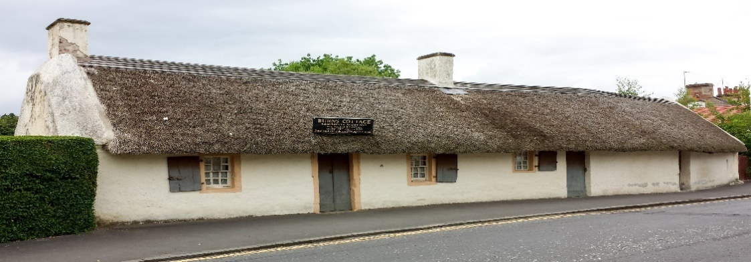](https://www.google.com/url?sa=i&url=https://commons.wikimedia.org/wiki/File:Burns_Cottage_-_Alloway.jpg&psig=AOvVaw0H0qTLlT0B5YI3Y37mw1CX&ust=1608409737489000&source=images&cd=vfe&ved=0CAIQjRxqFwoTCPCa2K6v2O0CFQAAAAAdAAAAABAD)

* 1759 - Robert Burns was born in Alloway, Ayrshire on January 25 in “the auld grey biggin” now known as Burns Cottage.
* 1774 – Wrote his first poem “O once I love’d…” a love poem.
* 1781 – Learned flax dressing.
* 1784 – Father dies.
* 1785 – Meets Jean Armour and has ‘other entanglements.’
* 1786 – Books passage to Jamaica three times on ‘The Nancy, The Belle and The Roselle.’
* 1786 – Kilmarnock edition is published, he becomes a celebrity.
* 1789 – Becomes an Exciseman
* 1790 – Wrote ‘Tam O’Shanter’ a comic masterpiece.
* 1791 – Wrote ‘Ae Fond Kiss’ Moves to Dumfries
* 1796 – Dies in Dumfries July 21 aged 37, his son Maxwell Burns is born to Jean Armour a day after his funeral. Burns died a poor man.

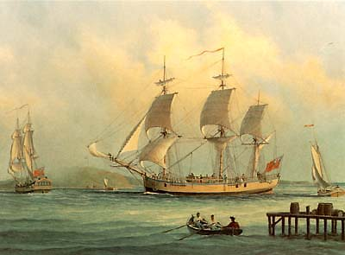

**Mair facts…….**

* Burns was a highly educated man full of contradictions doubt and fears. He had a huge vitality and vigour for life but suffered bouts of depression.
* At his lowest ebb he booked passage to Jamaica to work on a slave plantation. The slave trade ran through all Scottish life and its legacy is seen today in Glasgow, Edinburgh and the Highlands. That the slave trade could tempt as gracious a man as Burns shows the power and capacity of that abomination to corrupt men and society. **Today Black Lives Maitter and Nae Racism Here is the message. We tak the knee.**
* Common humanity and sympathy for others lit up the path Burns trod. He had a licht within him and aboot him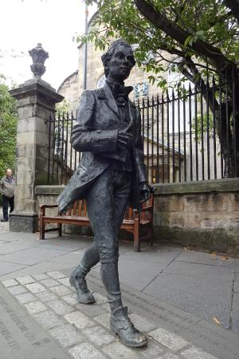. Scots poet Robert Fergusson influenced Burns writing style. Fergusson died a pauper at the age of 24 in Edinburgh. On arriving in Edinburgh, Burns paid for a gravestone for Fergusson. You can see the gravestone in the Canongate Kirkyard and statue of Fergusson outside on the pavement.

**Whit’s yir Favourite Wurd**

Whit’s your favourite Scots word that comes to mind when you think about Burns. Some of ours are:

**Haggis Moose Bletherin Drouthy Whisky**

What are your favourites from the above? Why? Make some sentences up from the words and have some fun with them.

**Whit’s the Wurd**

Below are some English words. What are the Scots word for them? Some are from Burns time. We’ve put some letters in to help.

**English Scots**

1. Plump/Pleasant _ _ n _ i _
2. Weaver W _ b _ _ _ _
3. Smelling _ e _ _ _ n
4. Dancing _ i _ _ _ _
5. Wipe D _ _ h _
6. Violin _ _ d _ _ _
7. Fists N i _ _ _ s
8. Also F _ rb _ _
9. Drinking _ o _ _ _ n

10.Talking _ l _ _ h _ _ _ _

How did you get on?

Answers on the next page

**Answers**

**English Scots**

1. Plump/Pleasant Sonsie
2. Weaver Wabster
3. Smelling Reekin
4. Dancing Jiggin
5. Wipe Dicht
6. Violin Fiddle
7. Fists Nieves
8. Also Forbye
9. Drinking Boosin

10.Talking Bletherin

**Bletherin** - It reminds me of my mum and her neighbours chatting over the washing line in the back green.

**For Rita Crombie, Edinburgh - ‘Sair finger’** reminds her of Burns. Although the Sair Figer poem wasn’t written by Burns, it is taught at primary school to celebrate Burns Day and is associated with him as a result.



***Put the Wurd In***

Put the richt Scots wurds into the sentences below, again select from the wurds below.

**Sark Bahookie Brither Wadna Hert**

**Breeks Thegither Scunner Aboon Lang**

1. He wore his old blue _ _ _ _.
2. He hud a big _ _ _ _
3. I didn’t like it, it wiz a _ _ _ _ _ _ _.
4. It wiz a very _ _ _ _ way hame.
5. She said, “Does ma _ _ _ _ _ _ _ _ look big in this.”
6. He wiz like a _ _ _ _ _ _ _ tae me.
7. She always wore _ _ _ _ _ _ and a jacket.
8. He said he _ _ _ _ _ dae it.
9. He wiz _ _ _ _ _ them all.

10.We sat shivering _ _ _ _ _ _ _ _ _

How did you get on?

Answers on the next page.

**“He hud a big hert”**

**Answers**

**Sark Bahookie Brither Wadna Hert**

**Breeks Thegither Scunner Aboon Lang**

1. He wore his old blue **sark.**
2. He hud a big **hert.**
3. I didn’t like it, it wiz a **scunner.**
4. It wiz a very **lang** way hame.
5. She said, “Does ma **bahookie** look big in this.”
6. He wiz like a **brither** tae me.
7. She always wore **breeks** and a jacket.
8. He said he **wadna** dae it.
9. He wiz **aboon** them all.

10.We sat shivering **thegither.**

Now make up sentences with the wurds.

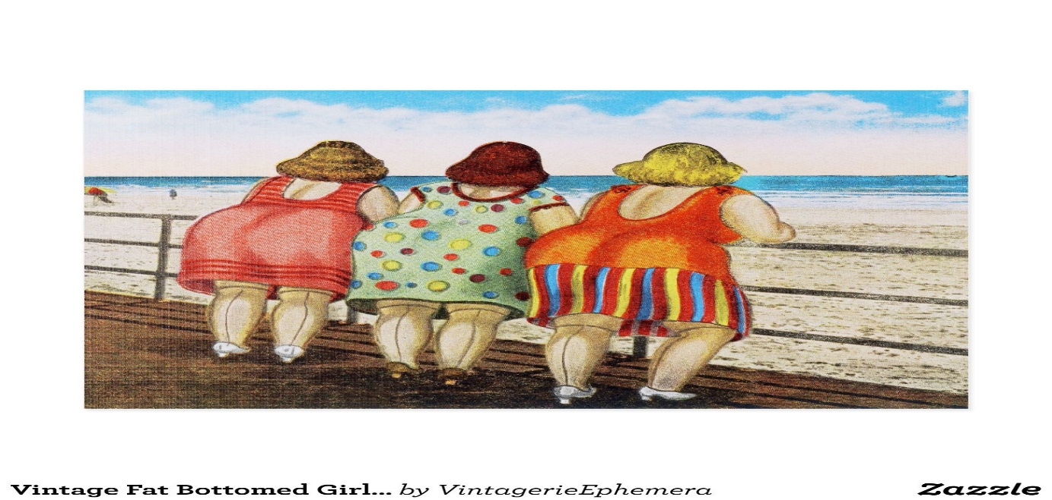

***Wurd O’ the Pack***

***Blellum***

This is one of our favourite words it means idle, talkative man. It was made famous by Burns in Tam O’Shanter where Tam is described as a ‘blethering, blustering, drunken blellum.’ In a few words we get the picture.

**Burns’ Supper**

### For us the word was always roar’d out at Grannie Clerra’s and Grandie Chays Burns’ Suppers. They hud them every year in their ain hoose wi their family and freens. Grannie Clerra, her best dress oan, an’ hair clipped up, Grandie Chay in his auld kilt. Grandie Chay’s pal Jimmy, piped in the guests and then the haggis.

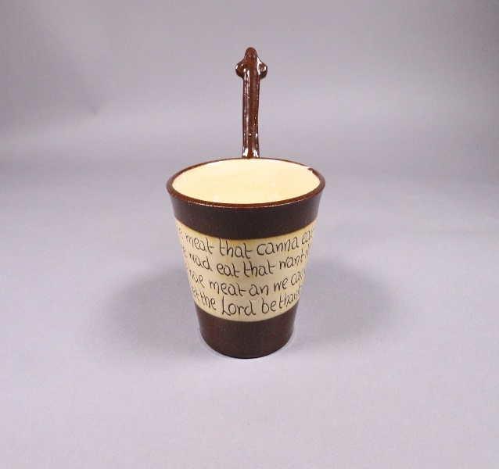

### Then Wee Sonsie Rosie did the Selkirk Grace.

### **Selkirk Grace**

Some hae meat and canna eat,   
   And some wad eat that want it;   
But we hae meat, and we can eat,   
   Sae let the Lord be thank it.

*Image Reproduced with kind permission of The City of Edinburgh Council Museums & Galleries. Thanks to Russell Clegg from Auld Reekie Retold for sharing this image with us.*

[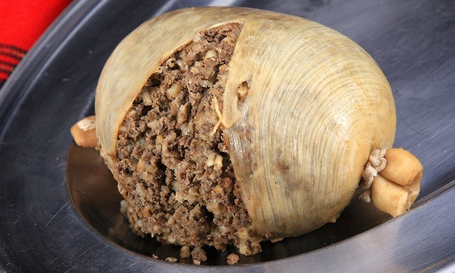](https://www.google.com/url?sa=i&url=https://www.dailymail.co.uk/news/article-3310527/Haggis-ban-lifted-Scottish-delegation-visits-Washington.html&psig=AOvVaw0PmBUCUaMwknoxCZowWtQb&ust=1608674729972000&source=images&cd=vfe&ved=0CAIQjRxqFwoTCPiTwcaK4O0CFQAAAAAdAAAAABAD)Big Bella then ripped intae,

**“Fair fa' your honest, sonsie face,   
Great chieftain o the puddin'-race!”**

**“Trenching your gushing entrails bright”**

At the **Immortal Memory** Grandie Chay, a wee bit fu, wud gie great emphasis tae the **‘bletherin, blustering, drunken blellum’** that was Tam O’Shanter. He gave even mair emphasis tae the shout **“Weel done Cutty Sark**.**”** Grannie Clerra wud often gie him a glower at that bit. The toast tae Burns wiz always gien wi a tear in the ee o’ all the company.

A’body wis touched by Burns’ immortality. Murdo gave the toast tae the lassies

**Murdo’s Toast**

[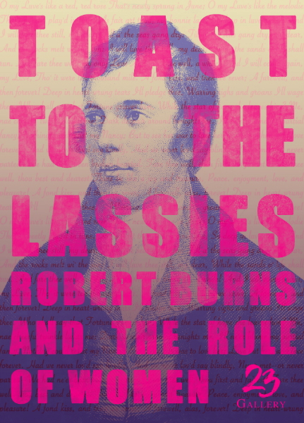](https://www.google.com/url?sa=i&url=https://artmag.co.uk/toast-to-the-lassies-robert-burns-the-role-of-women-call-for-submissions/&psig=AOvVaw2JLpI7ElptNhs4A6g9Qg2m&ust=1608672231721000&source=images&cd=vfe&ved=0CAIQjRxqFwoTCNCA_J6B4O0CFQAAAAAdAAAAABAD)

May the best ye’ve ever seen

Be the wrost ye’ll ever see

May a moose ne’er leave yea girnie

Wi a tear drap in his e’e

May ye aye keep hale an he’arty

Till ye’re auld eneugh tae dee

May ye aye be jist as happy

As we wish ye aye tae be.

Grannie Clerra always did the reply fae the lassies. She telt ane an a, that ony man that did not believe that “wummin” were equal to men, **“Weel, I wudna gie a button fur him.”**

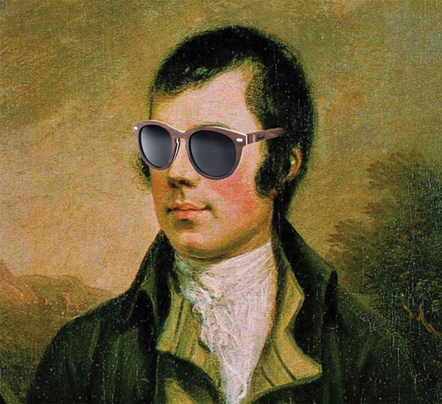She wid raise her gless and say**, “Rabbie was a braw man. He wiz Elvis afore rock n roll. Ach see they braw black sideburns** - **oh my aye.”** With a twinkle in her ee she wid raise her gless and shout out,

“**Tae the lasses o and a the wummin in the hale wide world!”**

After that drams were taken, it was singing, jigging and da’en a turn. Rod Summer wiz the last turn o the nicht.

**The Drookit Moose**

Puir wee moosie, found in a pail,

sypin weet fae yer heid tae yer tail.

It’s plain tae see that ye were drookit,

wi yer matted fur and skin a’sookit.

But then moosie, fit were ye daein?

Perhaps fae some great cat ye were fleen’.

But yer desperate flight tae escape these chases,

brought ye here!! Tae a Rentokill Shed, o’a’places!!

You werena’ tae know, how could ye have guessed,

The roon aboot here, you’re considered a pest.

There are men who work here, quite unforgiving,

Who cheerfully kill your kind for a living.

Ye were so close tae safety, it hardly seems fair,

That ye fell in a bucket and drooned yirsel’ there.

If only ye’d made yer way back tae yer field.

But ye chose tae hide here, and yer fate then was sealed.

Ah moosie if there’s any justice at all,

yir in some moosie heaven wi the angels on call.

I hope you arrived at some far better place,

where moosies are treated wi honour and grace.

A place where there’s comfort and plenty to eat,

and a hoosie weel bigit, all tidy and neat.

Wi’ long sunny days tae enjoy at yer ease,

Nae cat, nae mousetraps and lashings o’ cheese!!

Then a’body went aff tae bed with Rabbie Burns’ memory kept warm for anither year.

What memories do you have of reciting Burns or being involved with Burns at this time of year? What do you think of Burns and Burns Suppers. Hae a blether aboot oor wurd of the pack. Can you remember it?

**Blellum**

***Joke fae the Poke***

**We usually meet in community groups and pick a joke from the poke and read it out. As this is our Burns Special, we’ve added two of Burns epitaphs, where he has a wee dig at his deed pals.**

[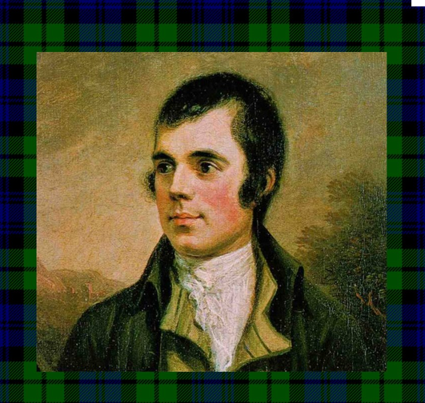](https://www.google.com/url?sa=i&url=https://mapeel.blogspot.com/2007/01/great-scots.html&psig=AOvVaw2avl89pm-ftSbNsHDVA1e7&ust=1608735342131000&source=images&cd=vfe&ved=0CAIQjRxqFwoTCKCk9q_s4e0CFQAAAAAdAAAAABAz)

Here lies Boghead among the dead

In hope to get salvation

But of such as he to heaven may be

Then welcome! Hail Damnation.

=====================================

[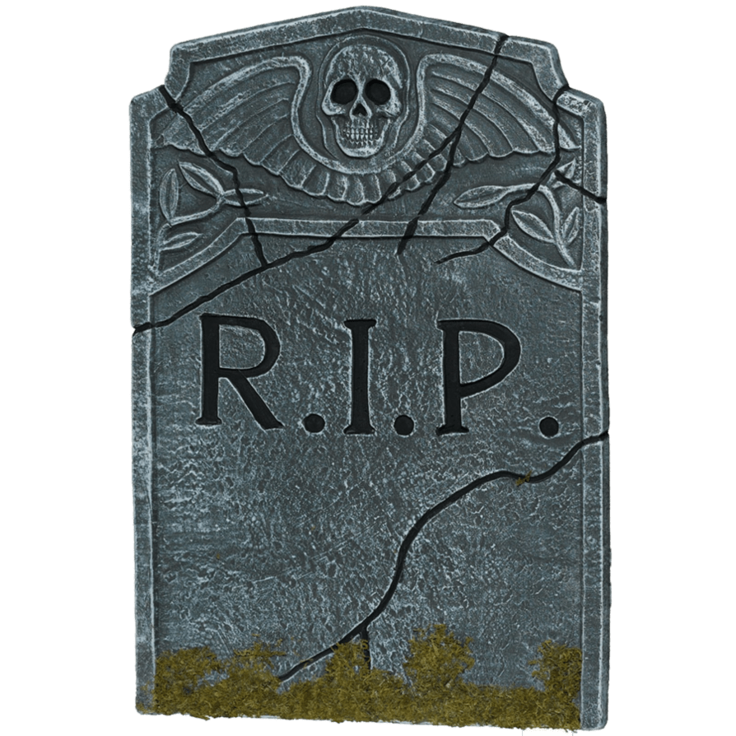](https://www.google.com/url?sa=i&url=https://www.stickpng.com/img/miscellaneous/graveyard/rip-headstone&psig=AOvVaw3hagxGSrYlKUMLyqEgKViS&ust=1608672575012000&source=images&cd=vfe&ved=0CAIQjRxqFwoTCND0mb2C4O0CFQAAAAAdAAAAABAE)

Who er thou art o reader know

That death has murdered Johnny

And here his body lies fu low

For soul he ne’er had ony.

**Robert Burns – The Quiz**

There are 3 choices but only one is the correct answer. Don’t worry if you pick the wrong one, it’s only a wee bit fun.

1. **Burns wrote the poem?**
2. To a house b) To a mouse c) To a Blouse
3. **Burns favourite musical instrument was?**
4. A fiddle b) An accordion c) A mouth organ
5. **Where was Robert Burns born?**
6. Kilmarnock b) Moss Gill c) Alloway
7. **When did Burns publish poems chiefly in the Scottish dialect – The Kilmarnock edition?**
8. 1776 b) 1786 c) 1796
9. **Which of these poets inspired Robert Burns?**
10. Walter Scott b) Robert Louis Stevenson

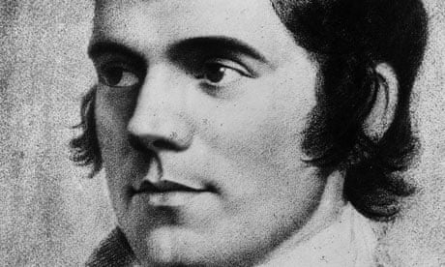c) Robert Fergusson

1. **Who did Burns Marry?**
2. Mary Campbell b) Lizzie Patterson c) Jean Armour
3. **What job did Burns do?**
4. Postman b) Ploughman c) Exciseman
5. **What song did Burns discover but not write all of the words ?**
6. Auld Lang Syne b) To a louse c) The …... Saturday Night
7. **When did Robert Burns die?**
8. 20 February 1800 b) 21 July 1796 c) 11 Nov 1802
9. **Where did he die?**
10. Edinburgh b) Glasgow c) Dumfries

How did you get on? Have a guid blether aboot your answers?

Answers on the next page

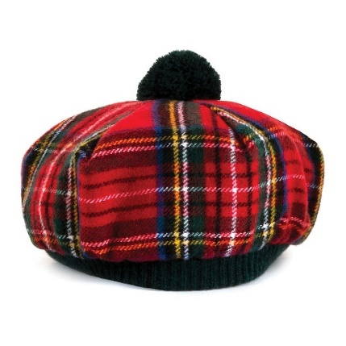

[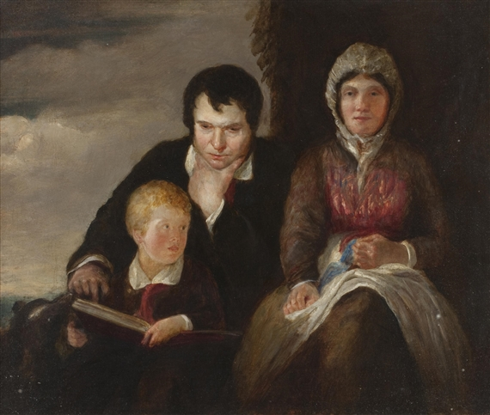](https://www.google.com/url?sa=i&url=https://www.mutualart.com/Artwork/Portrait-of-Robert-Burns--Jean-Armour-an/8C8547C49BA01401&psig=AOvVaw0JDZNR9RKEF76G9lijmJOa&ust=1608736818680000&source=images&cd=vfe&ved=0CAIQjRxqFwoTCNigg_Px4e0CFQAAAAAdAAAAABAb)**Answers**

1. (b) To a mouse
2. (a) A fiddle
3. (c) Alloway
4. (b) 1786
5. (c) Robert Fergusson
6. (c) Jean Armour
7. (c) Exciseman
8. (a) Auld Lang Syne
9. (b) 21 July 1796
10. (c) Dumfries

**Poem o’ the Pack**

You can listen to Scots actor [Paul Young](https://www.bbc.co.uk/arts/robertburns/works/readers/paul_young/) reading Sic a Wife as Willie Had. <https://www.bbc.co.uk/sounds/play/p0403k23>.

**Sic a wife as Willie Had**

**Robert Burns**

Willie Wastle dwalls on Tweed,

The spot they ca' it Linkumdoddie;

A creeshie wabster till his trade,

Can steal a clue wi' ony body:

He has a wife that's dour and din,

Tinkler Madgie was her mither;

[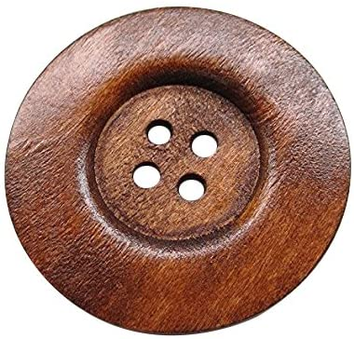](https://www.google.com/url?sa=i&url=https://www.amazon.co.uk/Chenkou-Craft-Buttons-Sewing-Button/dp/B01M2ZERQ4&psig=AOvVaw0hO_dJv7yGuo3gcMMbhPzk&ust=1608673097742000&source=images&cd=vfe&ved=0CAIQjRxqFwoTCID5v7aE4O0CFQAAAAAdAAAAABAI)Sic a wife as Willie's wife,

I wadna gie a button for her.

She has an e'e, she has but ane,

Our cat has twa, the very colour;

Five rusty teeth, forbye a stump,

A clapper-tongue wad deave a miller:

A whiskin beard about her mou,

Her nose and chin they threaten ither;

Sic a wife as Willie's wife,

I wad na gie a button for her.

She's bow-hough'd, she's hem-shin'd,

Ae limpin leg a hand-bread shorter;

She's twisted right, she's twisted left,

To balance fair in ilka quarter:

She has a hump upon her breast,

[](https://www.google.com/url?sa=i&url=https://www.amazon.co.uk/Chenkou-Craft-Buttons-Sewing-Button/dp/B01M2ZERQ4&psig=AOvVaw0hO_dJv7yGuo3gcMMbhPzk&ust=1608673097742000&source=images&cd=vfe&ved=0CAIQjRxqFwoTCID5v7aE4O0CFQAAAAAdAAAAABAI)The twin o' that upon her shouther;

Sic a wife as Willie's wife,

I wad na gie a button for her.

Auld baudrans by the ingle sits,

An wi' her loof her face a washin;

But Willie's wife is nae sae trig,

She dights her grunzie wi' a hushian:

Her waly nieves like midden-creels,

Her feet wad fyle the Logan-water;

Sic a wife as Willie's wife,

I wad na gie a button for her.

**List of Scots Wurds in English**

Wabster : weaver Trig: trim

Stown: have stolen Dights: wipes

Din: ill-coloured/noise Frunzie: nose

Deave: deafen Hushion: sleeve

Bow-houghed: bandy-legged Wallie nieves: large fists

What did you think of the poem? Have a go at reading it out loud. What words did you like? Have some fun making up sentences wi the wurds.

Do you have any funny poems in Scots that you like? Send them to us if you want.

**Dae ye Ken……** Paul young was born in Edinburgh the son of an actor John Young. He was educated at George Heriot school. He was a child actor and was in the film Geordie, where he played Geordie as a boy. He has appeared in loads of films and TV parts. He appears in Still Game as Shug McLaughlan, nicknamed Shug the Lug on account of his looks.

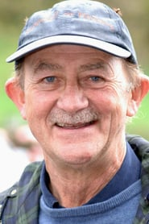

**Adult Learning in South West Edinburgh**

If you live in South West Edinburgh and are looking to improve your digital skills in general, or simply want to access YouTube music or videos – like the one in this pack <https://www.bbc.co.uk/sounds/play/p0403k23>. Please contact Lorraine for free help.

Email :  [lorrainedoherty@ea.edin.sch.uk](mailto:lorrainedoherty@ea.edin.sch.uk)

Phone: 07851461121

**Corona Virus**

A vaccine is on the way, however we still need to do all the things we have been doing. Stay healthy, well and above all,

**“Dinnae mak us ask, mind an’ wear a mask”**

[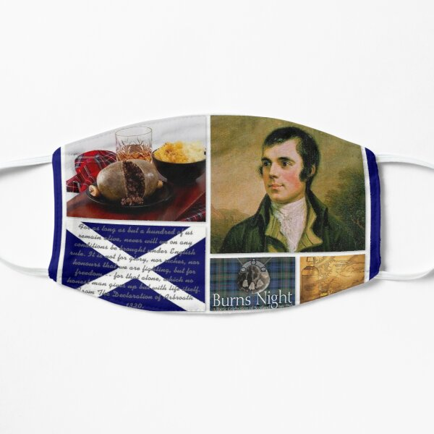](https://www.google.com/url?sa=i&url=https://www.redbubble.com/shop/robert%2Bburns%2Bmasks&psig=AOvVaw3eii6GQ6Bx3t8p1FHoan_Y&ust=1608673367105000&source=images&cd=vfe&ved=0CAIQjRxqFwoTCMi_4rmF4O0CFQAAAAAdAAAAABAD)

**Find the Scots Wurds**

|  |  |  |  |  |  |  |  |  |  |  |  |
| --- | --- | --- | --- | --- | --- | --- | --- | --- | --- | --- | --- |
| B | S | E | V | E | I | N | W | E | V | L | F |
| K | L | T | H | G | I | D | I | Y | C | A | I |
| R | R | E | N | N | U | C | S | B | B | N | D |
| V | E | A | T | L | F | K | T | R | A | G | D |
| W | G | T | S | H | E | R | I | O | H | N | L |
| A | A | F | S | E | E | T | E | F | O | I | E |
| B | X | D | R | B | H | R | I | E | O | G | S |
| O | T | B | N | E | A | J | I | C | K | G | D |
| O | J | F | R | A | X | W | W | N | I | I | X |
| N | S | O | N | S | I | E | O | A | E | J | N |
| T | H | E | G | I | T | H | E | R | T | K | A |
| M | Q | L | L | M | B | O | O | S | I | N | A |

|  |
| --- |
|  |
| ABOON | BAHOOKIE | BLETHERIN |
| BOOSIN | BREEKS | BRITHER |
| DIGHT | FIDDLE | FORBYE |
| HERT | JIGGING | LANG |
| NIEVES | REEKIN | SARK |
| SCUNNER | SONSIE | THEGITHER |
| WABSTER | WADNA |  |

Finally, we leave you with this comic poem by Burns. Burns had a mischievous wit. He could not resist putting the Holy Willies’ gas oan a peep.

**Epitaph on a wag in Mauchline**

[](https://www.google.com/url?sa=i&url=https://www.artruist.com/product/portrait-robert-burns-archibald-skirving-calum-colvin/&psig=AOvVaw3wdJeQnRQT_pf3Ra07B_cm&ust=1608736335525000&source=images&cd=vfe&ved=0CAIQjRxqFwoTCPjT_4Xw4e0CFQAAAAAdAAAAABAP)

Lament him Mauchline husbands a’

He often did assist ye

Fir hud ye staid whole weeks awa

Your wives they ne’er had missed ye.

Ye Mauchline bairns as on ye pass

To school in bands thegither

O ‘ tread ye lightly on his grass

Perhaps he wis yer faither.

**Thanks for your contributions**

Murdo from the Oxgangs Walking Group for sending us his Toast to to the lassies, Ruth and Kim, healthy lifestyle workers at Edinburgh & Lothian Greenspace Trust who inspired him to write this Toast.

Rod Summers for sending us his great tribute to Burns. The Drookit Moose.

February’s pack will look at comic ideas on the theme of love.

This is one of our contributors, where do you think he is?

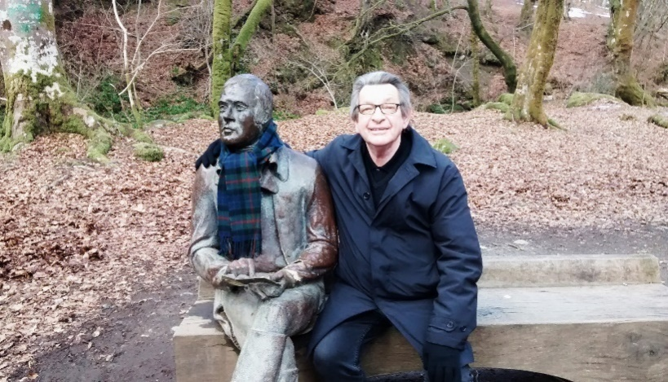

Hae Yer Say

We are planning on developing more Scots Literacy packs and to help us do that we would like you to phone or email your favourite jokes, Scots words, sayings, poems, songs and anything else you’d like to see include in future packs. My email and phone are below.

1. Did you enjoy it? If yes, what did you like?
2. If not, why not?
3. Anything else you would like to see in the pack?

Course material developed by Derek Suttie, Scots Literacy Tutor

Send your Scots words, jokes, poems, sayings, suggestions to:

[**Lydia.markham@ea.edin.sch.uk**](mailto:Lydia.markham@ea.edin.sch.uk)

**Phone: 07719 420 424**

Lydia Markham, Lifelong Learning Worker (Adult Learning),

SW Locality, City of Edinburgh Council.