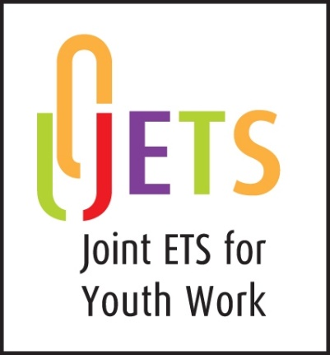

**INDIVIDUAL RECOGNITION PROCESS**

**ROUTE to** **PROFESSIONAL RECOGNITION in**

**YOUTH WORK and**

**YOUTH WORK IN COMMUNITY LEARNING & DEVELOPMENT**

### Form IR1

### EXPRESSION OF INTEREST

**A Co-operative Scheme of the UK & Ireland Joint ETS administered by its members: ETS (England), ETS (Wales), the North-South ETS (All Ireland), and CLD Scotland**

**APPLICATION FOR INDIVIDUAL RECOGNITION**

AS A QUALIFIED YOUTH WORKER

All applicants are required to complete the following information and provide evidence of being able to operate at a level expected of a newly qualified worker as detailed in section 2 of the Guidance document, ‘Individual Recognition Process’

#### PERSONAL INFORMATION

|  |  |
| --- | --- |
| **Title (Mr, Ms, Mrs, etc)** |  |
| **First Name** |  |
| **Middle Name(s)** |  |
| **Last Name** |  |
| **Previous/Other Name(s)** |  |
| **Correspondence Address** |  |
| **Country and**  **Post Code/Zip code** |  |
| **Telephone number (mobile or landline)** |  |
| **E-mail** |  |
| **Work Address if currently working in UK/Ireland** |  |
| **Post Code** |  |
| **Telephone number**  **(mobile or landline)** |  |
| **E-mail** |  |
| **Name of institution where qualification gained** |  |
| **Address and country of institution** |  |
| **Title of programme and qualification gained** |  |
| **Dates of study** |  |
| **Qualification content (if available, the preference would be for applications to be received with a full list of the modules studied)** |  |

Please state **in no more than 100 words** how your qualification equips you to be recognised as a professional Youth Worker in England, Ireland, Northern Ireland, Scotland, and Wales

|  |
| --- |
|  |

#### Details of your Academic Study

|  |  |  |  |
| --- | --- | --- | --- |
| Tick the box which describes your course of academic study | YES | NO | BRIEF EVIDENCE |
| i) The course of study undertaken was of at least three full academic years duration or the equivalent in part-time mode (or two years or part-time equivalent prior to 2010) |  |  |  |
| ii) At least 50% of the academic content of your course was in any one, or a combination of, sociology, psychology, social policy, principles and practice of youth work |  |  |  |
| iii) The fieldwork practice constituted at least 30 hours per week over 16 weeks for 2-year programmes or over 24 weeks for 3-year programmes or the pro rata equivalent for part-time courses. |  |  |  |
| iv) Over 50% of the fieldwork practice involved working with young people aged 11 to 25 with a focus on 13 to 19s. |  |  |  |
| v) The practice was undertaken in at least two or more different locations and included work with young people and development work with communities. |  |  |  |
| vi) The practice was supervised |  |  |  |
| vii) The practice was assessed. |  |  |  |

**NB.** Applicants who have followed postgraduate courses will be considered on the basis of the criteria set out above in sections ii, iv, v, vi, vii. For details on duration and fieldwork practice requirements please contact the relevant ETS agency to which you applied.

**No fee is required at this stage.** If your initial expression of interest meets the required criteria in the Guidance document for the Individual Recognition Process and you wish to proceed to Submission stage, you will be required to pay an appropriate non-refundable fee to accompany your submission.

Signed: __________________________________________________

Date: __________________________________________________



**Data Protection**

* Information that you provide will be used by the agencies participating in the Joint ETS Individual Recognition Process in accordance with each agency’s data protection policy and the Data Protection Act 2018. This information will be used by such agencies solely for the administration of the Individual Recognition process.
* You have the right to request a copy of the personal information held about you and can ask for it to be updated or deleted at any time.
* Information collected will not be disclosed to third parties outside of those involved in the Individual Recognition processes.