"COMMUNITIES EMPOWERED: MAKING IT REAL”
A masterclass with Steve Skinner

A Conference for CLD Sector Practitioners and Partners
Thursday 9 June 2016 – Camelon Education Centre, Falkirk

Name

Email
Telephone
Organisation
Post/Remit
Dietary or accessibility Requirements

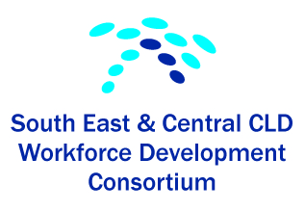
Please email your completed form to tsdadmin@falkirk.gov.uk

The South East and Central Workforce Development Consortium, in partnership with Falkirk Council are hosting a conference on Thursday 9th June with Steve Skinner as our guest facilitator
The day will have a balanced programme with inputs, discussion, case studies and examples of good practice, including community contributors. The event will have as its keynote speaker and main contributor Steve Skinner, who will also help us consider: -
- The different elements of the Community Empowerment Act and what it means for community development and community capacity building.
- The skills that workers and communities will need to take advantage of the Act
- How we can use the four building blocks of community capacity building in relation to the Act,
- What it could/should mean for community empowerment in practice.
- What roles we should have and how we can develop these
The event, therefore, is an opportunity for CLD workers to explore the challenges and possibilities implicit for us within the Community Empowerment Act, noting that these challenges and opportunities extend not just to workers, but also to communities.
Further information on Steve Skinner and his work on Community Capacity Building can be found on the internet at http://www.steveskinerassociates.org.uk/

