2020 issue

**Standards for Professional Practice Placement in Community Learning and Development.**

**Co-owned Support Resource Pack**

**DATE:**

**Guidelines for professional practice placement in Community Learning and Development**

**Contents** (needs update) **Page Number**

**1.**     **Statement from Minister** **3**

* Foreword 4
* Context 5
* Terminology 6
* Introduction - Purpose & Definition 7
* The benefits of a placement 8
* The Placement Partnership for Practice Learning 10

**2.**      **Who does what? ??**

* Checklist
* Feedback Form
* Flowchart (to be created)

**3.**     Standards for **Pre-placement ??**

* Pre-placement
* During Placement
* Post Placement

**4.**      **Standards for During Placement ??**

* Pre-placement
* During Placement
* Post Placement

**5.**  **Standards for Post placement ??**

* Pre-placement
* During Placement
* Post Placement

**6. What next for the Guidelines ??**

**Appendix 1     Resource links within the document ??**

**Statement from Minister needs to be redone**

In professions across education, health, social work and other human services, the essence of learning to do the job well is in grasping the link between theories and what actually happens when we work with people, their communities and the organisations that impact upon their lives. Models of practice come alive as they are tested in real life situations and our ability to have a positive impact on these events improves as we understand how our learning applies.

Like any profession, making the link between practice and academic learning is essential for Community Learning and Development (CLD) practitioners. CLD professionals require a wide range of skills and knowledge to encourage, share and deliver learning opportunities with diverse people and communities across informal settings to highly structured contexts. For professional CLD practitioners, quality and effectiveness depends on the rigour and critical awareness that comes from professional learning.

This is why these *Guidelines for Professional Practice Placement in Community Learning and Development* are important. Practice placements are the means by which academic and practice-based learning are brought together and it is hard to overstate the role that they play in developing competent CLD professionals. By advancing the quality of practice placements, we will improve the outcomes that CLD enables people and communities to achieve.

From the comments of Student CLD Practitioners, tutors and placement providers quoted in the document you will gain insight to the value placed on quality practice placements that benefits both Student CLD Practitioners practitioners and the learning culture of workplaces.

I therefore welcome this publication and look forward to seeing the impact of high quality practice placements as we work together to close the attainment gap and empower communities.



Shirley-Anne Somerville MSP

**1 Foreword needs to be redone**

**Quality as a concept may be hard to define but when we experience it, we absolutely know it. We share our story with others and are keen to model, repeat and enhance. Thus it is the notion of quality that sits at the heart of these Guidelines for Professional Practice in Community Learning and Development (CLD).**

**As the professional body, the CLD Standards Council for Scotland’s mission is to drive high standards of professional practice. In carrying out this mission, the Standards Council seeks to involve educational partners in communities and in further / higher education. Through the Approvals process, the CLD Standards Council continues to protect and promote the importance of placement within programmes of professional study in order to ensure that they fully prepare students for practice. The Standards Council places great importance in maintaining the 60/40% balance between academic and placement time.**

**Accordingly, further to a CLD Standards Council placement seminar, comprising practitioners, students and academics, the Professional Placement Review Group was formed. Building on the well-established placement system of strong co-operation and exchange, these Guidelines were developed to create a set of guiding principles for placement practice.**

**This document therefore offers a good practice guide for CLD Students, Placement Agencies and Educational Providers. It acknowledges the diversity of practices by considering what constitutes a CLD placement and defines the roles and responsibilities of everyone involved.**

**What follows is a comprehensive guide that promotes quality placement experiences for students, placement providers and educational establishments. This is essential as we aim to ensure that the communities of Scotland are served by experienced CLD practitioners who have undertaken quality professional learning. We should expect nothing less.**



**Marion Allison**

**Director of CLD Standards Council Scotland**

**Context**

Placements require a strong partnership between Student CLD Practitioners (SCP), the field of CLD practice (Placement Providers) and educational providers (EP).

The need for a resource which could reflect the diversity of placements and practice learning across Scotland has been identified for some time and it is hoped that this can provide support and contribute to on-going dialogue and developments. The need was identified by the educational providers to support the CLD Sector in their work with Student CLD Practitioners.

The aim of this pack is to clarify roles and responsibilities and promote consistent high quality CLD practice.

These national standards have been created by a range of practitioners from across the CLD Sector including academics, employers, students and placement supervisors.

A copy of these standards should be given to the Student CLD practitioner by the Education Provider as soon as they are accepted for the programme. This will allow time for them to familiarise themselves with the process and to plan for their learning experience. It should be emphasised that it is the student CLD practitioner’s responsibility to ensure the process/support/guidance happens throughout their learning programme. It could be considered that this pack performs as a “contract” between the student CLD practitioner, Educational Provider and the Placement Provider. This document must be included within the assessment of the Practice Placement element of the programme. This is a Standard within the Professional Approval Process.

 Template 1 Student CLD Practitioner Welcome Sheet

Further detail on how to use this pack is provided in section 2

# Definition of Terminology (review)

Over the course of many years the terminology used across education providers and the field of practice has changed therefore for clarity the following definitions will be used:

**Educational Provider:** Any organisation providing CLD learning. This could be a college, a university or independent training/learning provider.

**Field:** the settings where community learning and development practice takes place.

CLD Sector: ???????

Learner: the people/groups that students work with in the Community?

**Placement:** the setting and the time that Student CLD Practitioners are based in agencies and organisations in the field.

**Placement Provider:** an organisation with the ability to support a student CLD practitioner and who has agreed to the complete the plans and programme of learning associated with a practice placement.

**Practice Learning:** the learning that happens within placement.

**Practice Research:** the practice based action research projects carried out by students on placement.

**Programme:** needs definition

Supervised Practice: ?????

**Supervisor:** the agency practitioner who supports and assesses the student CLD practitioner’s ability, skills and professional competence whilst on placement.

**Tutor:** the Higher Education, Further Education or independent training/learning tutor who supports the student CLD practitioner with their continuing professional and academic development.

**Work-based Learning:** the context where a student CLD practitioner engages in a programme undertaking study which requires them to integrate learning primarily in their workplace.

**The above points on terminology should be read in conjunction with the refreshed Guidelines for the Professional Approval of CLD learning programmes (CLDSC, 2019 v9) and the Guidelines for Approval of CLD Learning Programmes: Developmental (CLDSC, 2017 v9.1)**

**Introduction**

**Purpose of this guide need to review this once resources etc available**

We recognise the range of roles and settings within the CLD Sector and the need for flexibility and consistency. This resource pack is designed to support the whole placement process and to create dialogue between all partners.

The resource pack is structured around sections aimed at Pre-placement, during placement and post placement and provides guidance on whether the student CLD practitioners, Educational providers or Placement Providers (Supervisors/Employers) will be involved at each stage. In this way we hope that partners will be able to appreciate the complementary roles that they play and the unique contribution that each brings.

For ease of reference there is an at a glance Checklist highlighting the roles of each partner at each stage of the process. These are titled:

- WS3_Pre placement checklist

- WS4_During placement checklist

- WS5_Post Placement checklist

These can be found in this pack or from i-develop

This pack should be given to the Student CLD Practitioner by the Educational Provider as soon as they are accepted onto the programme.

We have provided a Welcome letter sheet to support this. Template 1 - Student CLD Practitioner welcome sheet

It should be emphasised that it is the student CLD practitioner’s responsibility to ensure the process/support/guidance happens throughout their learning programme. It could be considered that this pack performs as a “contract” between the Student CLD Practitioner, Educational Provider and the Placement Provider. This document will be used within the assessment of the Practice Placement element of the programme.

**What is a Community Learning and Development Placement?**

Professional practice placement is a process of experiential and contextual learning which involves a partnership between the placement provider, the student CLD practitioner and the educational provider.

Professional education involves the provision of opportunities for emerging CLD professionals to develop a critical relationship to the theoretical concepts, philosophies, specific knowledge, skills, attitudes and values of the Community Learning and Development profession.

Professional practice placements in settings that represent the diverse scope of contemporary Community Learning and Development practice will help to prepare the student CLD practitioner for the multiple future roles that they may encounter upon graduation.

Placements take many forms (this list is not exhaustive):

* Full-time block placements take place over various time periods and involve the Student CLD Practitioner in an immersive professional experience.
* Part-time placements can take the form of an induction process or a longer term professional experience with fewer practice hours per-week.
* Work-based placements allow Student CLD Practitioners to use employment as a form of supervised practice.
* Research based internships or research projects
* And increasingly Educational Providers are looking at processes to support online/digital practice as Society moves their focus to this way of working.

**The benefits of a placement**

Providing an effective and rewarding educational experience for a student CLD practitioner can bring clear benefits for the agency and its staff and volunteers. The process of providing a placement often results in a two-way learning process in which the agency can learn as much about itself as the student CLD practitioner learns about the agency. Having a student CLD practitioner in the midst of your agency encourages reflection and a re-visiting of principles and practices that may have become habitual or institutionalised. Additionally, creating an optimal learning environment within the agency creates a space for everyone to learn and reflect in a collaborative, mutually respectful, open, flexible and supportive manner

Student CLD practitioners and Practice Supervisors can benefit by:

* contributing to the development of their professional education, supervision and leadership skills
* being prompted to critically reflect on their own practice
* being kept up to date with current theories and evidence
* supporting and enhancing the future of the Community Learning and Development profession
* providing opportunities to model sound professional and ethical behaviour
* increasing employability of the Student CLD Practitioner
* increasing organisational provision
* developing supervision and training skills

But don’t just take our word for it, here are some quotes from student CLD practitioners, Placement Providers and Educational providers:

*‘It provides students with the opportunity to put theory into practice, in real life situations. It is simple to read about how to deal with situations but things rarely happen that simply in the field. Furthermore, it provides students with the opportunity to experience the job first hand, decide if they like it, if they are good at it and how they would change it. It produces a more rounded worker.’* (Placement provider response)

*‘Acting as a sounding board for the Student CLD Practitioner as they learn about themselves, connect their practice to theory and compare/contrast their learning environment with their own working experiences.’* (Student CLD practitioner response)

*“Students who take time to build relationships and networks whilst on placement can use these later for further research and placement opportunities."*(Tutor response)

*‘Supporting students to meet competences: to make sure that if there is a problem, they tell the Student CLD Practitioner early enough for them to act on it and improve practice.’* (Placement provider response)

*‘Personally I feel that the most effective aspects of the supervisor’s role was the weekly support....This was very effective for me as it helped to ensure me that I was on the right track and hitting the deadlines on time. I feel that it was also effective for my supervisor as it allowed for them to stay updated on my progress and to ensure that I was working effectively.’* (Student CLD Practitioner response)

*“one of the most rewarding experiences happens when you hear practitioners and students talking about interesting and challenging practice that is making a difference in local communities."* (Tutor response)

*‘Placement - The work involved for the Student CLD Practitioner is representative of real life working experience. They are supported to work to a set of ethical standards, convert theory to practice and in addition meet placement organisational need. The Student CLD Practitioner experiences a diverse scope of community development work which helps them prepare for the varied type of roles that they could progress onto.  The organisation gains an opportunity to stay fresh and keep practices updated,  be challenged and allows the organisations to increase capacity to provide crucial front line services.’* (Placement provider response)

*“visiting the Student CLD Practitioner and supervisor in the organisation at the midway point of placement enables me to see how the Student CLD Practitioner is being supported, and importantly, how learning is taken place and evidenced"* **(Tutor response)**

**Placement Partnership**

**The diagram above shows how each of the partners connect with each other in a Professional Learning Context.** Each of the partners in the professional practice placement process has a particular role to play in ensuring the success of the learning opportunities offered throughout the placement experience. We provide this support pack as a means to ensure a consistent approach is taken by all educational providers, Placement supervisors and Student CLD practitioners. By putting the Student CLD Practitioner at the heart of the process we aim to ensure that Student CLD Practitioners are acting in a professional manner from the very beginning of their learning programme and are taking responsibility to support and improve the standards of that learning experience.

**WE may wish to revisit this section once the pack is complete!**

**2.**      **Who does what?**

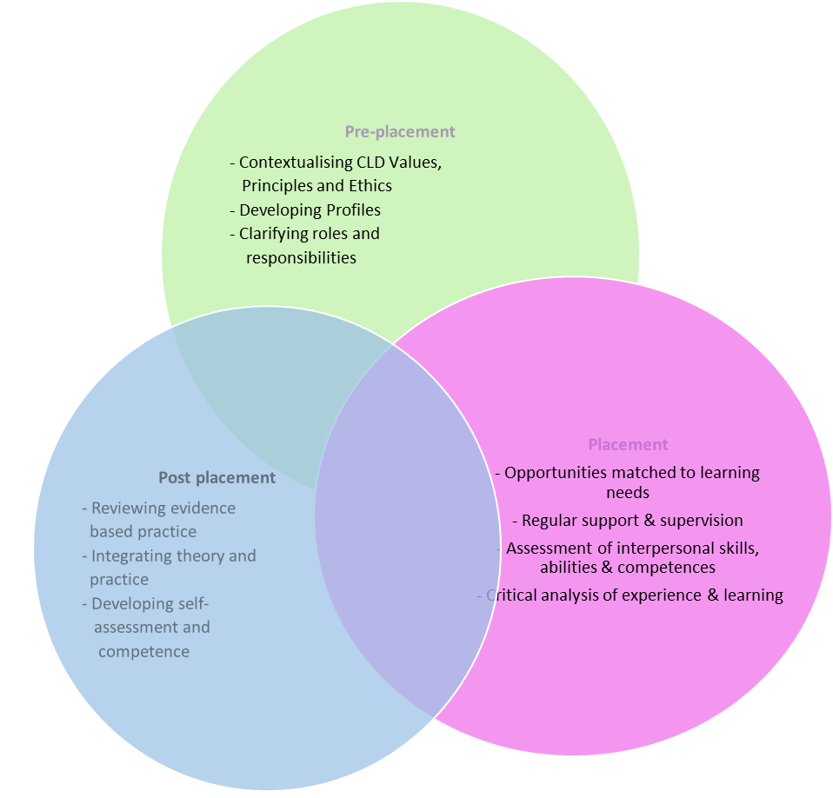

**In this pack we have provided some templates** **in the form of resources or worksheets** **to support the Practice Placement Process from beginning to end. Any lists within the documents should not be considered exhaustive and in fact if there are areas that you wish to be amended/added please send details to [contact@cldstandardscouncil.org.uk](mailto:contact@cldstandardscouncil.org.uk)**

**This pack is the property of the Student CLD Practitioner but must be shared with the Educational Provider and Practice Placement Supervisor.**

**Details of the resources within this pack are:**

**ONCE WE HAVE THESE FINALISED LIST TO BE ADDED**

* **Template 1 Student CLD Practitioner Welcome Sheet**
* ** Template 2_Before considering a CLD Practice Placement Student**



**Within each resource or template you will find a colour coding of who will be involved with each document.**

= Student CLD Practitioner

= Placement Providers

= Educational Providers

= Who does what? Do we need this?

= Documents/resources to support? Do we need this?

= CLDSC role Do we need this?

IF the educational provider, Student CLD Practitioner and Practice supervisor are required the bottom right corner of the document may look like this:

The dominant colour on top will be the one to start the process with the document and ensure it is completed. In example above it is the educational provider who will start off the work.

**3. Pre-placement**

The following are good practice points to be adopted during the pre-placement process.

**Pre placement NEED TO LOOK AT THIS**

For Student CLD Practitioners Template 3?

* Meet with their Tutor/Educational Provider to identify suitable professional practice placement opportunities that are attuned to their professional learning requirements.
* Meet with potential placement agencies/providers to determine compatibility negotiate and implement learning programmes with participants in the agency.
* Arrange an initial placement/practice visit where the Student CLD Practitioner and supervisor should discuss the practice learning experience and complete the agreement/plan and an agreed timescale.
* Undertake planning and preparation for the placement experience.
* Undertake an Induction and work within the practice agencies’ conditions of employment.
* Observe standards of behaviour and professional conduct required of them and adhere to the educational provider’s fitness to practise guidelines including CLD Code of ethics.

**For Placement Providers**

 **Template 2_Before considering taking a practice placement Student CLD Practitioner**

* Provide an outline of the professional learning opportunities offered by your agency.
* Participate in the supervisor development meeting/seminar where offered by the educational providers.
* Liaise with the Student CLD Practitioner and tutor to agree a practice learning plan and arrange induction see Template
* Keep in contact with the academic tutor (as required) about any concerns/queries or progress in fitness to practise. Placement Supervisors must be considered to be the gatekeepers of the standards of practice Template
* Provide a range of practice learning opportunities and a supportive environment in which to coach and support the Student CLD Practitioner in their learning and professional development. This must be included in the contract
* Carry out a risk assessment/checklist of duty of care for the Student CLD Practitioner whilst they are on placement.

For Educational Providers Put this 1st then Placement then Student

 Template 1 Student CLD Practitioner Welcome Sheet

* Provide this pack to student and explain it forms part of the contract between them, practice supervisor and you as the Educational Provider throughout the length of their programme.
* Pre-placement preparation for Student CLD Practitioners. Ensuring Student CLD Practitioners gain an understanding of professional standards and ethics. A **more detail/suggested checklist can be found** [**– here**](https://docs.google.com/document/d/1baHgombKmLY6fdSt9An3eWuEWZzi3PPS1AvVlnOkE6o/edit?usp=sharing) Full details of the URL are on page 22NEED TO REVIEW WHAT IS IN LINK
* Produce practice/placement guidance documents – handbook for Student CLD Practitioners and placement providers; placements forms, such as assessment forms; information on the placement review process; placement evaluation.
* Develop networks with the placement providers to secure quality placements and practice opportunities.
* Organise staff development opportunities for supervisors/tutors.
* Co-ordinate the placement/ practice learning and the assessment reports/feedback process by using templates available to support this.
* Establish clear lines of communication with the placement agency.
* Oversee the learner practice learning plan.
* Collate agency profiles to support the matching, visiting and negotiation of placements ensuring that you have permission to share this information with CLDSC.
* Provide pre-placement seminars for Student CLD Practitioners and practitioners.

**4. During Placement STILL NEED TO LOOK AT THIS SECTION**

The following are good practice points to be considered during the placement process.

**Links for further guidance on these areas –** [**can be found here**](https://drive.google.com/file/d/0B7b8EYXAkdI0RW5JWFUyRTc1a1E/view?usp=sharing) **.** Full details of the URL are on page 22

For Student CLD Practitioners

* Negotiate a work programme that reflects professional learning needs.
* Be prepared and participate in regular supervisory meetings.
* Be responsible for meeting the required amount of placement/practice hours.
* Liaise with your tutor and supervisor to arrange appropriate and relevant assessment during the placement.
* Explore linkages between conceptual frameworks and approaches to practice.
* Identify structured time to provide appropriate recordings about analysis of practice, project progress and areas for possible development.
* Share perspectives from their studies with their supervisors and wider team where possible.
* Engage in direct practice with participants in the field.
* Develop skills in planning and evaluation.
* Experiment with techniques of deliberation and reflection.

Draw from the range of key CLD indicators/competences and evidence practice accordingly.

**For Placement Providers**

* Meet the Student CLD Practitioner on a regular basis to give structured support, feedback and guidance.
* Complete the necessary practice feedback reports (assessed/non-assessed).
* Monitor, progress, attendance and timekeeping.
* Create opportunities for planning, implementing and evaluating CLD practice with individuals, groups and communities.
* Provide a learning environment where challenges for the learner are balanced with support from the supervisor, team and partner agencies.
* Undertake ongoing negotiation and review between Student CLD Practitioner and supervisor in relation to CLD competences/indicators and how these are being demonstrated and evidenced.
* Work towards increasing learners’ ability and application of reflective practice by developing and modelling praxis.
* Assess the Student CLD Practitioner and provide structured feedback around relevant and measureable learning outcomes.
* Give clear and timely feedback to any Student CLD Practitioner and educational provider if it appears that the learner is not meeting the standard to achieve a pass grade. Create a development plan where appropriate.

For Educational Providers

* Provide on-going Student CLD Practitioner and supervisor support, guidance and feedback on progress.
* Undertake visits as scheduled in the agreement/contract at start of each term/year/semester/unit as appropriate
* Undertake any necessary academic assessment and ensure that the supervisor is kept in the loop where any additional work is deemed to be required.
* Provide opportunity for any general issues to be raised by all parties.

need to turn this into a worksheet ??????

**This area is provided for you to make notes to support you in your placement and offers some prompts to start the dialogue with your Educational Provider and/or Placement Provider.**

**Move the following into one of the templates?**

As a Student CLD Practitioner what are your hopes, fears and expectations for your practice placement?

Do you understand your role within the placement setting?

Do you have an awareness of the principles and values of CLD, the Code of Ethics and Competences? Do you know how these will apply to your practice placement and how they will be assessed?

**5. Post Placement**

The following are good practice points to adopt Post placement.

**Post Placement:**

**For Practice Supervisors**

**For Student CLD Practitioners**

**For Practice Supervisors**

**For Placement Providers**

* Provide the necessary assessment report on placement and reflect on the process.
* Provide evaluation/feedback to educational provider on any improvements to the learning provision.

**Further guidance for Placement providers can be found [– here](https://docs.google.com/document/d/1tgBNspiey-9n1fap2SZhIqZ2jylA0vvXfgwvmebD_Ng/edit?usp=sharing)** Full details of the URL are on page 22

**For Educational Provider**

* Review placement learning process
* Create opportunities for Student CLD Practitioners to reflect on the placement and consider the impact of theory on their practice and the practice of the agency.

Provide an opportunity to discuss future practice learning opportunities.











**Feedback**

Having gone through this document and made use of it please let us know of any changes, additions or resources that you may find useful.

Email to [contact@cldstandardscouncil.org.uk](mailto:contact@cldstandardscouncil.org.uk)

**6. What next for Placement Guidelines**

This document will be made available on i-develop and resources will continue to be developed to support practice placement. The feedback opportunity above can be used by the field to make requests for changes.

**Some initial resources are included in the link** [**- here.**](https://docs.google.com/document/d/19yG_z6X8LLjo6LFIUSlamUVkqu2dAkzHp3jdmVF1nyI/edit?usp=sharing) Full details of URL can be found on page 22

**NEED TO DECIDE IF WE STILL WANT THESE AND WHERE TO INCLUDE:**

**Links for further guidance on these areas – [can be found here](https://drive.google.com/file/d/0B7b8EYXAkdI0RW5JWFUyRTc1a1E/view?usp=sharing)** Full details of the URL are on page 22

**Links for further guidance on these areas – [can be found here](https://drive.google.com/file/d/0B7b8EYXAkdI0RW5JWFUyRTc1a1E/view?usp=sharing)** Full details of the URL are on page 22

Appendix 1 NEED TO DECIDE IF WE STILL WANT THIS

Resource links within the document.

|  |  |  |
| --- | --- | --- |
| Page | Resource | Link |
| 11, 13, 15 | PRAXIS | https://drive.google.com/file/d/0B7b8EYXAkdI0RW5JWFUyRTc1a1E/view?usp=sharing |
| 12 | Resource for Practice Placement Providers | <https://docs.google.com/document/d/1tgBNspiey-9n1fap2SZhIqZ2jylA0vvXfgwvmebD_Ng/edit?usp=sharing> |
| 15 | Resource for Educational Providers | https://docs.google.com/document/d/1baHgombKmLY6fdSt9An3eWuEWZzi3PPS1AvVlnOkE6o/edit?usp=sharing |
| 21 | Initial resources | <https://docs.google.com/document/d/10GXn5TE7VW6Y0TNmAAdLMLR4NSo_J7Wb1_Sj36Z3bHA/edit?usp=sharing> |
|  |  |  |
|  |  |  |
|  |  |  |
|  |  |  |

With thanks to:

 

 

 

 