Instruction for west RIC

Login in to i-develop
Go to the West RIC group space -http://www.i-develop-cld.org.uk/course/view.php?id=163

Because you have been set-up as editors on this space you will have a GREEN turn on edit button
And also an Administration panel of options on the right hand of the screen
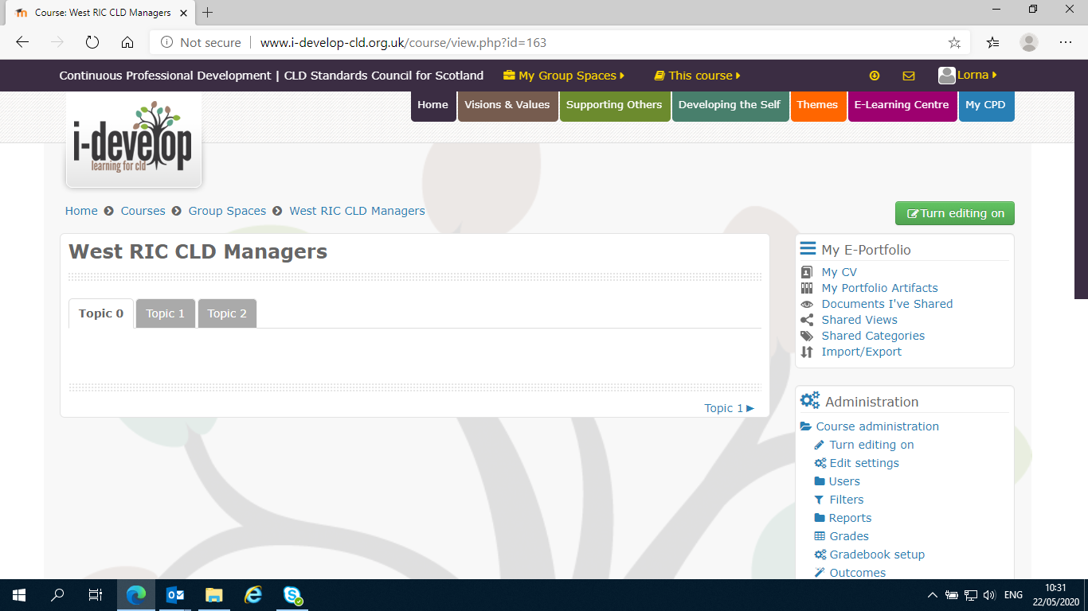

The Administration options let you ad other people, change their rights etc. – Suggest you leave this to Dominique if you are not familiar.

To edit –
When you click the green “”Turn editing on” button –it turns RED and changes to “Turn editing off”

A VERY iMPORTANT POINT – when you have finished editing you must click the RED “Turn editing off” button. IF you do not, you may loose your changes and even potentially cause the group space to corrupt and be lost entirely. Even if you have not made changes not turning the EDIT off might cause locking issues.
SO remember to turn off editing when done.

When you turn editing on various edit options will appear as below –

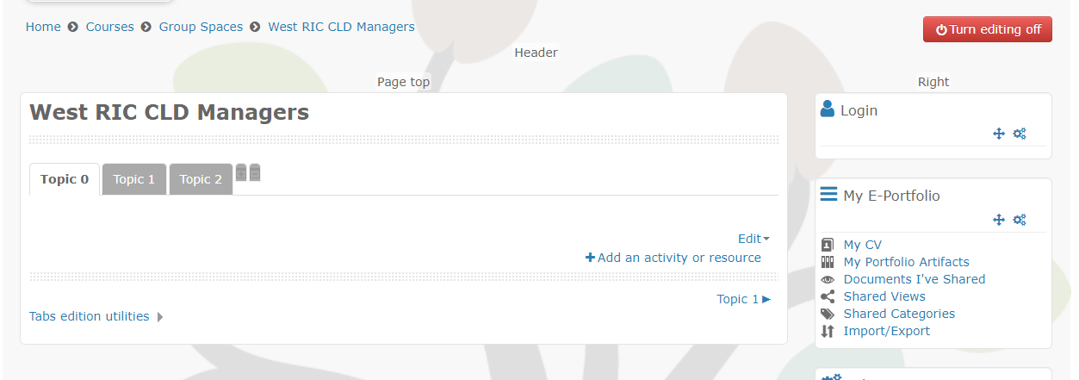

11

21

1 The Edit option presents a small drop down, the edit settings option lets you change the name of the tab (from Option1) and add some introductory text at the top of the tab if needed.

2 Add an activity or resource presents a pop up with options of different types of elements to add to you page. The ones you will most likely want to Add are
File , Folder, URL and Label. Label can be used to add headings and text.
( You might need to scroll down the list options pop-up in the to find these – you do this using the black bar between the list on the left and the description on the right)
You click the button next to the type of element you want, and then click the “ADD” button at the bottom of the pop-up.

Once you select a type of element you get a edit page to add details. You need to give it a title and you can add text which will appear on the finished page if you want.
For file and folder you can drag and drop a file or multiple files into the File area.

The text areas have fairly standards options for editing – Bold, bullets, heading level etc.

YOU MUST click the BLUE SAVE AND RETURN TO COURSE button which will be floating round the bottom of your window.

And remember when done – click the RED “TURN OF EDITING” button.

