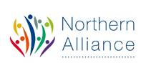
CLD delivery of Family Learning
case study

Making a difference through: Family Learning in Orkney
Community Learning and Development – key purposes
1.1. Community learning and development (CLD) has a powerful impact on the lives of learners and communities, supporting them to identify and work towards change. Whether that change takes place in an individual’s life, helps to create a resilient and enterprising community or contributes to better public services in a changing landscape, Scotland has a need for successful learners, confident individuals, responsible citizens and effective contributors working together to build a shared future. https://www.education.gov.scot/Documents/cld-regulations-la-guidance.pdf
Family Learning encourages family members to learn together as and within a family, with a focus on intergenerational learning. Family Learning activities can also be specifically designed to enable parents to learn how to support their children’s learning. The Northern Alliance are keen to capture case study examples of Family Learning activity from each of the 8 Local Authority areas to showcase Family Learning as a powerful method of engagement and learning.
https://education.gov.scot/improvement/research/what-is-family-learning

Here is an example of this practice:

Need for the project / activity why?

At the start of lockdown children and families seemed overwhelmed at what was happening with schools being shut, families being expected to home school and access learning online where possible. Therefore, from conversations with the community it became apparent that it would be beneficial to give families a pack that they could use as a family and have fun away from screens and the pressures that were happening around them.
CLD workers engaged with their local communities and identified a need for informal activities that parents, and children could engage in together, supporting attachment, increasing confidence and reducing boredom for families.
CLD workers recognised that during this time many more vulnerable families felt isolated, and many were lacking the skills to interact with their children in positive, fun activities which was affecting home life during the pandemic as well as the wellbeing and mental health of the parents and children/young people.

Description what and how?
The Community Resilience Fund was established by Orkney Islands Council, through hardship Funding from the UK Government, to support, among others, ‘Vulnerable isolated people and families, particularly those living in remote rural areas, families where a parent or both parents have lost employment or children living in poverty’.
The CLD team worked with the West Mainland Youth Achievement Group and Firth Youth Club to apply for this funding to purchase products to provide over 430 families across Orkney with Family Activity Packs full of interactive ideas for the whole family. Packs included: pens, pencils, paper, glue, scissors, colouring sheets, story books, recipes, puzzles, board game, outdoor games, seeds, upcycling ideas, time capsules, information from the Scottish Fire and Rescue Service, online Safety from Police Scotland and information on Youth Accreditation Programmes such as Hi5 and Dynamic Youth Awards.
Through working in partnership with schools across Orkney we were able to identify the young people and families in most need of receiving an Activity Pack. With support from local hauliers, the packs were transported to the Outer Isles and the CLD team delivered to mainland schools who distributed the packs to identified families.
The CLD team worked closely with West Mainland Youth Achievement Group and Firth Youth Club who secured the funding. Other partners included the Scottish Fire and Rescue Service, Police Scotland, Children and Family Services, Orkney Schools and local hauliers, all of whom contributed to the content and delivery of these packs. The success of this project is the partnership approach taken through the initial funding stages, through to the delivery of the learning materials to the families. Collaborative working to organise and arrange resources are two key elements of the CLD competencies which were central to this work, as was understanding the need and maintaining and developing relationships, which was pivotal at this time. This ensured that we could deliver learning opportunities in a range of different methods and contexts to improve outcomes for young people and their families.

Impact difference made

These packs were gratefully received from families from across Orkney. Especially in such an uncertain time for families and for children, it gave them a nice surprise and some focus for the children to receive some free resources to take some time out for themselves and as a family away from the fact that they were not able to do their normal routines, such as attend school, sports clubs, youth clubs etc.
The contents of the pack allowed families to engage together in learning and fun activities from cooking, to planting seeds in the garden, to quizzes or demonstrating their artistic flare through creating dragons from recycled material. This linked to outcomes around STEM, outdoor learning and the environment, encouraging people to engage in their outdoor spaces or have nature in their homes which has links to positive mental health. Whilst the cooking gave a focus for families to engage in fun activities, embedding skills for life whilst supporting attachment and positive behaviours between the parent and children. The pack also gave families the opportunity to discuss important life issues such as internet safety or the dangers of fire and safety awareness.
All the activities supported by the pack contents delivered learning and development outcomes for the wider family, be it numeracy or literacy skills, health and wellbeing or confidence building. For those who wanted to there was also the opportunity for young people to gather evidence toward accreditation through a Hi5 or Dynamic Youth Award, in conjunction with our youth work staff.
CLD staff offered additional support either virtually or through telephone calls, as required, to support families with what was in the pack and what they could do with it. Staff also provided support to those learners that were keen to complete the accreditation option.
Evidence how do we know?

Each pack included an evaluation sheet which we asked parents/ carers to complete. The CLD Team collated good comments and feedback through the evaluations and also through other feedback we received from further engagement opportunities. Parents got in touch to say thank you it was such a nice surprise for the children to receive this during these challenging times and spoke about it they took time out as a family to use the resources. They were also really appreciative of the fact that these physical resources meant they spent some quality time away from computer screens, learning and having fun both with siblings but also with the wider family.
Lessons learned?
With young people and parents spending a lot of time online attending classes, completing schoolwork and working from home, we hoped these packs would encourage families to learn together in a fun interactive way, away from their screens and give some downtime without adding any financial strain at such an uncertain time.
Although online activity has its place, feedback from this project highlighted that families also need the opportunity to learn and play together offline and these packs gave them the resource to allow this interaction.
As this was an immediate reaction to provide something, if we were to distribute something similar in the future, we would need to see how best to target those who received packs. We did this through schools as they know the families best and were very helpful in helping with the distribution, but some schools had different criteria for how they distributed these to families therefore we would need to be quite clear on this criteria for another time.
It would also be good to work out a more interactive way to gather feedback. Due to limited capacity, we relied on recipients returning questionnaires or gathering feedback from families we were already engaged with.

Images / learner quotes if available

“My children are ages 6 and 16. It was great for the 6 year old and fire safety for all. We used the materials to make cards for birthdays and being able to adjust the skipping rope to suit any age was great. It was well thought of and a super surprise.” Parent
“Just wanted to say a big thank you from my daughters. The activity packs are a big success!” Parent
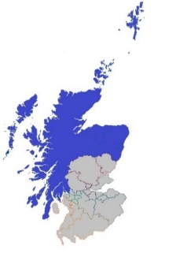
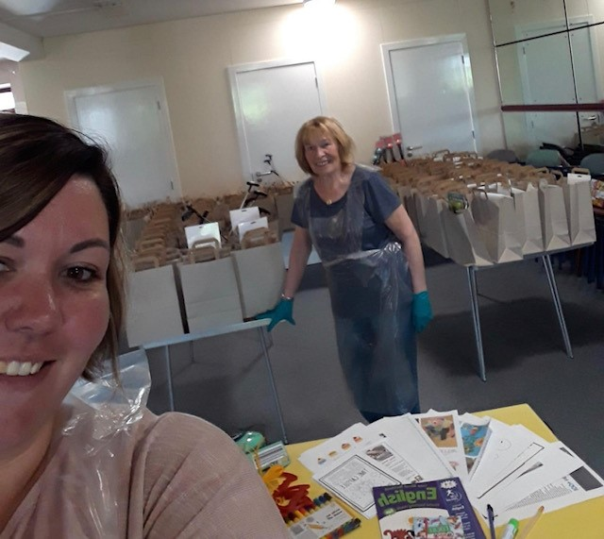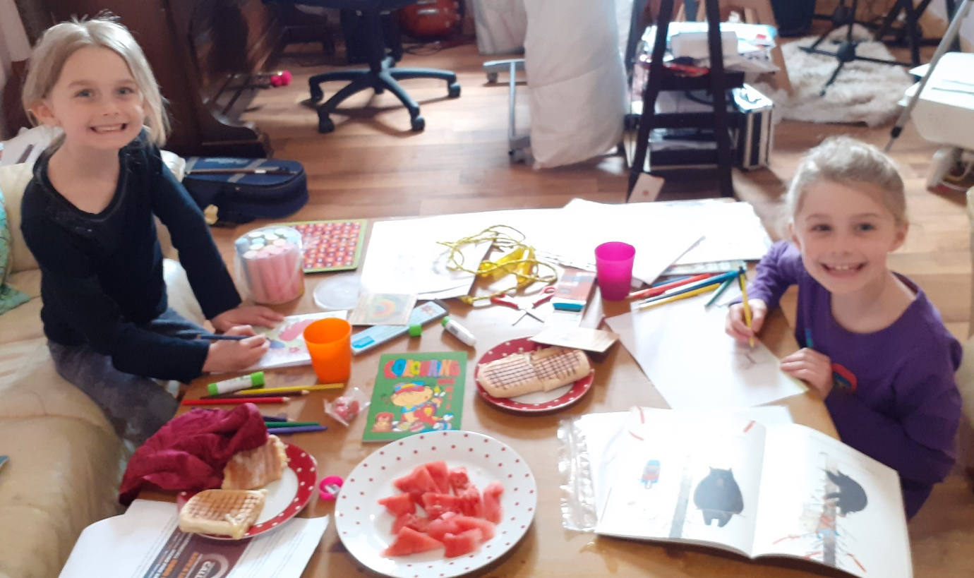“
Date: December 2021 Local authority: Orkney
https://northernalliance.scot
Community Learning and Development (CLD) Lead Officers coming together to deliver on the vision for the Northern Alliance across the geography of the North

