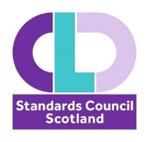
Family Learning National Occupational Standards review
Steering Group
14 October 2022
14:00 – 15:30

MS Teams
Join on your computer, mobile app or room device
Click here to join the meeting
Meeting ID: 336 631 276 548
Passcode: KrB9yc
Download Teams | Join on the web

 | Item | Papers/Links | Lead
1 | Welcome and introductions |  | KG
2 | Background to NOS, approach to NOS reviews |  | KG
3 | Review of Family Learning Functional Map | Course: Review of National Occupational Standards 2022-23, Topic: Family Learning (i-develop-cld.org.uk) | KG
4 | Review of Standards |  | KG
5 | Next steps - approach to governance and NOS sign-off |  | KG
6 | AOCB |  | All
7 | Date of Next meeting

