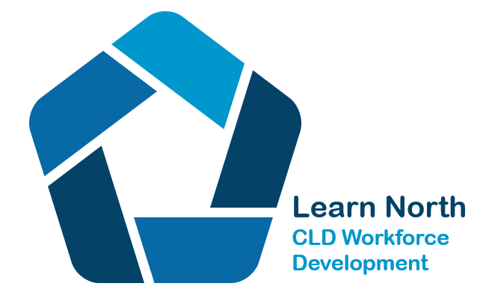
Supporting Community Learning and Development practice in the North of Scotland through professional learning

AGENDA
Date: Thursday 20th April
Venue: Teams

Agenda items:
1. Welcome and apologies
2. Minutes of last meeting and matters arising
4. Winter Learning Festival 2023
5. Financial arrangements
Proposal - Shared practise fund
6. Workforce Development
7. Newsletter: Feedback and future editions
8. Future Priorities
9. Local updates
10. AOCB

Future Meeting dates 2023 All still 1.00pm to 3.00pm
15th June
17th August
19th October
21st December (we can maybe discuss this one?)

