PASSING THE POWER TO PEOPLE AND COMMUNITIES
A Community Learning and Development Conversation
Hosted by the South East and Central Workforce Development Consortium
Wednesday 9th September
10.00 am till 4.00 pm
Edinburgh City Chambers, High Street,
Edinburgh
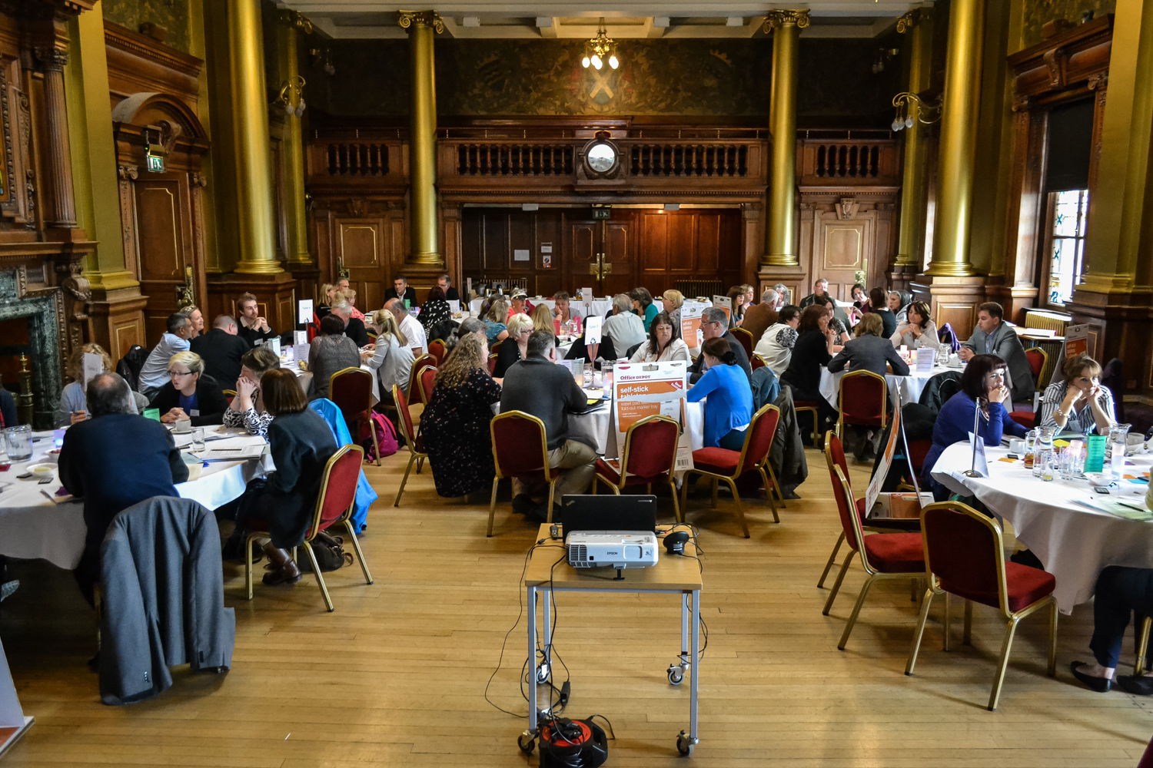
Report
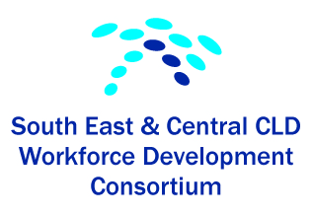

Welcome

It is with great pleasure that I present the summary report of the “Passing Power to People and Communities” event held on 9th September, 2015 in Edinburgh City Chambers.

This CLD conversation event was hosted by the South East & Central CLD Workforce Development Consortium and was planned and organised by a small working group consisting of additional representatives from Education Scotland and Falkirk Council.

The Consortium was set up in March 2011, and consists of representatives from the Third Sector and Local Authorities, stretching from the Borders to Stirling.

Our role is to provide:

- Continuing Professional Development for practitioners working in the CLD field
- Opportunities for networking and sharing practice

The” Passing Power to People and Communities” event was our annual Consortium conference for 2015. The focus of the event was to increase confidence, knowledge and understanding of the Community Empowerment Act, with speakers from the Scottish Government, Education Scotland and the Scottish Community Development Centre. The inputs were followed by table discussions on the opportunities and challenges that the Scottish Government’s community empowerment agenda presents to practitioners, organisations, and communities.

We launched our Community Activist Building Skills and Knowledge Training Resource Pack which has been developed by another consortium working group. Thanks to them for all their hours of hard work. The pack has generated much interest, with several local authority areas and voluntary sector organisations keen to be part of the next phase of piloting the pack.

The event generated much discussion around next steps and the Consortium will use this as the basis for forward planning and contributing to our Development Planning day in November 2015.

The event was very much a team effort, both prior to the event and on the day, so a BIG THANK YOU to all involved. We would also like to thank the staff at the City Chambers who provided an excellent service in a spectacular venue and to Education Scotland for contributing to the funding of the event.

In times of flux it is crucial to provide opportunities to strengthen our CLD workforce and to create occasions for conversations, networking and sharing practice.
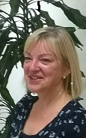
Diann Govenlock
Chair of South East & Central CLD
Workforce Development Consortium (East Lothian Council representative)

PASSING THE POWER TO PEOPLE AND COMMUNITIES
A Community Learning and Development Conversation
Programme
Time | Description
9.30 till 10.00 | Arrival and Registration and Refreshments
10.00 till 10.20 | Welcome and Introduction – Diann Govenlock, Chairperson, SE and Central Workforce Development Consortium  Introductory PP vote questions – Fiona McLean
10.20 till10.45 | The Community Empowerment Bill Overview  - Overview of the Bill  - Government approach to community empowerment / democratic renewal  - Participatory Budgeting / participation requests  - CLD role within Community Empowerment Bill  Jean Waddie, Bill Manager, Community Empowerment Unit, Scottish Government  John Galt, Development Officer, Education Scotland
10.45 till 11.05 | Community Empowerment and Community Engagement  - Challenges / Opportunities / Practice Research  Stuart Hashagen - Senior Community Development Advisor, SCDC
11.05 till 11.50 | Table Discussions  Challenges / opportunities  What opportunities and challenges does the Scottish Government’s community empowerment agenda present for communities?  In what ways can community learning and development practitioners respond to those opportunities and challenges?
11.50 till 12.10 | Feedback
12.10 till 12.30 | Launch of Community Activist – Building Skills and Knowledge “  Training Resource  Tricia Graham, Training Officer, CLD Service Falkirk Council  Sylvia Bradley, Community Activist, Westquarter Community Project
12.30 till 1.15 | Lunch
1.15 till 1.25 | Introduction to world café  Elenor Macdonald  Tables will be hosted by members of the Consortium & Passing the Power planning group members  Clark, Ian, Vicky, Fiona, Julie, Karen, Jim, John, Tricia
1.25 till 1.55 | World Café Discussion 1
1.55 till 2.25 | World Café Discussion 2
2.25 till 3.00 | Table Discussion 3
3.00 till 3.45 | Feedback maximum 3 points
3.45 till 4.00 | Evaluation / PP Vote  Fiona McLean  Final comments / summary / vote of thanks  Diann Govenlock
4.00 | Departure
Acknowledgements
The SE and Central Workforce Development Consortium would like to thank the following people for their contributions and support.

Passing the Power planning group
Diann Govenlock, SE and Central Workforce Development, East Lothian
Elenor Macdonald, SE and Central Workforce Development, Falkirk
Fiona McLean, SE and Central Workforce Development, Stirling
Jim Macdonald, Principal Officer, CLD Service, Falkirk
John Galt, Development Officer, Education Scotland

Guest Speakers
Jean Waddie - Bill Manager, Community Empowerment Unit, Scottish Government
Stuart Hashagen - Senior Community Development Advisor, Scottish Community Development Centre (SCDC)
John Galt – Development Officer, Education Scotland

A special thanks to
Sylvia Bradley, Community Activist, Westquarter Community Project
Adrian Moodie, Clerical Assistant, Community Learning and Development

The SE and Central Workforce Development Consortium would like to thank the following for supporting the development of the “Community Activist – Building Skills and Knowledge”, Training Resource:

Tricia Graham, Falkirk Council
Shona Keenan, West Lothian Council
Diann Govenlock, East Lothian Council
Jackie Mearns, Edinburgh City Council
Charlie Hastie, Falkirk Council
Tony Beekman, Falkirk Council
Kaela Scott, East Lothian council
Elenor Macdonald, Falkirk Council
Annette Lambourne, S.E and Central Workforce Development Consortium

Thanks to Education Scotland for contributing towards the funding for this event.

PASSING THE POWER TO PEOPLE AND COMMUNITIES
List of Attendees

FALKIRK
Alan Christie | Falkirk Council | Community Engagement Co-ordinator
Tony Beekman | Falkirk Council | Community Education Worker
Silvia Bradley | Falkirk Council | Community Activist
Tricia Graham | Falkirk Council | Training Officer
Charlie Hastie | Falkirk Council | Community Education Worker
Gail Johnston | Falkirk Council | Community Education Worker
Kate Kane | Falkirk Council | Local Community Planning Officer
Elenor Macdonald | Falkirk Council | Principal Officer
Jim Macdonald | Falkirk Council | Principal Officer
Frank McChord | Falkirk Council | Local Community Planning Officer
Ryan Topping | Falkirk Council | Community Education Worker
Suzanne Wood | Falkirk Council | Community Education Worker
Carol Ann Wright | Falkirk Council | Community Education Worker
John Burt | Falkirk Council | Community Education Worker
Adrian Moodie | Falkirk Council | Clerical Assistant

CLACKMANNANSHIRE
Mary Fox | Clackmannanshire Council | Youth Services Team Leader
Julie McGrath | Clackmannanshire  Third Sector Interface | Volunteer Development Officer  Consortium rep for Clacks
Karen Newbigging | Clackmannanshire Council | CLD Worker
Debbie Ross | Clackmannanshire Healthier Lives
Clark Whyte | Clackmannanshire Council | Adult Learning  Consortium rep for Clacks

STIRLING
Fiona Clark | Stirling Voluntary Enterprise
Linda Freil | Mercat Cross Community Council
Steph Lee | Raploch Community Partnership | Community Activist
Fiona McLean | Stirling Council | Culture and Quality Team Leader
Jo Polak | Stirling Council | Community Worker
Pauline Roberts | Stirling Council | Community Publicity  and Development Officer
Ronnie Robertson | Raploch Community Partnership | Community Activist
Gillian Taylor | Stirling Council | Customer Development Manager

WEST LOTHIAN
Joyce Baxter | Craigshill Good Neighbour Network | Treasurer
Anne Donoghue | Family & Community  Development West Lothian | Projects Manager
Susan Gordon | West Lothian Council | Community Planning  Development Officer
Julie Graham | Dedridge Good Neighbour Network | Co-ordinator
Jane Groves | Craigshill Good Neighbour Network | Co-ordinator
Derek Catto
Ruth Plevin
Mike Scott
Cheryl McLeod | Dedridge Good Neighbour Network | Coordinator
Sammy Saunders | Sunny Dale Association | Volunteer
Julie Smith | Fauldhouse Community  Development Trust | Project Manager
John Begbie | West Lothian College
Moira Mungall | Disability West Lothian

MIDLOTHIAN
Catherine Duns | Midlothian Council | Community Learning and  Development Worker
Miriam Leighton | Midlothian Voluntary Action | Community Empowerment  Project Worker
Karen McGowan | Midlothian Council | Lifelong Learning and  Employability Officer
Iain Murray | Scottish Government  Community Planning &  Empowerment Unit | Policy Officer
Jennifer Kelly | Edinburgh College | cld

EAST LOTHIAN
Caroline Davis | East Lothian Council | Dialogue Youth Coordinator
Diann Govenlock | East Lothian Council | Team Leader
Helen Harper | East Lothian Council | Community Development Officer
Sandra King | East Lothian Council | Area Manager  Community Partnerships
Margaret Macdonald | East Lothian Council | Community Development Officer
Katie Nevans | East Lothian Council | Community Development Officer
Kaela Scott | East Lothian Council | Local Community Planning Officer
Janice Thomson | Port Seton Management  Committee SCIO | Chair
Lori Tragheim | East Lothian Council | Community Development Officer

BORDERS
Clare Malster | Scottish Borders Council | Strategic Community Engagement Officer
Oonagh McGarry | Scottish Borders Council | CLD Team Leader (Adult)
Perrotine Orr | Borders Sport & Leisure Trust | Head of Active Communities

EDINBURGH
Helen Bourquin | City of Edinburgh Council | CLD
Pat Brechin | City of Edinburgh Council | CLD
Loraine Duckworth | City of Edinburgh Council | Services for Communities
Morag Grant | City of Edinburgh Council | CLD
Jackie Mearns | City of Edinburgh Council | CLD
Vicky Petrie | City of Edinburgh Council | CLD
Dinah Pountain | City of Edinburgh Council | CLD
Nancy Somerville | City of Edinburgh Council | CLD
Cath Tansey | City of Edinburgh Council | CLD
Callum McLeod | Edinburgh | CLD
Sheila Duncan | City Of Edinburgh | cld

GUESTS AND PRESENTERS
John Galt | Education Scotland | Presenter
Stuart Hashagen | Scottish Community  Development Centre (SCDC) | Presenter
Ann Kivlin | Education Scotland | Invited Guest
Alan Milson | Standards Council  for CLD in Scotland | Invited Guest
Jean Waddie | Scottish Government | Presenter

EAST DUMBARTONSHIRE

Claire Masson | East Dunbartonshire Council

EAST AYRSHIRE
Elaine Miller | East Ayrshire Council | Federation and Community  Council Development Officer

PASSING THE POWER TO PEOPLE AND COMMUNITIES
Community Activist – Building Skills and Knowledge “
Training Resource

The purpose of the training resource pack is to help practitioners to provide training and support for community activists and volunteers, to build on the underpinning knowledge and skills required to work more effectively in their communities and develop opportunities for growth and change.
It is an introductory level programme which can be delivered as a whole programme or be delivered on a more ad hoc basis depending on meeting specific group needs.
The training resource consist of four units:
- Exploring and understanding community activism
- Your community: Who they are and how do you reach them
- Taking control of what affects your community
- Putting it into practice
Included in the materials are: pre-course information materials, application process, reflection tools, tutor notes, self-study / background reading, research links, and a local project.
The programme is notionally levelled at SCQF level 6 in line with the other PDA qualifications relevant to our sector.
Update
Since the launch on the 9th September, the SE and Central Consortium has hosted a briefing day at Grangemouth Municipal Chambers which attracted 22 members of staff from local authority and third sector organisations. Participants were from the South East & Central Consortium areas and also from as far afield as Aberdeen City, North Lanarkshire, Perth & Kinross and North Ayrshire. Due to the level of interest we are considering the need to offer another briefing session.
Over the next 6 months we are planning to pilot and review the materials. To further support the development and production of the materials the Consortium has applied for a small grant to contribute to the costs for taking this forward.
We are currently working with the CLD Standards Council to explore the development of a group space on I-develop which will allow us to create a hosting platform for the Consortium to share relevant consortium materials and resources.
For further information please contact your Consortium area representative (see back page).

PASSING THE POWER TO PEOPLE AND COMMUNITIES
A Community Learning and Development Conversation
During our “Passing the Power” conversation, we held a number of table discussion / world café conversation sessions at various points of the programme hosted by facilitators and scribes.
Included in this report is a summary / reflection of key points raised by participants.
Table Discussion 1:
What opportunities and challenges does the Scottish Government’s community empowerment agenda present for communities?
In what ways can community learning and development practitioners respond to those opportunities and challenges?
Challenges
- There is a need for the Government to make sure the act is about more than just consultation. It needs to be about real involvement where views are seen to be taken on board and where public bodies commit to take account of the process and inputs. Transparency of decision making needs to be improved along with feedback to stakeholders on how and why decisions are reached.
- The rapidly decreasing numbers of CLD practitioners raises questions as to who will provide the necessary community development support to local communities and groups to take the requirements of the Act forward.

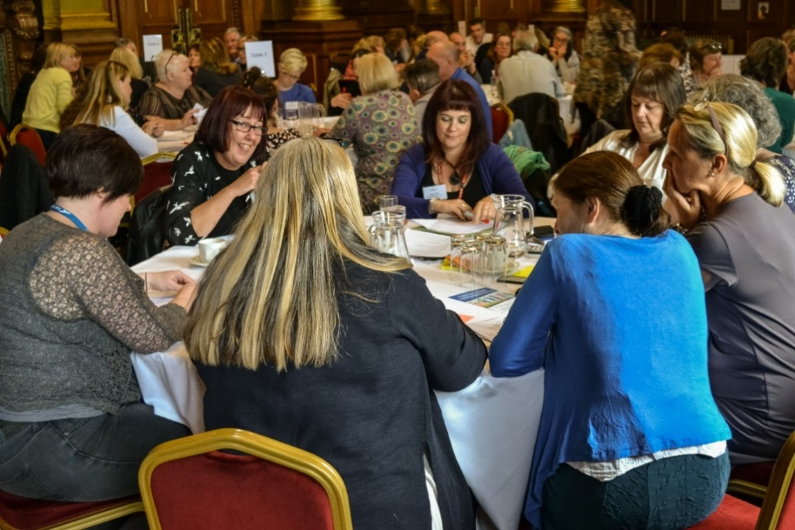

- To ensure that in supporting the transfer of ownership of assets to local community groups it is the right decision for the whole community and it is sustainable (financial sustainability; management sustainability, sustainability of community involvement; condition and maintenance of the asset). A comment was noted that the levels of participation can fall away the greater the level of involvement that is required.
- Equity and equality of access will be a major challenge to ensure that those in the most disadvantaged groups and communities have the support they require to enable their full participation.
- The austerity measures and budget cuts being imposed on CLD raises concerns about the capacity of all partners to participate in partnership and networking developments.
- There is a challenge in developing and implementing effective communication and awareness raising methodologies to ensure that communities and other involved groups are fully up to date with the act and its implications / opportunities.

Opportunities
- The Act provides a strong legislative base for the increased involvement of communities and community groups in decision making that affects them.
- There is an opportunity for Community Learning and Development deliverers to pro-actively support groups to increase the involvement of communities in decision making, and in improving outcomes and services. This could be achieved by CLD practitioners supporting groups in making participation requests, and by using community capacity building to develop community skills and increase social capital.
- Potential to use the Community Activists training pack.
- CLD practitioners have the opportunity to support local groups in taking forward community ownership of local assets.
- There is an opportunity for the development of local and neighbourhood partnerships and networking to provide a more joined up service delivery to local communities.
- CLD should look to involve schools in raising awareness of the Act with pupils, and in the development of volunteers as the next generation of community activists.
- There is an opportunity for examples and case studies of good practice to be shared along with resources such as I-develop, which support community development.
- Many people feel that in the past the focus of community development has been focussed on urban areas. This is an opportunity to engage with rural communities and to do things differently in terms of service delivery to meet needs.

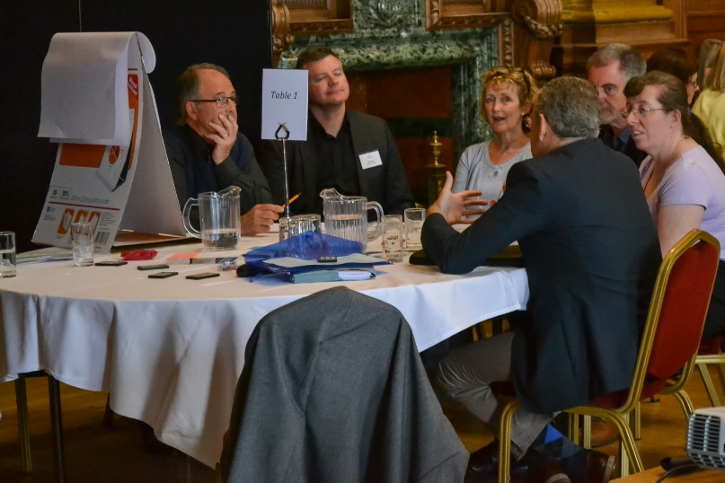
PASSING THE POWER TO PEOPLE AND COMMUNITIES
A Community Learning and Development Conversation
World Café Conversations (table discussions 2)

- Participation Requests - A Participation Request is “a request to take part in a process established by the (public service) authority with a view to improving an outcome of a public service.”
In what ways, and in what areas of CLD, can we as CLD practitioners support communities and community organisations to take advantage of this opportunity to participate in decision making processes?

- A capacity building programme to upskill groups at neighbourhood level should be put in place. (Role for community activist pack).
- Groups using participation requests need to be representative of their community (role for national standards for community engagement).
- Practitioners should work with local communities to develop their infrastructure to meet potential demands in relation to participation requests.

- From “Having a Say to Having the Power” - We are in a period of diminishing resources, yet one of increasing recognition of the role of CLD, particularly in empowering local communities. This might be seen as an opportunity for CLD to get back to its roots in community development.
How do we move from communities “having a say” to taking more responsibility/having the power?

- Community development is not always about a “quick fix”. To take communities and groups and organisations from having a say to having the power is a longer term project which requires sustainability of support throughout the process.
- Information can mean power and as practitioners we should ensure that local communities and organisations have the means to access the information they require, and in language that they can understand.
- CLD partners should not be supporting tokenism in relation to community participation. Arnstein’s model of participation was seen as a good reference point.

- Skills Development and Professional Learning
What do you envisage as the priority areas for training and workforce development to enable practitioners and community activists to achieve the desired outcomes of the Community Empowerment Bill and the National Standards for Community Engagement?

- There needs to be clarity about roles and responsibilities for providing workforce development, particularly in times of budget cuts and diminishing resources.
- There is a need to undertake a skills audit to inform and shape a responsive training programme for CLD and partners.
- Continue to develop and deliver training on engagement methods bearing in mind the current review of the national standards for community engagement.

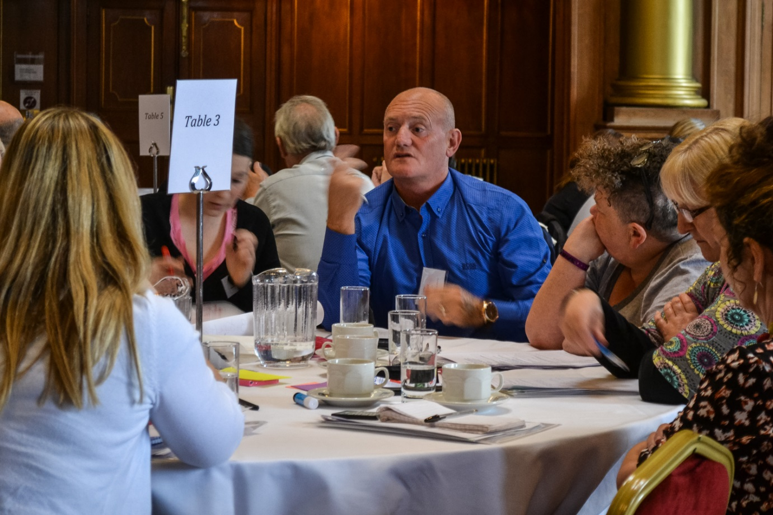

- Change
What needs to change, nationally and in your area or sector, to strengthen the community development and community capacity building support offered to communities?

- It was commented that there can be a tendency to produce an endless stream of strategy documents that mean nothing in reality, therefore a clearer vision of what community planning will look like on ground is needed.
- The statutory support for CLD is too loose and inconsistent in implementation, and needs to be strengthened as it will always lose out compared to employability or formal education.
- CLD needs to identify and be clear about the crucial role of community development and community capacity building in its delivery. This could also help to enhance the profile of CLD.

- Community Ownership of Resources - Community ownership of assets is seen as a key enabler for community empowerment.

What do you consider to be the benefits and risks for?
Communities?
Local Authorities?

Benefits?
- There are very good examples of positive outcomes stemming from community ownership of resources. Some of these are linked to sustainability and food such as the Community Farm in Arran, and the provision of local allotments.
- Community ownership can enable local management to set policies for the use of facilities and to respond timeously to local needs and demands.
- Community ownership will enable local development without the constraints placed on local authorities and in some places can provide employment opportunities.
Risks?
- Assets can be transferred for the wrong reasons such as a money saving exercise for the local authority and on the basis of “take it on” or “lose it”. This can be disempowering rather than empowering.
- Resources can be transferred that are not fit for purpose, transferring to the community what is a liability and a burden rather than an asset.
- Sustainability of management needs to be careful considered beyond the group of people who initially take it on.
- Safeguards are required to ensure that all community groups get the same level of access.

- Equality of Opportunity
What can CLD practitioners do to ensure that less empowered communities or communities of interest have equal access to the opportunities that the legislation presents?

- CLD practitioners should take time to plan and focus resources on how we enable different groups and individuals to get involved. There should be a focus on inclusiveness.
- CLD should create the right environment for less empowered communities or communities of interest to become involved, e.g. access to the internet, creating community spaces, inter-generational activities.
- We should recognise that working with more deprived communities takes time and not assume that short bursts of support will always be the answer.

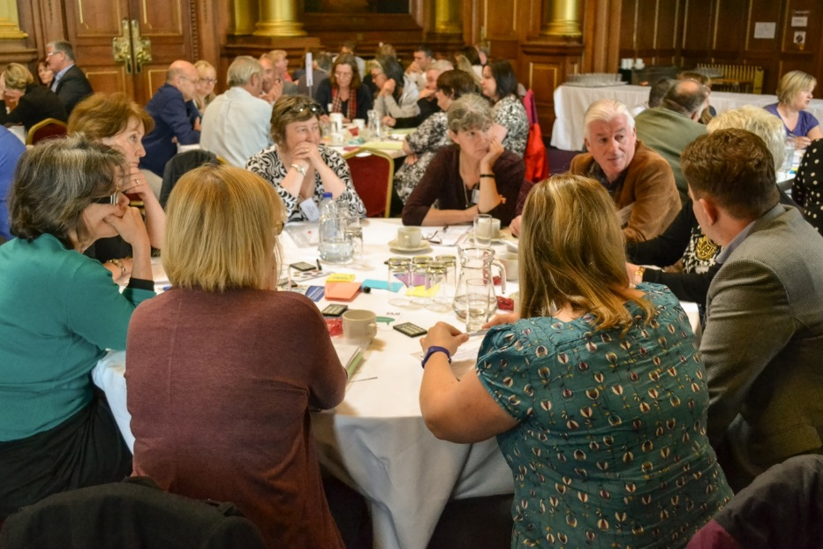

- National Standards for Community Engagement
In light of the shift from engagement to empowerment, should the National Standards reflect this too? If they were to become the National Standards for Community Empowerment, in what way could they be designed to help communities get more power and confidence to shape their own futures?
- Engagement isn’t seen as a “people” word, therefore the national standards for community empowerment might have wider acceptance, although it has to be recognised that engagement can be seen as a means of leading to empowerment.
- Empowerment should emphasise the necessary shift from short-term funding towards long-term sustainability for community organisations.

- Suggested focus of new / revised standards should be on long-term sustainability of community initiatives and organisations as well as accountability and collaboration.

- Participatory Budgeting
What impacts can Participatory Budgeting have on communities?

- Participatory budgeting promotes an increased sense of ownership within communities and can also develop increased community cohesion through a shared agenda.
- It increases communities’ awareness of Council budgeting processes and the cost of some Council Services.
- Actions may be taken forward that the Council might miss, but there is a danger that vested interests and groups who shout the loudest might get their agenda progressed at the expense of others.

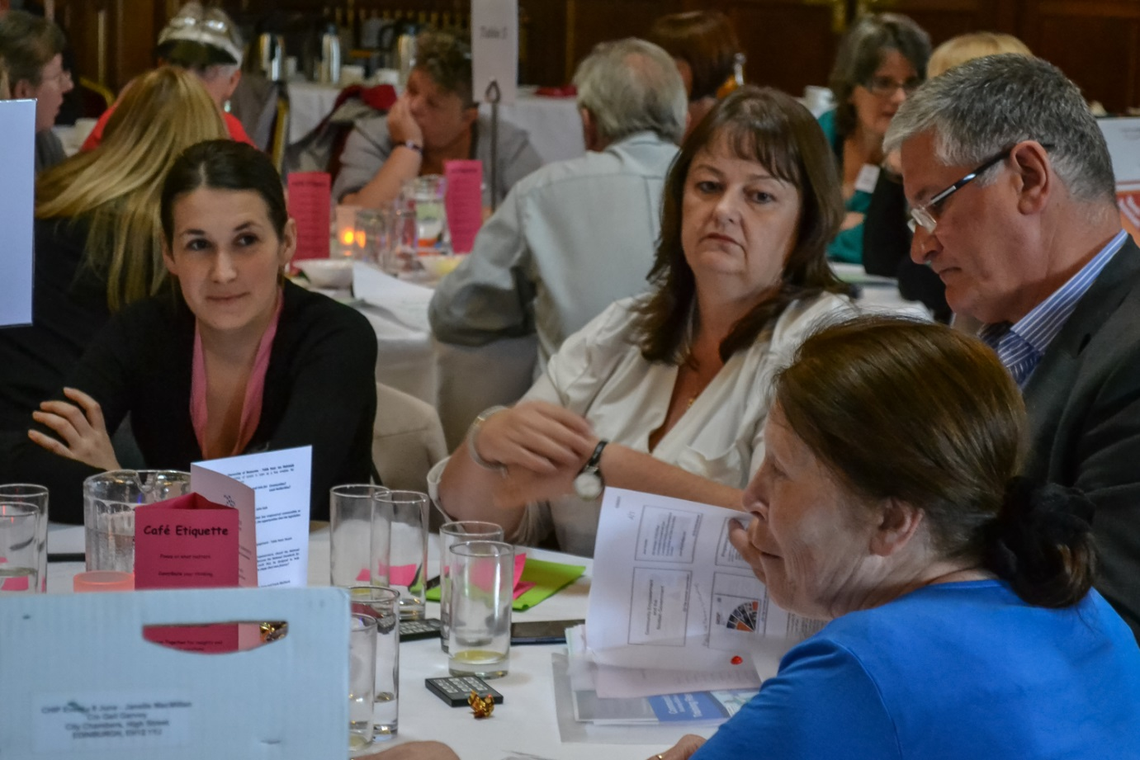

Table Discussion 3

In light of what you have heard and discussed today, what are the next steps?
- For you as an individual?
- For your organisation?
- Local area?
- Nationally?

For you as an individual?

- Read the Act and further improve personal knowledge and understanding of the Act and its implications for CLD.
- Take information back to other CLD staff, community groups, partners and other Council staff to develop their awareness of the Act and its potential.
- CLD practice is about community engagement and capacity building. We can use the Government’s emphasis on community empowerment and democratic renewal as an opportunity to refocus what we do.
- Individual practitioners should refresh their community engagement and capacity building skills.
- Look for opportunities for joint learning with communities – CLD practitioners and community activists learning from each other and building their skills together.
- Become members of the CLD Standards Council.

For your organisation?

- Pass on information to CLD Partnerships and initiate discussions on what actions they should be taking.
- Prepare a report and input this with recommendations into local authority committee processes.
- Hold awareness raising staff seminar.
- Prepare summary of main points, as jargon free as possible, for distribution to staff and groups.
- Ensure staff are seen to be raising the Act with community groups.
- All organisations with CLD practitioners should maintain and develop their role to support community empowerment and democratic renewal – including youth work and adult learning organisations.

Your local area?

- Develop and implement a programme of awareness raising sessions for community organisations and individuals.
- CLD Partnerships should consider / review their role and prepare list of actions for inclusion within action plans.
- Colleges to identify their role in relation to the Act and to progress this through CLD Partnerships.

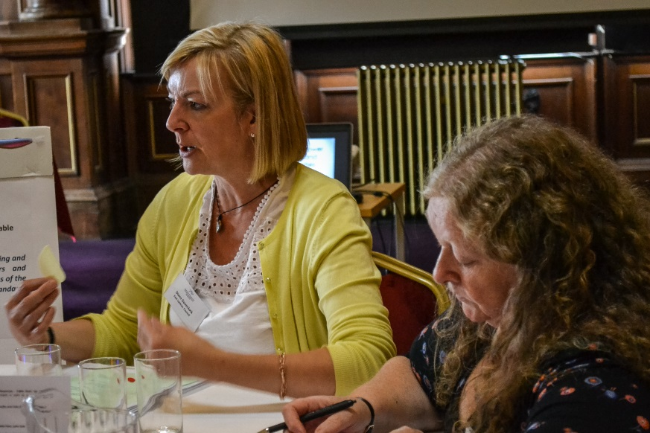

- Community Activists Training Pack to be used to raise awareness of the Act and its links to community activism.
- Encourage schools to include awareness and implications of the Act as part of their curriculum and links to active citizenship. N.B. for all pupils, not just those who aren’t seen as academic.
- Local authorities and their partners need to make sure that their CLD plans direct staff and resources to support community empowerment and democratic renewal. This support should be clearly targeted at less affluent/ less empowered communities.
- Local authorities and their partners need to engage with the community sector in their area to promote/discuss/support the new opportunities available through the Act.
- Ask managers to provide an opportunity to bring together CLD and Community Planning staff to discuss how we can implement the Community Empowerment Bill.

Nationally?

- Education Scotland to include the report of this conference in its E-Bulletin.
- Education Scotland to develop opportunities for the sharing of good practice in relation to the Act.
- Education Scotland to take forward the proposal to include the Act and its implications as part of the Modern Studies curriculum in schools.
- Standards Council to develop the use of the I-Develop initiative to include awareness raising and the sharing of good practice and information.
- Education Scotland to consider an in-depth skills audit of CLD practitioners.
- The Government should publicise their timeline for implementation of the Act
- The Government & Education Scotland need to re-emphasise to Community Planning Partnerships (CPPs) and all Public Services that they expect them to allocate staff and resources to support community capacity building in less affluent/ less empowered communities. The planned guidance to CPPs on the Act will be the opportunity to do this.
- Education Scotland & the CLD Standards Council should develop and publicise more good practice examples of CLD practitioners supporting community empowerment in less affluent/ less empowered communities.

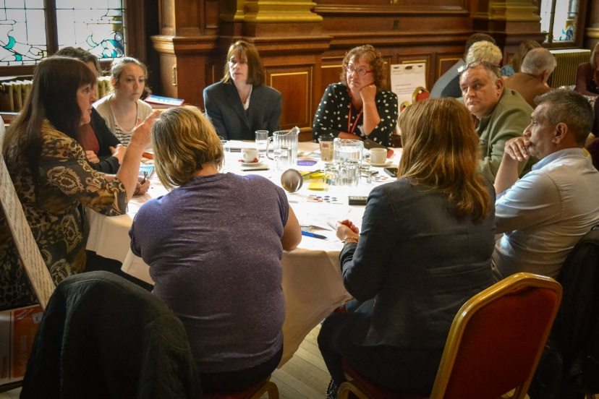

We are currently working with the CLD Standards Council to explore the development of a group space on I-develop which will allow us to create a hosting platform for the Consortium to share relevant consortium materials and resources.

The South East and Central Workforce Development Consortium would like to thank everyone for attending this event and look forward to seeing you at future events.
The full notes provided by table hosts and facilitators, on which this report is based are available on request from elenor.macdonald@falkirk.gov.uk
Copies of the presentation materials will be placed on the conference space on i-develop.

PP Vote Questions

How would you rate your current knowledge/understanding of the Community Empowerment Act?
Morning

How would you rate your current knowledge/understanding of the Community Empowerment Act?
By the end of the event

As a member of your own community, do you feel that you have the power to influence decision making in your community?
Morning

Following today’s conversation do you feel that the measures in the Community empowerment Act increase opportunities for local communities and individuals to become more involved?
By the end of the event

How many here today have registered for the Standards Council for CLD in Scotland?
Morning

How many here today now intend to register for the Standards Council?
By the end of the event

Did you have the opportunity to share practice that contributes to community empowerment?
By the end of the event

Did you have the opportunity to reflect and consider your own contribution to community empowerment?
By the end of the event

Did today help identify our local and national priorities for workforce development?
By the end of the event

Do you think today will help to inform national and local policy development?
By the end of the event

PASSING THE POWER TO PEOPLE AND COMMUNITIES
South East and Central Workforce Development Consortium – membership
- East Lothian, Diann Govenlock (Chair)
- City of Edinburgh, Vicky Petrie
- Clackmannanshire, Clarke Whyte and Julie McGrath
- Midlothian, Karen McGowan
- West Lothian, Ian McIntosh, Derek Catto
- Falkirk, Elenor Macdonald
- Scottish Borders, Oonagh McGarry, Norrie Tait
- Stirling Council, Fiona McLean
