

  

Community Learning

& Development Plan 2015-2018

[www.cldplanning.com](http://www.cldplanning.com)

**Quality Improvement Guidance**

**Improving Quality is Everyone’s Responsibility**

**Index**

Introduction

Partnerships

Roles and Responsibilities

Process Mapping: Planning Cycle, Delivery, Review, Self-evaluation, Reporting & Improvement Planning

Quality Indicators & Quality Assurance Frameworks



Quality Improvement is a never ending process.

Our aim is to achieve the best possible outcomes for local people by delivering the best quality services designed to meet their needs.



Resources/tools

Introduction

This document sets out the processes required to ensure effective management of the CLD plan; to provide evidence of outcomes and the impact of the plan itself.

It also sets out the frameworks and tools that can be utilised to ensure that systematic, robust self-evaluation and improvement planning takes place.

***The Requirements for Community Learning and Development (Scotland) Regulations 2013 (the CLD Regulations)***

**West Dunbartonshire’s CLD Plan was published on 1st September 2015.**

**It is administered by West Dunbartonshire Council’s Working4U Service**

**and can be found at** [**www.cldplanning.com**](http://www.cldplanning.com)

Partnerships

Locally the delivery of the Strategic Guidance and Regulations will be progressed on behalf of Community Planning West Dunbartonshire (CPWD) through three key partnership models:

**\* Adult Learning Partnership (ALP) * Youth Alliance (YA) * Your Community**

These partnerships sit within CPWD arrangements, reporting through the Delivery & Improvement Groups which underpin the partnership and the Single Outcome Agreement. The **Your Community** element of the plan is managed by WDC CPP Team. This guidance is designed to support the management of the Plan for **ALP & YA**.

**Based on a robust needs assessment the Partnerships have identified key priorities:**

**ALP** Work Life: Adult Learning is the key to employability.

Personal Life: Adult Learning is essential to enable and encourage adults in Scotland.

Community Life: Effective adult learning is at the core of a Scottish knowledge-based society.

Family Life: Adult Learning within the family provides modelling for children and young people.

**YA** Skills for Learning, Life and Work (including 16+ employability) young people.

Health & Wellbeing - Early Intervention and Prevention “Substance Misuse” (young people 11-25).

Involvement, Consultation and Representation (young people 11-25).

Roles and Responsibilities

West Dunbartonshire Council’s Working4U Service (W4U) has overall responsibility for meeting the legislative requirements and being Administrators of the Web Planning Tool ([www.cldplanning.com](http://www.cldplanning.com)). In planning for improvement, W4U will regularly review the skills and training needs of partners and provide training and support where required to ensure the best outcomes are achieved.

**Roles and responsibilities** for **Administrators** and **Users** of the tool are set out in a Protocol document *(Appendix 1).*

W4U objectives set within the plan to manage Performance and Workforce Development are to:

* Improve performance and services ensuring that legislative and inspection requirements are met.
* Ensure that current partnership arrangements for planning, monitoring and evaluating are fit for the purpose as set out in the Regulations guidance.
* Ensure that learners and communities achieve the best outcomes possible through improved partnership working and better co-ordinated services.
* Increase the capacity of staff and partnerships to manage the plan effectively ensuring joint self-evaluation in the delivery of high quality CLD opportunities.

**Each Partnership has established its own terms of operating:**

Adult Learning Partnership set its out in the Terms of Reference. *(Appendix 2)*

Youth Alliance set its out in the new Operational Structure Chart. *(Appendix 3)*

Additional roles and responsibilities will be agreed and adopted as the plan progresses and partner agencies take on the delivery of objectives, actions and activities.

Process Mapping

**Self-evaluation** will be embedded where it will be most effective and not just a one off exercise occasionally. YA & ALP will establish this using the quality assurance frameworks, tools and resources supplied.

**Measuring of Outcomes** can be achieved by using a range of tools. A systematic approach to gathering this information will be researched by YA & ALP and appropriate measuring tools adopted by 31/8/16.

**Performance** will be measured partly against Performance Indicators (PI’s) established within the Single Outcome Agreement; also by meeting milestones/targets. Year two of the plan will be when PI’s can be established using baseline information gathered in year one.

**Baseline information is** to be established by both YA & ALP who will be responsible for gathering baseline data relevant to each objective from April 16 – March 17 unless already available (from April 15-16).

**Reporting** will be to the relevant Delivery Improvement Group (DIG) within the Community Planning structure. Twice yearly progress updates and twice yearly full reports. Progress updates can be input to the planning tool anytime.

**Updating the Plan** will happen by having a review every six months from 1st September 2015**.** Operational groups willfeedback to wider partnerships and minutes will be taken to record the review feedback. A review will include updating any documents or links as well as progress against actions/activities and changes to the Risks section. The overview template will then be updated by the Administrators and published annually in April.

Quality Improvement Process Map

Quality Assurance **Frameworks**

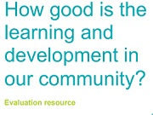

**Why use this resource?**

* It helps those adopting a CLD approach to their work understand what they are doing well and what they can do better.
* It will support you to understand and improve the impact you are making.

**A note about the term ‘self-evaluation’.**

*“This term is used to cover the way in which individuals, groups and partnerships explore their progress and identify what has improved and what still needs to improve. It is a way of using evidence to assess achievements, success and areas that require action. It is never an end in itself but a means to inform action which will lead to increasingly positive impacts on the people and communities you work with”.*

**How to use it.**

*“As you look through the document you will see a number of quality indicators which focus on specific areas for improvement. They will help you identify your strengths and areas for improvement. They will help you understand the difference you are making and what you need to do next. They are designed to support you in thinking about how well you use resources and ideas from elsewhere and plan for coming changes”.*

<http://www.educationscotland.gov.uk/Images/how-good-is-the-learning-and-development-in-our-community-v2_tcm4-875684.pdf> (11/5/16)

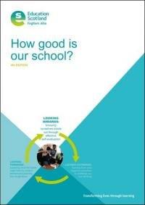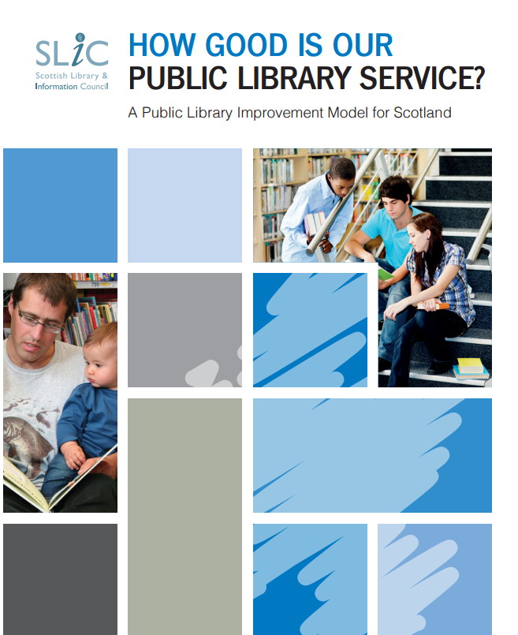



Education Scotland quality framework for

the external review of Scotland’s colleges,

updated August 2012

<http://www.educationscotland.gov.uk/inspectionandreview/Images/QFAug2012_tcm4-727419.pdf>

**Resources/tools:** How Good is Our CLD Plan – Self Evaluation Template Example *(Blank version Appendix 4)*

|  |  |  |  |  |  |
| --- | --- | --- | --- | --- | --- |
| **QUALITY INDICATOR Impact on learners ( 2.1 from HGI The Learning & Development in Our Community)**  **Theme:** Improving learning, health & wellbeing and outcomes. | | | | | |
| **Key question:**  How well do we meet the needs of learners? How do we know? | | | |  | How good do we think we are? |
| **Key areas** | **Evidence** | **Strengths** | **Areas for Improvement** | **What difference have we made? Evidence of Impact:** | **Rating (1 – 6)** |
| Targeting hardest to reach | Quantitative data  Equal opps data | Availability of local data. Key partners round table sharing information | Finding out what hard to reach learners say their needs are. |  |  |
| Achieving & attaining | Quantitative data  No. of awards | Access to baseline data | Co-ordinate delivery of awards. |  |  |
| Reducing barriers | Qualitative data  Evidence of progression | Access to Crèche  Enabling leaners to identify their own barriers to learning | Sharing information with wider agencies to improve learner’s experiences and further reduce barriers. |  |  |
| Positive destination | Quantitative data  Tracking | Young peoples data (SLDR) | Systematic gathering of impact/destinations for adults |  |  |
| **Identifying Areas of ‘Good Practice’ to Share – Self Evaluation:**  Shared CPD with schools to support increasing attainment & achievement (Youth Achievement Award training for school staff delivered by Partner agency) | | | | | |
| **Review Notes:** Storing qualitative data is a difficulty. Need to find examples of good practice in how this is done. Most of the areas for improvement are achievable in short to medium term. A funding review for crèche provision could result in reduced services. Need to explore alternatives.  Overall Impact is good and is supported with robust evidence, both qualitative and quantitative. Aiming for very good next time. Next review date in 6 months time. | | | | | |

**Planning and Self-evaluation information/tools/resources:**



[www.cldplanning.com](http://www.cldplanning.com)

<http://www.scdc.org.uk/what/LEAP/> (Planning cycle based on LEAP)

<http://www.youthlinkscotland.org/Index.asp?MainID=20153> (National Youth work Outcomes)

<http://www.cldselfevaluationtoolkit.co.uk/>

<http://www.evaluationsupportscotland.org.uk/resources/tools/>

**Community engagement:**

<http://www.scdc.org.uk/what/national-standards/>

Appendix 1 – Protocol



West Dunbartonshire Council’s Working4U Service (W4U) partly own the rights to a Web Based Planning Tool [www.cldplanning.com](http://www.cldplanning.com) which has been approved for use by the Youth Alliance and Adult Learning Partnership to capture their contribution to the CLD Plan for West Dunbartonshire in order to meet the ***Requirements for Community Learning and Development (Scotland) Regulations 2013.*** This document sets out the protocol for use of this website.

**Site Administrators**

As West Dunbartonshire Council’s Working4U Service has responsibility for managing this website, having developed it, the service will retain the **administration rights** which give them access to customise and personalise the web plan template.

**Administrator roles and responsibilities**

* Ensure that the plan is managed appropriately and that all users are aware of their responsibilities and subscribe to this protocol.
* Ensure West Dunbartonshire Councils policies and procedures are adhered to in respect of data sharing, publishing documents and ICT security.
* Only Administrators can upload documents to the document library and attach to plans as they are public facing.
* Provide training/support to anyone using the plan.
* Manage the feedback received, passing to appropriate Partnerships when required.
* Ensure any financial responsibilities are met.
* Liaise with East Dunbartonshire and Argyll & Bute Councils to manage the shared responsibilities for the Web Domain.
* Liaise with Web Designers (NB Communications).

**User Roles and Responsibilities**

1. Users will have access to the web plan in order to input information if they **hold a lead responsibility** for any aspect of the plan. Anyone added as a user will automatically be agreeing to adhere to this protocol and will therefore be considered as a contract agreement for use of the web planning tool.
2. No-one other than Administrators can make changes to the **Public facing** element of the plan (questions 1 – 12a and document library). Users will be able to add information from Question 12b onwards.
3. Any documents added/stored in the Document Library must meet any relevant legislative requirements. Any documents that have never been published on line or on social media before, i.e. not a “**Public”** document must be anonymised unless **informed** consent is available. *This means: **No personal details, initials** or any other **identifying features** are published. **This includes photographs**. Reports/documents that are already Public documents can be uploaded without seeking consent but these **must be sent to Administrators for uploading** to document library and attaching to appropriate plan.
4. Under no circumstances should any of the information held on the planning website be shared or distributed wider than the partnerships involved in developing the plans without prior approval from the Administrators.
5. All documents produced for uploading to the plan must be in PDF format, have the authors name, contact details and the date written on it as a footer.
6. Users will be responsible for contacting the administrators to ask them remove any documents that are no longer relevant to the plan or are out of date.

*For more information visit <https://ico.org.uk/for-organisations/guide-to-data-protection/anonymisation/>

*\*N.B. the web plan is currently not able to manage storing consents associated with photographs or stories therefore Administrators will create a folder to store them securely on West Dunbartonshire Council’s server where appropriate.*

**Current Administrators are:**

Hazel Lindsay, Workforce Development Senior, W4U

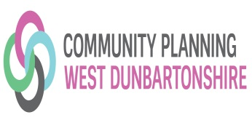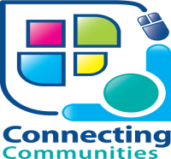[Hazel.Lindsay@west-dunbarton.gov.uk](mailto:Hazel.Lindsay@west-dunbarton.gov.uk)

Ross Wood, Senior Performance Management Worker, W4U

[Ross.Wood@west-dunbarton.gov.uk](mailto:Ross.Wood@west-dunbarton.gov.uk)

Appendix 2 – ALP Terms of Reference

**WEST DUNBARTONSHIRE ADULT LEARNING PARTNERSHIP**

**TERMS OF REFERENCE**

1. PURPOSE

The Adult Learning Partnership is a forum to engender a shared vision of Community Based Adult Learning in West Dunbartonshire through effective partnership working.

Our partnership working will be in the context of the Single Outcome Agreement, the Strategic Guidance for Community Planning Partnerships for Community Learning and Development and West Dunbartonshire Community Learning and Development Plan 2015-18. In particular:

* National outcomes:

We are better educated, more skilled and more successful, renowned for our *research* *and innovation*.

* Local outcomes:

Improved core employability skills and assisted people into work

Improved attainment and achievement through Life Long Learning

1. MEMBERSHIP

The Partnership compromises:

Ingram Wilson, Rehab/Employability Co-ordinator (Mental Health)

David Russell, Senior Access and Training Officer, West Dunbartonshire Libraries

John Rushton Section Head, West Dunbartonshire Libraries

Suzanne Greer, Community Planning Partnership( CPP) Co-ordinator

Fiona McKenzie, Head of Schools and Communities, West College Scotland

Marina McCracken, Community Outreach Coordinator, West College Scotland

Lorraine MacLeod, Performance, Information and Training Coordinator, Working4U Money

Craig Bendoris, Team Leader, Skills Development Scotland (SDS)

Jacqui McGuire, Careers Adviser, 20+, SDS

Rhona Watson, West Dunbartonshire Council for Voluntary Services (WDCVS)

Jane Logue, Senior Adult Learning Worker, Working4U Learning

Clare Henry, Senior Community Literacies Worker, Working4U Learning

1. WAYS OF WORKING
   1. The partnership will meet on a 6 weekly basis, subject to operational requirements.
   2. Sub-groups may be formed to undertake specific pieces of work.
   3. Individuals may be co-opted to provide specific advice and expertise as required.
   4. Meetings will be chaired by the Working4U Adult Learning Senior Worker
   5. Minutes of the meeting will be taken and circulated by the Admin Support Unit (ASU) and Working4U Learning.
   6. Apologies should be submitted to the ASU or Chair
   7. Meetings should last no more than 2 hours.
   8. There should be a quorum of 3 people
2. ACTIVITIES

The Partnership will coordinate adult learning provision by working together in the following areas:

**Raising the profile of Adult Learning through:**

* Branding
* Shared events
* Developing internet and social media presence
* Celebrating Learning
* Developing a media profile
* Promoting the positive impacts of Adult Learning at a political level

**Learner involvement:**

* Consultation with existing learners
* Developing an Adult Learners’ Forum
* Involving learners in planning

**Sharing Information/Practice**

* Mapping of Provision with reference to the Strategic Skills Pipeline
* Joint information/development sessions
* Joint planning and coordination
* Joint delivery of learning

5. TERMS OF REFERENCE

The Terms of Reference will be reviewed annually in January.

Appendix 3 – YA Operational Structure Chart

WD Community Planning Partnership

Community Alliance

**Delivery Improvement Groups (DIGS)**

**Youth Alliance Core Membership**

**Chair:** Working4U Learning (Shirley McAlpine) 🡪🡪🡪Reports to Children & Families DIG

Older People DIG

Safe & Strong & Involved DIG

Children & Families DIG

Employment & Economic Growth DIG

**CLD Plan Sub Groups**

(Strategic/Operational)

**Youth Alliance Working Groups**

Strategic/Operational

Involvement, Consultation & Representation

Sub Lead: W4U Learning

Health & Wellbeing (Substance Misuse)

Sub Lead: Y sort-it

Skills for Learning, Life & Work

(Including 16+ employability)

Sub Lead: W4U Learning

Appendix 4 – Self Evaluation blank template

|  |  |  |  |  |  |
| --- | --- | --- | --- | --- | --- |
| **QUALITY INDICATOR**  **Theme:** | | | | | |
| **Key question:** | | | |  | How good do we think we are? |
| **Key areas** | **Evidence** | **Strengths** | **Areas for Improvement** | **What difference have we made? Evidence of Impact:** | **Rating (1 – 6)** |
|  |  |  |  |  |  |
|  |  |  |  |  |  |
|  |  |  |  |  |  |
|  |  |  |  |  |  |
| **Identifying Areas of ‘Good Practice’ to Share – Self Evaluation** | | | | | |
| **Review Notes:** | | | | | |