West CLD Alliance Learning Lunch

National Standards for Community Engagement Workshop

Who this session is aimed at: Council staff and partners involved in community learning and development / capacity building with community.

How will this session be delivered: Workshop / interactive

How many delegates can attend: at most 20

Duration: 2 hours

Session Lead: Paul Nelis,
Scottish Community Development Centre, Glasgow

Course code | Date | Time | Location
WCLDA | Wednesday 30 May 2018 | 12-2pm  (Please arrive by 11.45am for registration) | Clydebank  Leisure Centre  Queens Quay, Clydebank, G81 1BF

Aims: The overall aim of the Community Engagement workshop is to equip staff with the knowledge of what the ‘Standards’ are (since they were refreshed in 2016) and how they can be applied in everyday practice and in a range of settings.

Learning Outcomes from the training:
- An in-depth understanding of the NSfCE and the resource which can be used in practice to support community engagement.
- An understanding of how to use the NSfCE in planning and evaluating the engagement process to learn lessons for future practice.

To book by phone, call 01389 738582 and ask for Hazel (you can leave a voicemail message) or email on hazel.lindsay@west-dunbarton.gov.uk quoting the stated course/date.

Supported by the Standards Council for Scotland
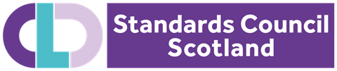

Map of Clydebank Leisure Centre

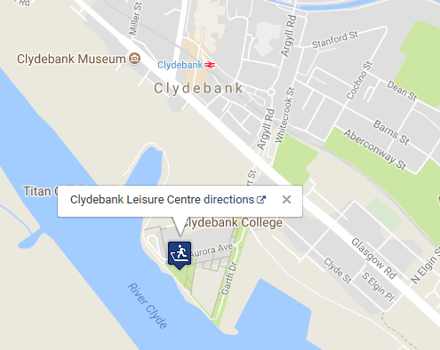

Leisure Centre Parking available

Nearest Train Station is Clydebank

