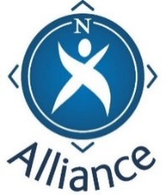

Family Learning – understanding the picture

This short introductory programme has been designed for partners involved in working with families. It presents a Community Learning and Development (CLD) picture of family learning and underpins the important role of partners working together in the interests of children, families and young people.
Come and take part in shaping a clear approach to this important area of partnership work.
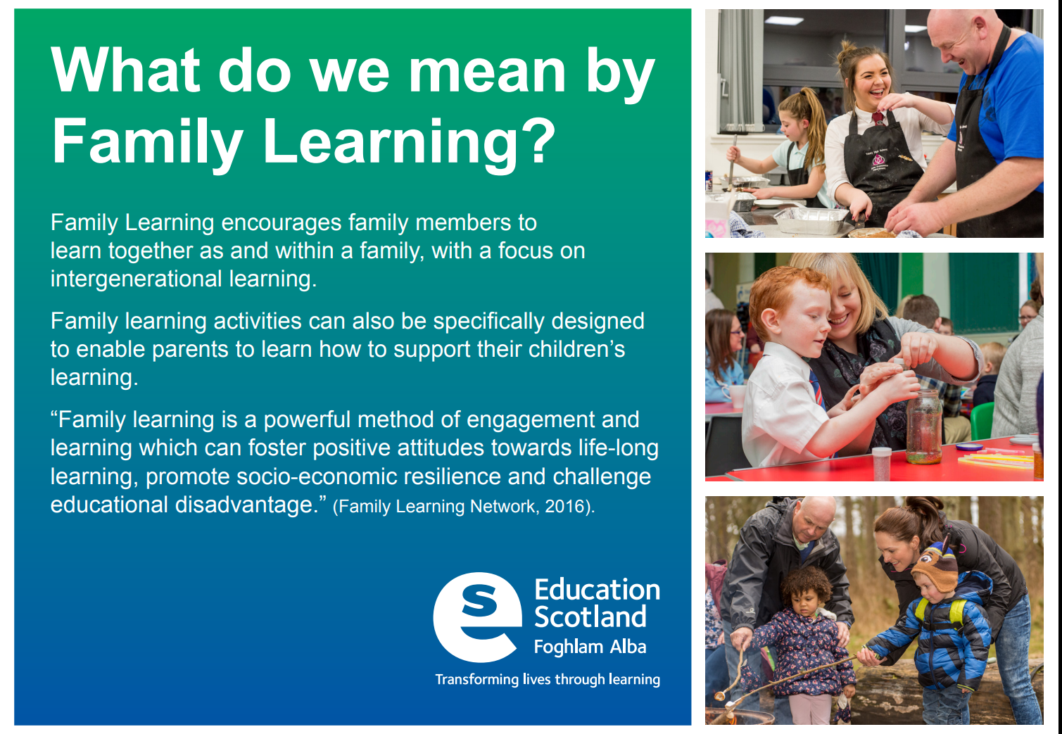
Date:

Venue:

Time:

Book a place:

